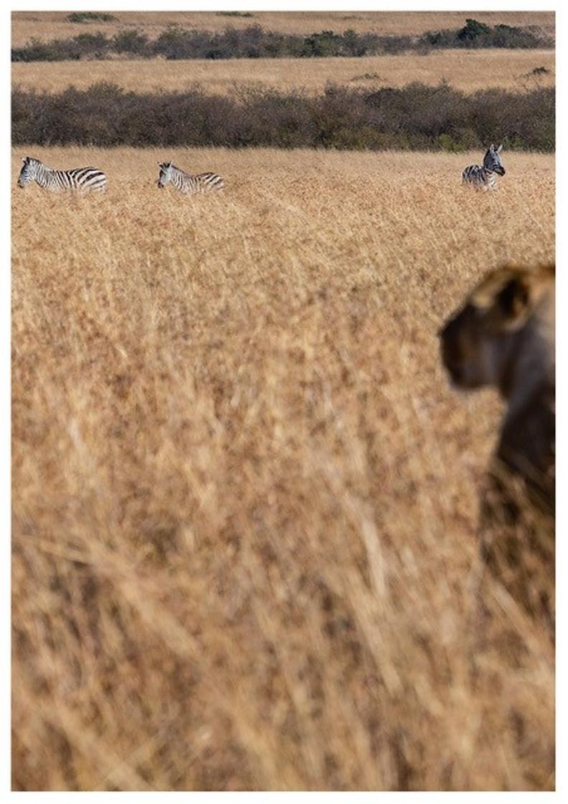


8-Day Zambia Highlights Safari - Standard - NETT

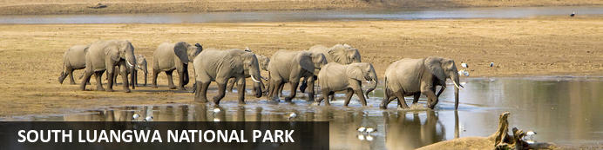
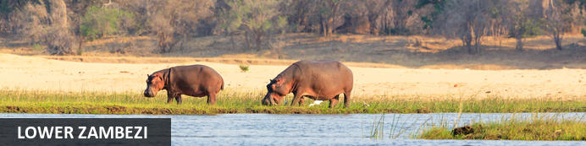
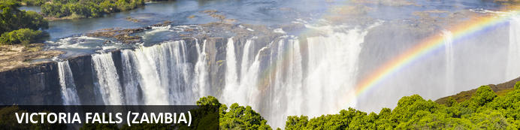

8-Day Zambia Highlights Safari - Standard - NETT
South Luangwa National Park - Lower Zambezi - Victoria Falls (Zambia)
8 Days / 7 Nights
Reference: 2024
Date of Issue: 02 November 2023

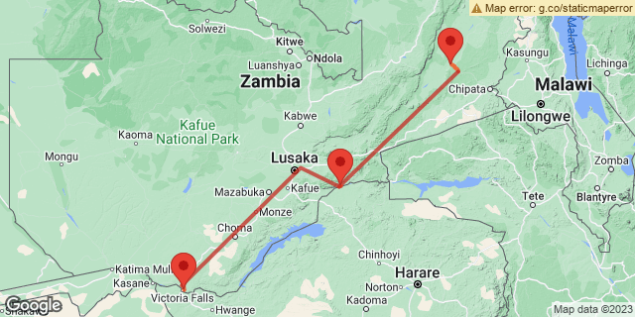

Click here to view your Digital Itinerary

Introduction
This 8-Day Zambia Highlights Safari is the perfect combination of the main highlights in Zambia to include South Luangwa, Lower Zambezi and Victoria Falls in Livingstone. A great itinerary including diverse wildlife and the magnificent falls from the Zambian side.
Add a visit to Kafue National Park to make this itinerary even better

Accommodation | Destination | Basis | Duration
Flatdogs Camp | South Luangwa National Park | FI | 3 Nights
Chongwe Camp | Lower Zambezi | FI | 2 Nights
AVANI Victoria Falls Resort | Victoria Falls (Zambia) | B&B | 2 Nights

Key
B&B: Bed and Breakfast
FI: Fully Inclusive - Bed, All Meals, Fees and Activities

Price
NETT STO COSTS
1st January 2024 – 31st March 2024
2 guests - USD 5 375 per person sharing
Single Person - USD 5 995
1st April 2024 – 31st October 2024
2 guests - USD 6 210 per person sharing
Single Person - USD 7 000
1st November 2024 – 31st December 2024
2 guests - USD 5 375 per person sharing
Single Person - USD 5 995

**Rates are subject to change

Included
- Accommodation as indicated - can change depending on availability and request at time of booking
- Meals as indicated
- Activities as indicated
- Welcome services
- Seat rate internal flights as indicated
- Airport & airstrip transfers as necessary
- Tour file with detailed itinerary, map with route descriptions, vouchers etc.
- 24 hour personal and friendly support
- Fast and efficient response to service providers

Excluded
- Items of a personal nature
- Optional extra activities
- International flights
- Holiday or personal insurance
- Staff gratuities
- Park entry fees
- Visas and visa fees

Day 1-4: Flatdogs Camp, South Luangwa National Park

South Luangwa National Park
While most of Zambia's parks are forced into hibernation over the rainy season, from November to March, the South Luangwa National Park shines as an exceptional green destination.
Discover abundant wildlife and unspoiled bush. This is Zambia's premier wildlife destination. A big game safari guaranteed. Largely unexplored and untouched, South Luangwa National Park is as raw and wild as it gets. It’s the birthplace of guided walking safaris so explore the bush on foot, the guides here are some of the best.
Guided game drives and night drives deliver great sightings. Expect large elephant and buffalo herds and a high density of leopard. And phenomenal birding especially during rain season (November to April).

Day Itinerary
- Meet & greet at Lusaka's Kenneth Kaunda International Airport on arrival. You will be assisted with your check-in for your onward flight
- Seat rate flight from Lusaka to Mfuwe Airport
- From the Airstrip you will enjoy a game drive into camp
Airstrip Transfer Time: 35 minutes from Mfuwe Airport
- 2 full days are set aside to enjoy the scheduled camp activities with your lodge guide. This includes day and night game drives as well as guided walking safaris.

Overnight: Flatdogs Camp View iBrochure
On the border of the South Luangwa National Park. You're as close to the Mfuwe entrance gate as possible and that much closer to discovering 9,050 sq km of pure, wild African bush. Did we mention it's wild?
A flat dog is known as any large reptile of family crocodile. For its location, the name Flatdogs Camp seems apt since it’s perched right there on the banks of the Luangwa River, literally teeming with thousands of these gnarly snouted fellows. Your new neighbours. Well that is, the crocodiles, hippos, the 200 mammal species and 450 bird species found in this area. It’s a wildlife festival. Great news since that's what you came here for.
Offering four different types of accommodation, Flatdogs Camp is ideal for any traveller with a heart for that prolific wildlife encounter. From spacious chalets and safari tents to a unique treehouse getaway or the private tented house for ultimate exclusivity. No matter your preference of room type, the wildlife experience - one in the same.
The dining experience too. The Restaurant is flexible with no set meals or given meal times. It’s up to you. No matter when or where you dine, under the thatched lapa, in the courtyard or garden - all with a view onto the river, the meals are simple but done well.
Lounge around reading a book. Cool off in the pool. Head out on another exciting game drive or walking safari.
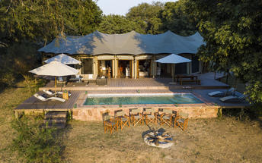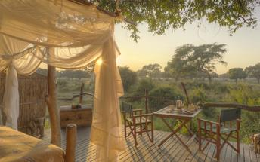

Basis
Fully Inclusive - Bed, All Meals, Fees and Activities

Included
- All meals, laundry & 2 scheduled camp activities per day

Excluded
- Drinks, additional activities, park fees and levies

Day 4-6: Chongwe Camp, Lower Zambezi

Lower Zambezi
Zambia's Lower Zambezi is fast becoming a major game park in the region with excellent wildlife safaris. With about 120km of river frontage, this wild and undeveloped park is a vast floodplain of tributaries, islands and channels beyond which its grassy acacia plains rise up to a heavily wooded escarpment. Across the river is Zimbabwe and Mana Pools effectively making one large game reserve of quite magnificent constituents.
A safari on water is as relaxing and enchanting as a safari on foot is exciting. The ever-changing scenery is always magical with large heavy-limbed trees overhanging the water, lush islands and winding channels. The game viewing is excellent as you draw no attention and pose no threat in your silent, gliding vessel.
Game drives, walking safaris, sport fishing, canoeing and night drives all feature on your daily to-do list in the Lower Zambezi National Park with the variety of wildlife and birdlife never far from your binocular vision.

Day Itinerary
- After breakfast, and a last morning activity (if time allows), you will be transferred back to Mfuwe Airport
- Seat rate flight from Mfuwe Airport to Royal Airstrip
- Transfer to the lodge on arrival
- 1 full day is set aside to enjoy the scheduled camp activities with your lodge guide, which include day and night game drives, walking safaris, canoeing, boat cruises, fishing & cultural tours

Overnight: Chongwe Camp View iBrochure
In the Lower Zambezi National Park, for reasons of survival, things need to blend in to the landscape. Chongwe River Camp is no exception.
If Chongwe tried to outdo its dramatic setting between the Zambezi and Chongwe Rivers, it would have been a short-lived contest. Towered over by a thicket of acacias, lithe trunks dancing upwards to the picturesque umbrella-shaped canopies, Chongwe River Camp is understated safari elegance on the shores of an African river giant.
The suites, just eight of them, are built from local hardwood with tented sides, glass fronts and thatched roofs. The en suite bathrooms look out to the bush and up to the sky and your private veranda looks out over the river confluence.
Dining is a fairly expansive occasion with fresh ingredients, fine wine and a sensational setting joining forces for a wickedly romantic evening. A little way off, in a private nook, the Chongwe Albida Suite is an African villa with the luxury and seclusion of an A-lister's me-my-friends-and-I play pad.
The Lower Zambezi National Park is big game country. Barricaded in by the heavily wooded Zambezi escarpment and fed by a vast drainage basin, life in the Zambezi Valley tends to appear larger than elsewhere. Elephant, lion, buffalo, giraffe, hippo, kudu, zebra, waterbuck, impala... even the elusive and enchanting sable and roan antelopes dwell in this land of giants.
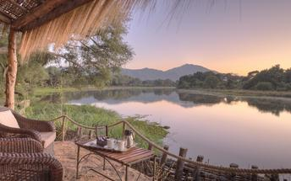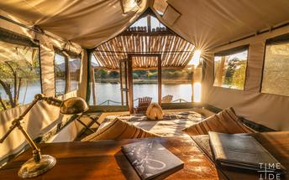

Basis
Fully Inclusive - Bed, All Meals, Fees and Activities

Included
- All meals, local drinks, activities, laundry, local transfers, park fees and levies

Excluded
- Premium drinks

Day 6-8: AVANI Victoria Falls Resort, Victoria Falls (Zambia)

Victoria Falls (Zambia)
One of Zambia's main highlights, alongside all its incredible wildlife destinations, Victoria Falls about midway on the Zambezi River course is spectacular. The largest sheet of falling water in the world with a mean flow of 935 cubic metres per second. Crazy.
Cruise the Zambezi River, at sunset and for dinner is recommended. Take a helicopter flip over the falls, it's not called "The Flight of Angels" for nothing. It's well worth it. A chance to grasp just how incredible the falls really are. Meander the rain forests. Adrenaline activities abound, which of course Devil's Pool is front runner on the Zambian side from Livingstone Island. You will actually swim to the edge of the falls and plunge into the natural rock pool on the ledge. It's one for daredevils. Only conducted when the water levels are low enough, so if this is a must on your activity list then you'd best plan for travel between late August to early January. Even then this depends on rainfall so best to check in advance.

Day Itinerary
- After breakfast, and a last morning activity (if time allows), you will be transferred back to Royal Airstrip for your onward flight
- Seat rate flight from Royal Airstrip to Livingstone Airport via Lusaka's Kenneth Kaunda International airport
- Transfer to your hotel on arrival
- 1 full day is set aside to enjoy the following activities as included:
- 1 x African Queen sunset cruise on the Zambezi River
- 1 x Guided tour of the falls (Zambian side)
- 1 x 15 minute helicopter flight over the falls

Overnight: AVANI Victoria Falls Resort View iBrochure
When you visit Victoria Falls the first thing to consider is proximity to the falls themselves. Stay at Avani Victoria Falls Resort in Livingstone and you’ve got exclusive access. You’re inside the Mosi-oa-Tunya National Park. Cue wildlife. Add activities and there you have it, the makings of your adventure on the doorstep of the Seventh World Wonder.
An African palace of vibrant colours. A combination of Zambian elements and East African artefacts. A resort of 212 rooms and suites, a five-minute walk from the falls. You have unlimited and complimentary access. Plus you can enjoy the viewing decks at sister property, The Royal Livingstone Hotel
The Avani Victoria Falls Resort has it all, including different room types (from standard to ultra-luxury), all essential amenities, boma dinners with traditional dancing and multiple other dining options for you to explore. It’s as much an adventure for your taste buds as is the destination in terms of sightseeing and activities. Although a large hotel, with so many options, it hardly feels the size.
Grab your sunglasses and your Panama hat, add a cocktail and the view of grazing zebra on the lawn. Expect service that will make you feel welcome and at home. Expect a setting and all the extras to make you feel like you’re on holiday. Now that’s how it should be!
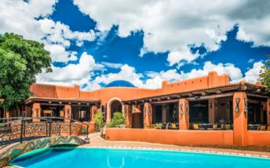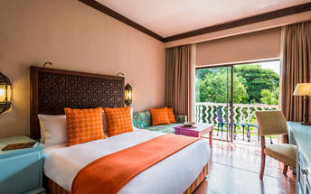

Basis
Bed and Breakfast

Day 8: End of Itinerary

Day Itinerary
- After a morning activity (optional extra) you will be transferred to Livingstone Airport in time to catch your departure flight.
- End of services

Basis
Bed and Breakfast

Transport

Flight Information
Date | Flight | Airline | Departure Airport | Time | Arrival Airport | Time | Class | Ref
 | Scheduled |  | Kenneth Kaunda International Airport [LUN] |  | Mfuwe Airport [MFU]
 | Scheduled |  | Mfuwe Airport [MFU] |  | Royal Airstrip
 | Scheduled |  | Royal Airstrip |  | Kenneth Kaunda International Airport [LUN]
 | Scheduled |  | Kenneth Kaunda International Airport [LUN] |  | Harry Mwanga Nkumbula International Airport [LVI]

Transfers
Date | Company | Pick Up | Drop Off | Time | Vehicle
 |  | Mfuwe Airport [MFU] | Flatdogs Camp |  | Transfer
 |  | Flatdogs Camp | Mfuwe Airport [MFU] |  | Transfer
 |  | Royal Airstrip | Chongwe Camp |  | Transfer
 |  | Chongwe Camp | Royal Airstrip |  | Transfer
 |  | Harry Mwanga Nkumbula International Airport [LVI] | AVANI Victoria Falls Resort |  | Transfer
 |  | AVANI Victoria Falls Resort | Harry Mwanga Nkumbula International Airport [LVI] |  | Transfer

Terms and Conditions

Namibia Tours & Safaris Terms and Conditions
Contract
1.1 The contract will become effective as from the date the invoice is completed and the deposit, referred to in Clause 2.1, is received by Africa Tours & Safaris CC (hereinafter known as the Company).
1.2 The contract is subject to the Namibian Law.
1.3 Any person making a reservation as per Clause 8.4 accepts the terms and conditions of this agreement set out hereunder.
How to Book
2.1 A 20% deposit of the full amount due is required to confirm any reservation and is to be done by the agent or client (see Clause 8.1) in writing or by e-mail.
2.2 The Company must receive the balance of the contract price no later than 42 days (6 weeks) prior to departure.
2.3 If the Company does not receive the full contract price 42 days (6 weeks) before the departure date, the Company may cancel the reservation and retain whatever deposit or other funds it has already received from the client or his agent.
How to Pay
3 The payment options will be provided upon confirmation of a booking.
Our Cancellation Policy
4.1 Any cancellation of a confirmed booking must be done in writing (email) to the Company whereupon cancellation charges as per Clause 4.2 will apply.
4.2 The following cancellation fees (as a percentage of the fully quoted price) are applicable to any cancelled travel:
Notice from date of travel: Cancellation fee:
42 days or more 20% (deposit forfeited)
29 – 41 days 50%
15 – 28 days 75%
0 – 14 days 100%
Please note: the notice period is calculated from the date of cancellation to the start date of the tour/safari booking.
4.3 No refund will be made by the Company if, for any reason, inclusions or parts of the tour cannot be carried out / or utilised. These would include all facets such as meals, game drives, accommodation etc. This would also apply to any client who has booked a tour but fails to undertake the tour for any reason.
Our Changes Policy
5 If a booking is changed to an earlier date than originally reserved, the Company will endeavour to change it. If the booking is for a later date, charges as per Clause 4.2 could apply.
As things go, we've all had to adapt to changes during the Coronavirus pandemic and so too have we therefore amended our terms and conditions for travel during such times. Check out the Updated COVID Terms and Conditions here.
Price Changes
6.1 The Company reserves the right to increase the price of any tour prior to departure due to factors beyond the control of the Company, such as, without being limited to, and increase in fuel prices, new Government legislation, accommodation price increases, fluctuations in exchange rates, etc.
6.2 If the Company announces an in increase in the tour price in terms of this Clause, such addition amount must be paid to the Company before the departure of such tour or else the Company shall have the right to cancel the tour and the charges in Clause 4.2 will apply.
Changes to Itineraries
7 The Company shall at any time have the right, in its entire discretion, to alter the terms of the booking in relation to the route, timetable, itinerary and accommodation. The Company shall, however, make every effort to offer the client an alternative tour of a comparable standard.
Should the alternative be of a lesser standard, the client will be refunded the difference, but should there be an increase, the client shall have the right to either reject the alternative and obtain a refund of the relevant portion of the original contract sum, or to accept the alternative and pay the increased cost. In the event of the client rejecting the alternative tour and claiming a refund, such rejection will be treated as a cancellation and the refund will be calculated according to Clause 4.2 hereof. The client shall have no claim against the Company for any damages arising out of the alternative booking.
Responsibility and Liability
8.1 Neither the Company nor any person acting for through and on behalf of the Company shall be liable for any loss or damage whatsoever arising from any cause whatsoever and without restricting the generality of the aforegoing shall particularly not be responsible for the loss or damage arising from any errors or omissions contained in its brochure or other literature, late or non-confirmation or acceptance or bookings, loss or damage caused by delays, sickness, injury or death, whether occasioned by negligence or not.
8.2 The Company shall have the right at any time at is sole discretion, to cancel or the remainder thereof or to make an alteration in the route, accommodation price or other details. This would include any event of any tour being rendered impossible, illegal or inadvisable by weather, avalanches, strike, war, government or other interference or due to any other cause whatsoever. The extra expenses incurred as a result thereof shall be the responsibility of the client.
8.3 The Company may at its discretion and without liability or cost to itself at any time cancel, or terminate, a client's booking and in particular, without limiting the generality of the aforegoing, it shall be entitled to do so in the event of illness or the illegal or incompatible behaviour of any client undertaking the tour, who shall in such circumstances not be entitled to any refund.
8.4 Any person making a reservation with the Company (refer to Clause 1.1) warrants that her or she has the necessary authority to enter into this contract on behalf of the person or persons included in such a booking. The person making the reservation shall be liable for the total amount due to the Company.

Client's Obligations
9.1 It is the onus and responsibility of the client to obtain the necessary comprehensive insurance before departure for any possible cancellations, medical expenses, protection or personal property and money.
9.2 The onus is upon the client to ensure that passports and visas are valid for the duration of the safari. The Company cannot be held liable for any necessary visas or other travel documents not held by clients. In the event of a client not having the necessary documentation to enter any area or country the Company shall reserve the right to leave the client a the point of entry of such area or country. In such an event, the Company will not be held responsible to the client for further travel arrangements.
9.3 The onus is upon the client to ensure that the SARS-CoV-2 PCR tests are done prior to commencement of the safari and valid on arrival in accordance to the requirements of the country of intended travel and for the airline with which the client will travel. The same applies for any necessary testing for departure. The costs of any such COVID testing will be for the clients own account. While The Company can assist with arrangements for testing in-country, The Company will not be held responsible to the client for such arrangements and with regards to return time of test results.
9.4 Should the client need to undergo mandatory quarantine once in-country with regards to the SARS-CoV-2 virus, either on arrival as called for by the authorities or due to testing positive once in-country, this will be at the clients own expense.
Health and Personal Safety
10.1 The client shall be reasonably fit to undertake the tour.
10.2 Anti-malaria precautions should be commenced prior to tour departure. A medical doctor should be consulted for advice.
10.3 Tours offered by the Company cover a wide spectrum of the African wilds and neither the Company, its employees or agents can be held responsible for any injury or other related incidents whilst on the tour / safari.
10.4 The Company cannot be held responsible for any client who falls ill or contracts the SARS-CoV-2 virus while in-country. The client accepts that travel is at own risk.
Baggage
11.1 Clients are limited to one soft sports type bag per person with a maximum weight of 20 kilograms. This includes photographic equipment and hand luggage.
11.2 Due to the rugged terrain, the Company cannot be held responsible for damage or loss of any personal items including bags, contents of bags or photographic and related equipment. Due to extremely dusty conditions, please ensure all bags are dust proof.
Airline and Car Hire Clause
12.1 The Company will act as the agent of the client when booking the client with a car hire company, an airline or air charter service. The client therefore contracts with the car hire company, airline or charter service and not with the Company.
12.2 Charter flights are normally operated by smaller type aircraft such as Cessna 210. Luggage is strictly limited to 10-15 kgs (depending on terms of particular airline used) per person in soft hold all type bags. Due to the desert heat, it is not safe to overload aircraft thus this limit needs to be strictly controlled.
Travelling or thinking of travelling during the COVID-19 pandemic? Take a look at our COVID Terms and Conditions for more information on how this will work and differ from our standard terms and conditions as listed above.

