

Classic Highlights of Kenya & Tanzania
Nairobi City - Masai Mara National Reserve - Lake Elmenteita - Amboseli National Park - Ngorongoro Crater - Serengeti National Park - Lake Manyara National Park
12 Days / 11 Nights

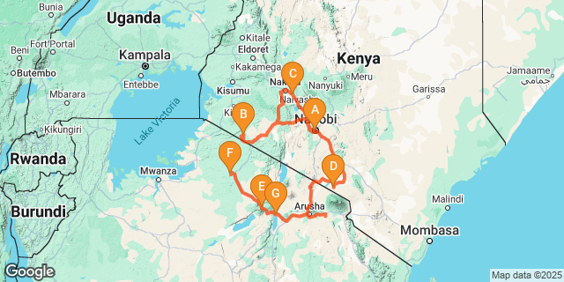

Introduction

Start | Accommodation | Destination | Basis | Duration
Day 1 | Nairobi Serena Hotel | Nairobi City | B&B | 1 Night
Day 2 | Mara Serena Safari Lodge | Masai Mara National Reserve | FB | 2 Nights
Day 4 | Lake Elmenteita Serena Camp | Lake Elmenteita | FB | 1 Night
Day 5 | Amboseli Serena Safari Lodge | Amboseli National Park | FB | 2 Nights
Day 7 | Ngorongoro Serena Safari Lodge | Ngorongoro Crater | FB | 2 Nights
Day 9 | Serengeti Serena Safari Lodge | Serengeti National Park | FB | 2 Nights
Day 11 | Lake Manyara Serena Safari Lodge | Lake Manyara National Park | FB | 1 Night

Key
B&B: Bed and Breakfast
FB: Full Board - Dinner, Bed, Breakfast and Lunch

Included
- Accommodation & Meals as stipulated in the itinerary.
- Transportation on safari will be in a 4 x 4 land cruiser with a pop up roof for easy game viewing & photography.
- Services of a professional driver-guide
- All transfers
- All park fees
- All Government taxes and levies.
- 24 hours stand-by contact number.
- Guaranteed window seat.
- Two-way long range high frequency radio communication in each vehicle.
- On safari accessories in each vehicle: First-aid kit, wildlife books, cools box and fire extinguisher.

Excluded
- All items of personal nature e.g. telephone call bills, fax/email bills etc.
- Gratuities and Tips to Hotels / Camps staff and Driver/Guide(s).
- International flight/s and departure taxes and other taxes.
- Laundry services.
- Visa fees. Visas are available on arrival at all Entry point/s
- Easter Supplements

Day 1
Nairobi Serena Hotel, Nairobi City

Day Itinerary
Jambo! Upon arrival at Jomo Kenyatta International Airport in Nairobi, you will be met by Classic Safaris representative who will assist with the transfer to Nairobi Serena Hotel.
Overnight: Nairobi Serena Hotel
Meal Plan: Bed and Breakfast
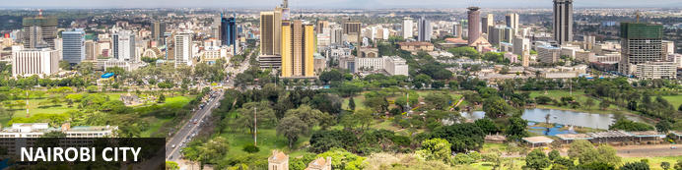
Nairobi is Africa’s 4th largest city and is a vibrant and exciting place and although it has developed a reputation which keeps tourist visits brief there are some fascinating attractions: its café culture, unbridled nightlife, the National Museum, the Karen Blixen Museum and most notably just 20 minutes from the city centre wild lions and buffalo roam in the world’s only urban game reserve.

Overnight: Nairobi Serena Hotel
The Nairobi Serena Hotel is nestled among lush gardens at the edge of Nairobi’s Central Park. The elegant guest rooms include satellite TV, minibars, coffee and tea making stations, free daily newspapers, and free Wi-Fi. With three on-site restaurants, a coffee bar and a pool bar serving drinks, guests are spoilt for choice when it comes to dining. Guests can enjoy leisurely strolls through the large grounds, have a splash in the heated pool, or enjoy relaxing massages and treatments at the Maisha Spa and Health Club.
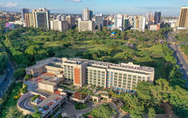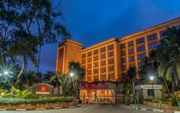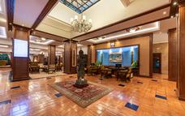

Basis
Bed and Breakfast

Day 2
Mara Serena Safari Lodge, Masai Mara National Reserve

Day Itinerary
Your comfortable drive now takes you to the Maasai Mara, Kenya’s most famous wildlife reserve and the setting for much of the film Out of Africa. It is classic savannah grasslands, where animals are plentiful and the vistas spectacular. Here Maasai tend their cattle in concert with free roaming wildlife – all sharing the same land with minimal conflicts. You will have two days of wildlife-viewing opportunities in the Maasai Mara Reserve, also known as the “Jewel of Africa,” inhabited by many of Africa's most popular wild animals, including lion, cheetah, elephant, leopard, black rhino and hippo. There are over 500 resident species of birds in the park including ostrich, larks and sunbirds as well as the lovely Lilac-breasted Roller.

The area is famous for rolling grassland and for the Mara River, which runs through the reserve from north to south. The reserve covers an area of 700 square miles and forms part of the Serengeti ecosystem, hosting the world famous spectacle of the annual migration of up to two million wildebeest, thousands of zebra and an escort of carnivores as they follow the rains and succulent new grass. A costly trek as many of the lame, laggard and sick will fall prey to ravenous packs of predators and many more will die crossing the swirling flood waters of the Mara River.
Optional activities (at additional cost) include a balloon safari for an exhilarating experience over the savannah as the early sun rises and the animals are more active. Or, you can visit a Maasai Village to see how this nomadic tribe has existed through the millennia in harmony with nature.
Overnight: Mara Serena Safari Lodge
Meal Plan: Full Board

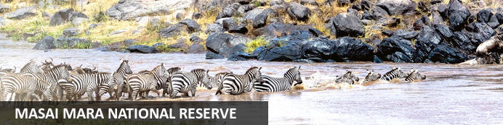
One of Kenya’s undisputed natural highlights is the Masai Mara National Reserve, which sprawls across more than 1500 square kilometres of the country’s southwest. The park protects a phenomenal array of game, including elephant, lion, leopard and buffalo, as well as crocodile and hippopotamus in the Mara River. The birdlife is no less impressive, with over 450 resident bird species. However, the true highlight here is the Great Migration, recognised as one of the Seven New Wonders of the World. To survive the dry months of July to September, some 1.7 million wildebeest, migrate from the parched plains of the Serengeti National Park in Tanzania. Along with much smaller numbers of antelope, buffalo and zebra, they move to the more forgiving grasslands of the Masai Mara. In their wake come predators such as lion, hyena and cheetah, for whom these giant herds are an easy source of prey.

Overnight: Mara Serena Safari Lodge
Mara Serena Safari Lodge welcomes you to a world of stunning sights, warm hospitality, and top-notch amenities. Nestled in the iconic Mara Triangle, our lodge stands out with its picturesque location atop a hill, offering sweeping views of the savannah and the Mara River.
Designed in the style of a traditional Maasai Manyatta, our lodge combines authentic charm with modern comforts. Our rooms and suites, arranged neatly to provide uninterrupted river views, ensure a serene and comfortable stay. Guests can also enjoy breathtaking views from our restaurant, bar, and rock-enclosed swimming pool. After a day of adventure, pamper yourself with a steam shower or an Swedish Massage at our Maisha Spa & Gym.
Embark on exciting excursions into the Masai Mara Game Reserve, with activities tailored to your preferences. Indulge in delicious cuisine at our onsite restaurant, including unforgettable "Bush Dining" and "Sundowner" experiences. Create lasting memories with your family through game drives, breakfasts by the hippo pool, and visits to an authentic Maasai village.
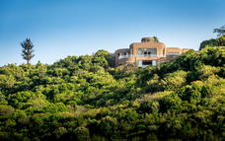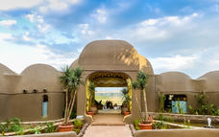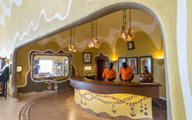

Basis
Full Board - Dinner, Bed, Breakfast and Lunch

Day 3
Mara Serena Safari Lodge, Masai Mara National Reserve

Day Itinerary
Morning and afyternoon game drives. All meals and overnight stay at the lodge
Overnight: Mara Serena Safari Lodge
Meal Plan: Full Board

Basis
Full Board - Dinner, Bed, Breakfast and Lunch

Day 4
Lake Elmenteita Serena Camp, Lake Elmenteita

Day Itinerary
After breakfast drive south to Lake Nakuru which is the most famous of the Great Rift Valley lakes and home to a shifting population of over one million flamingos. Arrive in time for lunch at the Sarova Lion Hill Lodge, which enjoys sweeping views across the lake. Spend the afternoon on safari in Kenya's first and largest rhino sanctuary where sightings of both black and white rhino are almost guaranteed and where you have a higher than average chance of spotting a leopard. Other wildlife includes; lion, hippo, the rare Rothschild's giraffe, Colobus monkey, numerous plains game and 450 species of birds.
Overnight: Sarova Lion Hill Lodge
Meal Plan: Full Board
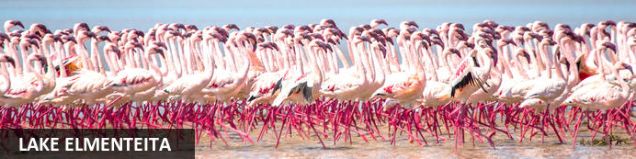
Elmenteita, meaning ‘place of dust’, is a photogenic, little soda lake situated in Kenya’s Great Rift Valley. Famously attracting many visiting flamingos as well as many other birds, it has been named as a World Heritage Site for its prolific birdlife. This is where Kenya’s most famous settler Lord Delamere lived and he was responsible for much of Kenya’s early agricultural experimentation in this fertile area; it is still inhabited by some of his descendants. The shores are often filled with wildlife and the surrounding forests are perfect for long walks and bird watching. Visitors can look forward to visiting the idyllic Kekopey hot springs, game viewing along the lake’s edge, and numerous other activities. Look out for eland, kudu, zebra, gazelle, and warthog families.

Overnight: Lake Elmenteita Serena Camp
Lake Elmenteita Serena Camp is situated within Kenya's Soysambu Conservancy and offers breathtaking vistas of the nearby volcanoes. Visitors have the option of staying in deluxe tents or the elegant flamingo suites, both of which come equipped with modern amenities such as complimentary Wi-Fi, satellite television, mini-fridges and mosquito nets.
For dining, guests can savor their meals in the central dining area or al fresco in the midst of the bush, taking in the mesmerizing sunset views. The camp boasts a picturesque outdoor swimming pool where visitors can unwind and soak up the African sun. Moreover, an on-site massage service is available, providing a range of treatments to enhance your stay.
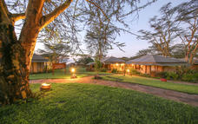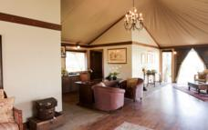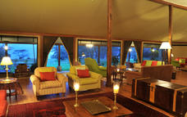

Basis
Full Board - Dinner, Bed, Breakfast and Lunch

Day 5
Amboseli Serena Safari Lodge, Amboseli National Park

Day Itinerary
Depart to Amboseli National Park, located at the foot of Africa's highest mountain, Mount Kilimanjaro. The snow-capped peak of Mount Kilimanjaro rises above a saucer of clouds and dominates every aspect of Amboseli. This park covers only 150 square miles but despite its small size and its fragile ecosystem it supports a wide range of mammals (well over 50 of the larger species) and birds (over 400 species). Afternoon game viewing drive. Later as the sun sets, you will be transferred back to your lodge for dinner and overnight.
Overnight: Amboseli Serena Safari Lodge
Meal Plan: Full Board
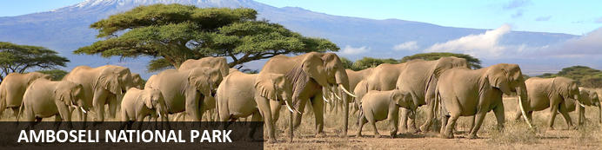
Located in the southern reaches of Kenya, the Amboseli National Park is renowned for its excellent variety of wildlife such as Maasai giraffe, elephant, lion and cheetah and not surprisingly it is one of Kenya's most popular parks. The landscape of Amboseli is dominated by the majestic snowcap of Mount Kilimanjaro, as well as open plains, acacia woodland, swamps and the massif of Ol Doinyo Orok. The birding is excellent, especially closer to the lakes and swamps. The park is famous for being the best place in Africa to get close to large herds of elephants among other wildlife species. Other attractions include opportunities to meet the Maasai people and soak up spectacular views of Mount Kilimanjaro, the highest free-standing mountain in the world.

Overnight: Amboseli Serena Safari Lodge
Nestled in the heart of Amboseli National Park and near Mount Kilimanjaro, Amboseli Serena Safari Lodge offers 92 rooms with complimentary Wi-Fi, 24-hour room service, and a private balcony. The hotel's facilities include a swimming pool and sundeck, a gift shop, a spacious interior bar with a terrace, a campfire bar, and a bush BBQ area. Guests can enjoy a variety of activities such as guided walks, bird-watching walks, dinner in the bush, and Maasai dance performances in the dedicated exterior bush BBQ area. The lodge's stunning location offers guests an array of exciting excursions, including exploring Amboseli National Park, thrilling safari activities, eco-tourism adventures, bush expeditions, and more, creating countless unforgettable experiences for a perfect Kenyan holiday.
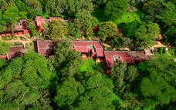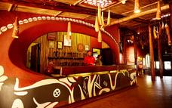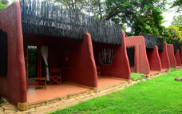

Basis
Full Board - Dinner, Bed, Breakfast and Lunch

Day 6
Amboseli Serena Safari Lodge, Amboseli National Park

Day Itinerary
This morning, enjoy a game drive. Amboseli is best known for views of spectacular Mount Kilimanjaro, the highest mountain in Africa at some 19,341 feet. The park affords you the best opportunity to get close to the mighty elephant. You might also spot Cape buffalo, zebra, wild dog, and others. During the heat of the day, relax at your lodge. You will have a game viewing drive in the afternoon. All meals and overnight at the lodge.
Overnight: Amboseli Serena Safari Lodge
Meal Plan: Full Board

Basis
Full Board - Dinner, Bed, Breakfast and Lunch

Day 7
Ngorongoro Serena Safari Lodge, Ngorongoro Crater

Day Itinerary
After breakfast, drive towards Namanga to clear with customs. Continue to Arusha town arriving for lunch at Kibo Palace Hotel. After lunch in Arusha, drive to the famous Ngorongoro Crater Conservation Area (NCCA), which features rolling plains, lakes, craters, mountains and dormant volcanoes. Journey up
the side of the vast Ngorongoro Crater, a World Heritage Site, which is one of the largest volcanic craters in the world (almost 20 kilometers wide, 610-760 metres deep and covering a total area of 264 sq km) and arrive at the Ngorongoro Serena Lodge in time for one of the finest views in the world.
Overnight: Ngorongoro Serena Safari Lodge
Meal Plan: Full Board
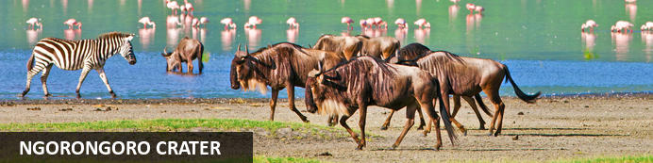
Located in Northern Tanzania, the Ngorongoro Crater is best known for its natural beauty and abundance of diverse wildlife; which makes it one of Africa’s most popular safari destinations. Surrounded by Tanzania’s highlands, this UNESCO-listed crater is said to be the world’s largest intact volcanic caldera. Visitors can look forward to spotting the world-renowned Big Five and a host of other wildlife species including large herds of zebra and wildebeest. It is famed as one of Tanzania’s best tourist attractions offering visitors an array of wonderful activities including excellent bird watching, trekking, wildlife viewing, mountain biking and visiting a local Maasai village. Don’t miss the opportunity to jump on an excursion to the magnificent Olduvai Gorge.

Overnight: Ngorongoro Serena Safari Lodge
Nestled high on the jagged rim of the Ngorongoro Crater and shrouded in mist, the Ngorongoro Serena Safari Lodge is a stunning example of ecological and architectural harmony. The boulder-built buildings of the Lodge are camouflaged by indigenous creepers and linked by timber walkways that skirt ancient trees. Inside, guests are greeted by the hushed ambiance of a game-viewing hide and the ochre, rust, and charcoal imagery of a prehistoric cavern, decorated with Maasai iron spears, bright-beaded robes, and intricately-carved artifacts. The rooms, strung around the crater rim, are adorned with brass lamps, wildwood mirrors, and Maasai carvings, each featuring its own rock-enclosed balcony and uninterrupted views of the Crater below. After a day of adventure, guests can follow a gentle nature trail, take a guided walk to the Crater's rim, or simply relax with a herbal massage as the sun sets behind the mountains. Explore the Cradle of Mankind at Ngorongoro Serena Safari Lodge and experience one of the most unique travel experiences in the world.
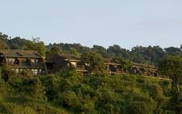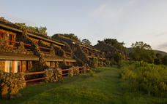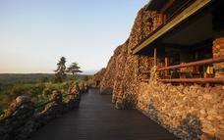

Basis
Full Board - Dinner, Bed, Breakfast and Lunch

Day 8
Ngorongoro Serena Safari Lodge, Ngorongoro Crater

Day Itinerary
After breakfast, descend into the ‘8th Wonder of the World’, a unique biosphere that has remained virtually unchanged since the dawn of time. Enclosed within its towering walls are grasslands, swamps, forests, saltpans, a fresh water lake and a glorious variety of birdlife. Here too are all the members of the ‘Big Five’ (lion, elephant, rhino, leopard and buffalo) as well as a large cast of plains game and one of Africa’s densest populations of predators. Enjoy a picnic lunch on the crater floor before climbing back up to the lodge in time for relaxation before dinner.
Overnight: Ngorongoro Serena Safari Lodge
Meal Plan: Full Board

Basis
Full Board - Dinner, Bed, Breakfast and Lunch

Day 9
Serengeti Serena Safari Lodge, Serengeti National Park

Day Itinerary
After breakfast, leave the NCCA and cross into neighbouring Serengeti National Park. Arrive in time for lunch. Afternoon game drive.
Overnight: Serengeti Serena Safari Lodge
Meal Plan: Full Board
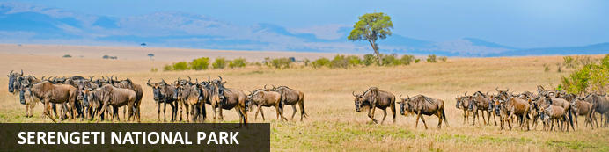
The Serengeti, together with Kenya’s Masai Mara Game Park, constitute Africa's most famous wildlife park, spread over the enthralling landscapes of northern Tanzania. This is a precious ecosystem, supporting the annual wildebeest migration through the Serengeti and the Masai Mara. The largest mass movement of land mammals on the planet involves more than a million animals following the rains, including more than 1.5 million white-bearded wildebeest and 250 000 zebras. Prides of lions, as well as groups of elephants, giraffes, gazelles, and eland, roam among the photogenic vast grass plains between weird-and-wonderful-looking acacia trees. Aside from traditional vehicle safaris, hot-air ballooning over the Serengeti plains and horse riding safaris are on offer.

Overnight: Serengeti Serena Safari Lodge
Perched high on an acacia-lined ridge overlooking the vast, grassy plains of the Serengeti, Serengeti Serena Safari Lodge seamlessly blends traditional African architecture with modern style to offer an award-winning hotel experience. Stay in stone-built, thatched-roof "rondavel" lodges, dine under a blanket of stars, and enjoy unforgettable adventures such as private safaris, guided nature walks, and massage treatments. The lodge is centrally located near the Western Corridor and Grumeti River and boasts a pool that looks out over the endless plains. Cultural entertainment is on offer, with traditional Makonde carvings adorning the rooms and the stunning domed dining room showcasing performances, heritage, and art.
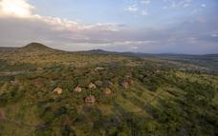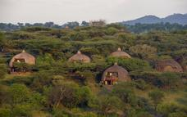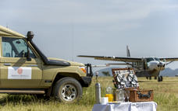

Basis
Full Board - Dinner, Bed, Breakfast and Lunch

Day 10
Serengeti Serena Safari Lodge, Serengeti National Park

Day Itinerary
After breakfast, enjoy a full day’s game driving (meals taken in true safari style ‘in the bush’) in the vast and sensational Serengeti, which covers 14,763 sq km of endlessly rolling savannah. Venue for ‘the greatest wildlife show on Earth’, the annual migration of over one million wildebeest, the park is
also renowned for its lions, cheetahs, zebras, giraffes and plains game. Overnight at the lodge.
Overnight: Serengeti Serena Safari Lodge
Meal Plan: Full Board

Basis
Full Board - Dinner, Bed, Breakfast and Lunch

Day 11
Lake Manyara Serena Safari Lodge, Lake Manyara National Park

Day Itinerary
After breakfast, drive to beautiful Lake Manyara, a shallow alkaline lake that shimmers in a cleft in the Great Rift Valley. Arrive in time for lunch at the Lake Manyara Serena Safari Lodge, which stands on the edge of the escarpment, overlooking the lake. A small but uniquely diverse national
park, Manyara is home to the world-famous tree-climbing lions, thousands of flamingoes and nearly 500 species of birds. Return to the lodge in time for a swim in the stunning horizon pool and dinner in the elegant central dining room.
Overnight: Lake Manyara Serena Safari Lodge
Meal Plan: Full Board
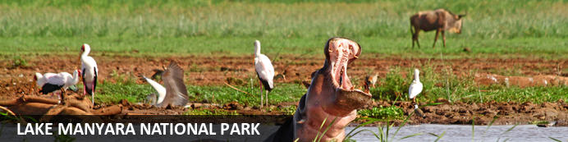
Situated in Tanzania’s central-northern region with the Lake Manyara to its east and the Manyara Escarpment to its west, the Lake Manyara National Park offers breathtaking views and a large variety of habitats supporting an array of wildlife. This small park is home to surprising biodiversity and features a magnificent landscape of acacia woodlands, forests, baobab strewn cliffs, algae-streaked hot springs, swamps and the lake itself. The park supports over 400 species of bird and the largest concentration of baboons anywhere in the world. Other species to spot include giraffes, zebras, wildebeest, impala, waterbuck, warthog, the Cape clawless otter, and the Egyptian mongoose. Don’t miss the opportunity to see thousands of flamingos on the lake, the renowned tree-climbing lions, and large families of elephants strolling through the forest.

Overnight: Lake Manyara Serena Safari Lodge
Lake Manyara Serena Safari Lodge is nestled in a peaceful location within the Lake Manyara National Park, offering a stunning view of Tanzania's Mto wa Mbu escarpment. The lodge is designed to reflect the brilliant birdlife of the region with avian curves and wall frescoes depicting migratory patterns, while the accommodation, housed in circular two-story rondavels, offers traditional charm and modern amenities. The lodge provides opportunities for game drives, outdoor excursions, village tours, lounging by the "vanishing horizon" pool, and dining at the Flamingo Restaurant, with the option of arranging a bush meal. Additionally, Lake Manyara is a popular destination for birdwatching, as it is home to over 300 migratory birds, including flamingos, eagles, and kingfishers. The park is also abundant in wildlife, with sightings of monkeys, hyenas, giraffes, elephants, and many more.
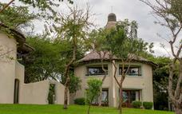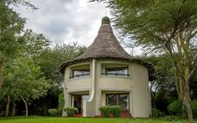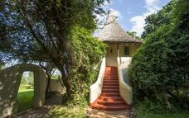

Basis
Full Board - Dinner, Bed, Breakfast and Lunch

Day 12
End of Itinerary

Day Itinerary
Drive to Arusha town for lunch at Arusha Coffee Lodge. After lunch, you will be transferred to Kilimanjaro airport for your International flight back home.

