

CLASSIC TANZANIA HORIZONS SAFARI
Arusha - Lake Manyara National Park - Serengeti National Park - Central Serengeti - Ngorongoro Crater
7 Days / 6 Nights

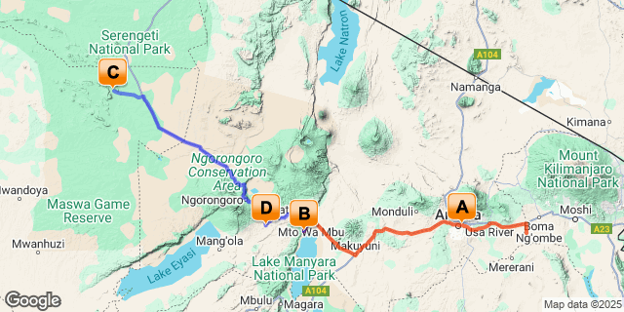

Introduction

Start | Accommodation | Destination | Basis | Duration
Day 1 | The African Tulip | Arusha | B&B | 1 Night
Day 2 | Lake Manyara Kilimamoja Lodge | Lake Manyara National Park | FB | 1 Night
Day 3 | Ole Serai Luxury Camp Moru Kopjes | Serengeti National Park | FB | 3 Nights
Day 6 | Ngorongoro Oldeani Mountain Lodge | Ngorongoro Crater | FB | 1 Night

Key
B&B: Bed and Breakfast
FB: Full Board - Dinner, Bed, Breakfast and Lunch

Included
​​​
- Accommodation as stipulated in the itinerary.
- Transportation in a chauffeur driven 4x4.
- Services of a professional English speaking driver-guide
- All game viewing drives.
- Flying Doctor’s fee.
- All park entrance fees as indicated in the itinerary.
- One way flight Serengeti – Arusha on a light Aircraft, 15 Kg baggage allowance.
- All Government taxes and levies.
- Complimentary 500 ml mineral water per person per game drive in the safari vehicle.
- All meet and greet services.
- All arrival and departure transfers.
- 24 hours stand-by contact number.
- Meals as indicated in the itinerary.
- Two-way long range high frequency radio communication in each vehicle.
- On safari accessories in each vehicle: - First-aid kit, wildlife books, a pair of binoculars, cool box and fire extinguisher.

Excluded
- All items of personal nature e.g. telephone call bills, fax/email bills etc.
- Tipping / Gratuities
- Extra Meals Not Included above
- International flight and departure taxes.
- Laundry services.
- Visa Fees
- Travel Insurance
- Any other item(s) not included in our itinerary.

Day 1
The African Tulip, Arusha

Day Itinerary
Jambo! Upon arrival at Kilimanjaro International Airport, you will be met by Classic Safaris Representative who will greet you and assist with the transfer to Kibo Palace for Overnight stay.
Overnight Stay: The African Tulip
Meal Plan: Bed & Breakfast
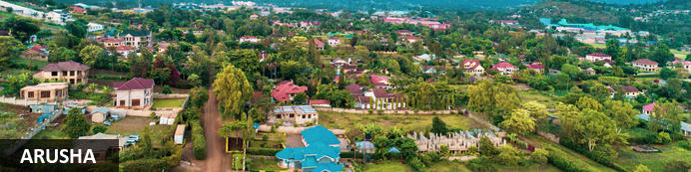
Resting at the foot of Mount Meru, the sprawling city of Arusha is known as the safari capital of northern Tanzania. It serves as an excellent base from which to explore the remarkably scenic surrounding area which includes majestic Mount Kilimanjaro, as well as the Manyara, Tarangire and Ngorongoro National Parks. Arusha is a good spot to take a day or two off from the safari circuit as it features a temperate climate and lush surrounds. Visitors can look forward to exploring the wildlife-abundant Serengeti National Park; the magnificent Arusha National Park; and taking on the challenge of climbing Mount Meru, Africa’s fifth highest mountain.

Overnight: The African Tulip
The African Tulip is an elegant and charming Luxury Boutique Hotel in the heart of Arusha. A warm and friendly welcome awaits guests who want to experience the best of Tanzanian hospitality. The hotel has been designed with safari travellers, business persons, families, honeymooners, elite and leisure travellers in mind. It has amenities of convenience whilst offering a high standard of luxury.
The hotel has 29 guest rooms, 7 of which are suites. The rooms are individually and stylishly decorated using warm African tones. A lot of African material and local art has been used reflecting the common thread that runs throughout the hotel which is one of consistence and quality.
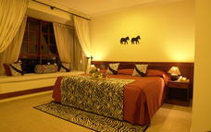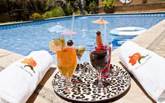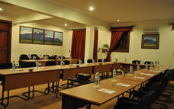

Basis
Bed and Breakfast

Included
Bed & Breakfast

Day 2
Lake Manyara Kilimamoja Lodge, Lake Manyara National Park

Day Itinerary
After Breakfast, depart to the beautiful Lake Manyara a shallow alkaline lake that shimmers in a cleft in the Great Rift Valley. You will arrive for lunch at your lodge followed by an afternoon game drive. Animals found here includes elephant, buffalo, hippo, lion, leopard, occasional cheetah and giraffe. Lions here have opted to rest up during the heat of midday in trees, giving Manyara lions somehow different behavior.
Later as the sun sets, you will be transferred back to your lodge
Dinner and overnight stay Lake Manyara Kilimamoja Lodge.
Meal Plan: Full Board
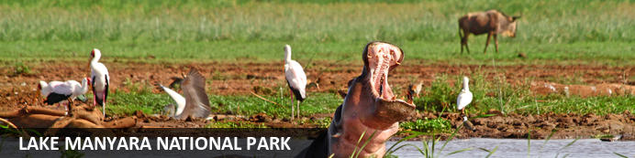
Situated in Tanzania’s central-northern region with the Lake Manyara to its east and the Manyara Escarpment to its west, the Lake Manyara National Park offers breathtaking views and a large variety of habitats supporting an array of wildlife. This small park is home to surprising biodiversity and features a magnificent landscape of acacia woodlands, forests, baobab strewn cliffs, algae-streaked hot springs, swamps and the lake itself. The park supports over 400 species of bird and the largest concentration of baboons anywhere in the world. Other species to spot include giraffes, zebras, wildebeest, impala, waterbuck, warthog, the Cape clawless otter, and the Egyptian mongoose. Don’t miss the opportunity to see thousands of flamingos on the lake, the renowned tree-climbing lions, and large families of elephants strolling through the forest.

Overnight: Lake Manyara Kilimamoja Lodge
Lake Manyara Kilimamoja Lodge is nestled on the rim of the Great African Rift Valley with stunning views of Lake Manyara, Mount Meru and on a clear day, Mount Kilimanjaro.
The lodge is situated in lush green gardens and local vegetation with over 130 species of bird. It offers an ideal place in which to base a northern safari experience. The Ngorongoro Crater, Oldeani, Lake Eyasi, Lake Manyara and the Ngorongoro Highlands are just a short drive away from the lodge. Sitting around the outside fireplace watching the sun setting over the Great Rift Valley and listening to the humming of the birds in the background is a fitting way to end the day, and preparing for a sumptuous dinner feast.
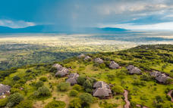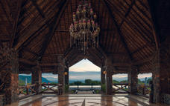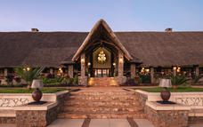

Basis
Full Board - Dinner, Bed, Breakfast and Lunch

Day 3-6
Ole Serai Luxury Camp Moru Kopjes, Serengeti National Park

Day Itinerary
Drive to Serengeti National Park. You will have 3 days of game drives in this Park. Serengeti National Park is a World Heritage Site teeming with wildlife: over 2 million ungulates, 4000 lions, 1000 leopard, 550 cheetahs and some 500 bird species inhabit an area close to 15,000 square kilometers in size. Join us on a safari and explore the endless Serengeti plains dotted with trees and kopjes from which majestic lions control their kingdom; gaze upon the Great Migration in awe or find an elusive leopard in a riverine forest. Or perhaps see everything from a bird’s-eye view and soar over the plains at sunrise during a hot air balloon safari.
All meals and Overnight Stay at Ole Serai Luxury Camp - Moru Kopjes
Meal Plan: Full Board.
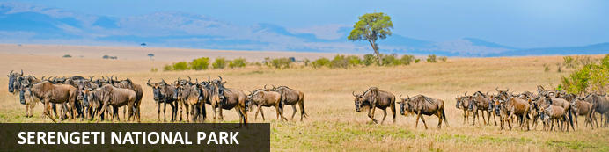
The Serengeti, together with Kenya’s Masai Mara Game Park, constitute Africa's most famous wildlife park, spread over the enthralling landscapes of northern Tanzania. This is a precious ecosystem, supporting the annual wildebeest migration through the Serengeti and the Masai Mara. The largest mass movement of land mammals on the planet involves more than a million animals following the rains, including more than 1.5 million white-bearded wildebeest and 250 000 zebras. Prides of lions, as well as groups of elephants, giraffes, gazelles, and eland, roam among the photogenic vast grass plains between weird-and-wonderful-looking acacia trees. Aside from traditional vehicle safaris, hot-air ballooning over the Serengeti plains and horse riding safaris are on offer.

Optional
WALKING SAFARIS
APERITIFS AND COCKTAILS AT THE BONFIRE
SWAHILI LESSON
STAR GAZING
STORY TELLING AROUND THE FIRE PLACE
CULTURAL ACTIVITIES
SPECIAL ARRANGEMENT FOR THE HONEY MOONERS
BUSH DINNER
BUSH LUNCH
BUSH BREAKFAST

WALKING SAFARIS
The walking safaris starts from the boma towards Rongai river which is about 150 meters from the lodge, this walking safaris is called short walk of about 1 to 2 hours. During the walking safaris you will be introduced about the nature of plants and animals that are dominating around this area including Acacia tortillas, birds, hippos and hippo pool and the root of migration which is exactly in front of the lodge and destination for the lion’s birth.
The safari will be led by our professional guide with armed ranger along the River towards the plain areas to learn more on Acacia trees, whistling thorn and umbrella trees which are dominating in Rongai, this walking safari will be accompanied by a lot of wild animal sounds around the river including Thompson, water buck and a nice melody of birds and jackals.
The walking safaris normally start at 7.00Am to 9.00Am or 4.00pm to 6.00pm. These hours are recommended mostly because the animals surrounding these areas are very visible and not arrogant during this time due to avoid devastation of water and sun
After one or two hours walking safaris you will be well come by a chilled complimentary glass of amarula in our boma

APERITIFS AND COCKTAILS AT THE BONFIRE
Our Serengeti bar tender will provide varieties of the local cocktails including Serengeti blues, Serengeti sunset at the fire place with a finger bite snacks
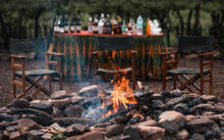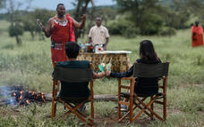

SWAHILI LESSON
The Swahili phrase, HAKUNA MATATA, meaning (No Trouble) was made famous by lion king Disney movie. Learn Swahili words with our resident teachers who will give you a one on one lesson every evening at the fire place

STAR GAZING
On a clear night standing under the sky is like having a blankets star surrounds
These are the same stars that guide the Masai Nomads to greener areas for their livestock. However, the best viewing of constellation can be seen from the boma. Grab a night cap and join us outside under the African sky.

STORY TELLING AROUND THE FIRE PLACE
Play and traditional stories told around the fire place

CULTURAL ACTIVITIES
This is taught by a traditional Massai and cover the lifestyle of the locals including fire making lessons traditional dancing and singing as well historical background on livestock

SPECIAL ARRANGEMENT FOR THE HONEY MOONERS
Hide away table for dinner under the umbrella tree with candle lit, special natural flowers on the table and bed with a chilled bottle of sparkling wine, including masai fire lights

BUSH DINNER
Located around the hippo pool under the umbrella tree facing at the Hippos with traditional Massai fire lighting, mostly BBQ Dinner recommended

BUSH LUNCH
Delicious bbq bush lunch located at (MAWE MEUPE) 15km from the lodge, and the area is well covered by the white stones and umbrella trees as well as long range of an endless plains of Serengeti.

BUSH BREAKFAST
Located around the hippo pool under the umbrella tree facing at the Hippos instrumented along with birds’ melody
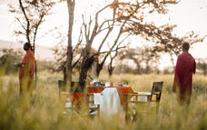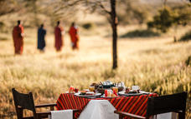

Overnight: Ole Serai Luxury Camp Moru Kopjes
This Luxury Camp is ideally located within Central Seronera area of the famous Serengeti National Park in Tanzania around the vicinity of the famous Moru Kopjes and Lake Magadi.
The Camp site is perched between the Rongai Hills & Nyaroboro Hills, a few metres away from the banks of the Mbalageti / Seronera River having an abundant variety of resident wildlife (including all the Big 5) as well as a Hippo Pool located only a few metres away from the camp.
Due to the Campsite’s ideal location, the great spectacle of the world-famous Annual Migration can be witnessed almost as close as to the camp’s doorsteps – since the site lies along one of the main migratory corridors/routes which the wildebeest use during their Great Migration going to and fro the North and South of the Serengeti.
The Rooms and the Guest areas have been specifically designed to offer the Guests an optimum 180-degree view while on their bed or while enjoying their meal or drinks and to bring them as close to the nature as possible from the covered verandas. These stunning views embrace
the sparsely spaced Acacia Tortillas Trees with the abundance of animals in the vicinity making the experience awe-inspiring.
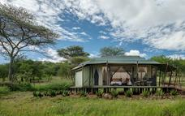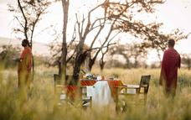

Basis
Full Board - Dinner, Bed, Breakfast and Lunch

Day 6
Ngorongoro Oldeani Mountain Lodge, Ngorongoro Crater

Day Itinerary
Early morning breakfast, Depart Serengeti and drive to Ngorongoro Crater with packed lunch. Descend into the 8th Wonder of the World, a unique biosphere that has remained virtually unchanged since the dawn of time. Enclosed within its towering walss are grasslands, forests, saltpans, a fresh water lake and a glorious variety of birdlife. Here too are all the members of the 'Big Five' (Lion, Rhino, elephant, Leopard and Buffalo) as well as a large cast of plains game and one of Africa's densest populations of predators. Enjoy a picnic lunch on the crater floor before climbing back up to the lodge in time for relaxation before dinner.

Dinner and overnight stay at Ngorongoro Oldeani Mountain Lodge
Meal Plan: Full Board
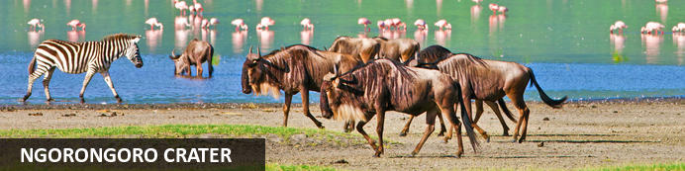
Located in Northern Tanzania, the Ngorongoro Crater is best known for its natural beauty and abundance of diverse wildlife; which makes it one of Africa’s most popular safari destinations. Surrounded by Tanzania’s highlands, this UNESCO-listed crater is said to be the world’s largest intact volcanic caldera. Visitors can look forward to spotting the world-renowned Big Five and a host of other wildlife species including large herds of zebra and wildebeest. It is famed as one of Tanzania’s best tourist attractions offering visitors an array of wonderful activities including excellent bird watching, trekking, wildlife viewing, mountain biking and visiting a local Maasai village. Don’t miss the opportunity to jump on an excursion to the magnificent Olduvai Gorge.

Overnight: Ngorongoro Oldeani Mountain Lodge
O'ldeani Ngorongoro Mountain Lodge is a colonial lodge situated on a picturesque hill with spectacular views of Oldeani Mountain and the Ngorongoro Crater Rim. The lodge is elevated, featuring spectacular views that extend all the way to Lake Eyasi and Lake Manyara.
The property is set on 40 acres of lush green gardens and local vegetation, with over 130 species of birds. The lodge is accessed over a pond and one's first impression is the grand central hallway with wooden trusses looking out over the fireplace, infinity pool and out to Mount O'ldeani, which is part of the caldera of the Ngorongoro crater, only 12 km away.
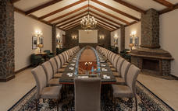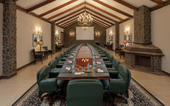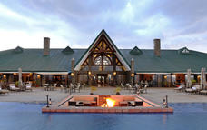

Basis
Full Board - Dinner, Bed, Breakfast and Lunch

Day 7
End of Itinerary

Day Itinerary
Drive back to Arusha , Lunch and dayroom use African Tulip Hotel until 1800hrs. Later you will be escorted to the airport for your departure flight back home.

