Kenya & Tanzania- packing, tipping, electrical, E-sim cards
Documents:
• Flight info (Printouts of e-tickets may be required at the border)
• Insurance info (required)
• Passport (required - with photocopy)
• Any required vouchers and pre-departure information
• Any required visas or vaccination certificates (yellow fever certification to get into Tanzania from Kenya)

GENERAL SUGGESTIONS

On safari, typically all you will need to bring is casual clothing and most of the safari camps offer laundry services. You will have the opportunity to do small amounts of laundry a couple of times if necessary. You will be on the move a lot, so our advice is to pack as lightly as possible. It is important to pack clothes for warm days and cool evenings.
Cold weather/early mornings & late evenings:
• Long-sleeved shirts or sweater
• early spring or late fall: Scarf, gloves, hat, layers
Also, most lodges/camps/hotels provide basic toiletries like shampoo conditioner and soap.

CLOTHING COLORS:

Neutral colours (grey, khaki or beige) are great for travelling; they easily mix and match, and they don’t tend to show the dust of travel. If a walking safari is part of your trip, neutral colours that blend into the surroundings may be helpful to have.

We generally suggest that you avoid white or cream coloured clothing, it’s simply not practical and considered a warning colour to some animals if you’re on a walking excursion or open sided vehicle. Certain shades of bright blue may attract insects like the tstetse fly. It is also best to avoid brightly coloured clothing like bright yellow, bright pink etc, the colours will likely attract insects if they are drawn to brightly coloured flowers. Typically, these rules are for when you are on the actual safari drive or walk, around camp, you can wear whatever you want.

In most countries, where the military plays a strong role, camouflage or military fatigue look-alikes may be illegal so no camouflage please.

Clothing – keep it simple!

- A sweater or hoodie: It can be quite chilly in the highlands or in the desert in the mornings (wool or fleece; the latter usually weighs less).
- Rain gear: a lightweight goretex type jacket/shell with a hood is ideal.
- A collapsible umbrella is handy for both sun & rain.
- 2-3 pairs loose slacks/pants
- 2-3 pairs of shorts the longer the better especially for women as there are more conservative parts of the world. Note: travel pants with the zip-off legs are a good way to save space.
- 3 + t-shirts &/or short sleeved shirts
- 2 shirts with long, baggy sleeves for protection from mosquitoes and other insects and/or the sun. They are also great for early mornings and for evening warmth
- pairs of underwear (5-6+) / socks (4+)
- Swimsuit
- 1 wide brimmed hat or ball cap
- Bandana (may help with dust or with heat)
- Sarong: handy for sun protection or evening dinners at camp
- Zanzibar – extra swimsuit, coverup, and possibly casual outfit

PERSONAL ITEMS:

- Insect repellent (the higher the DEET % the better) / possible “afterbite” stick if desired
- Sunscreen, Lip balm
- Sunglasses
- Laundry soap
- Facecloth
- Towelettes/wet naps
- Ziploc bag with some toilet paper for unexpected bush stops / hand sanitizer
- Toothbrush, toothpaste, floss, deodorant, moisturizer, shaving gear, Qtips, brush/comb
- Ear plugs / eye mask if desired
- Wide angle binoculars (if possible, can sometimes borrow from camps as well)
- Camera equipment, including battery chargers, cables, SD cards etc.
Note: label batteries and chargers, often camps have main charging station
Plug adapters and voltage converters as necessary

Health & Safety:

FIRST AID KIT - When you are considering taking any kind of medication you should consult with your doctor / take small sample sizes of the below:
• sunscreen, Aspirin, Ibuprofen, bandaids/plasters, tape, anti-histamines, antibacterial gel/wipes, antiseptic cream, Imodium or similar tablets for mild cases of diarrhea, extra prescription drugs you may be taking in their original packaging.
Laundry facilities - are offered by some of our hotels for a charge. You should write a list of items that you send for washing. It will be difficult for hotels to have your laundry ready if you arrive in the late afternoon and leave the next morning so save this for when you are 2 or more nights in a location.

WHAT BAGS TO USE:

Checked Bag: a duffle-style/soft bag is great for the smaller flights within Africa. Otherwise, a medium size bag with wheels can be accommodated if it is soft-sided.

Carry-on: A daypack (small backpack) is perfect. It can hold all the items you need on an aircraft (medications, camera, binoculars etc.), and it will conveniently store those items you may need through the day on touring days.

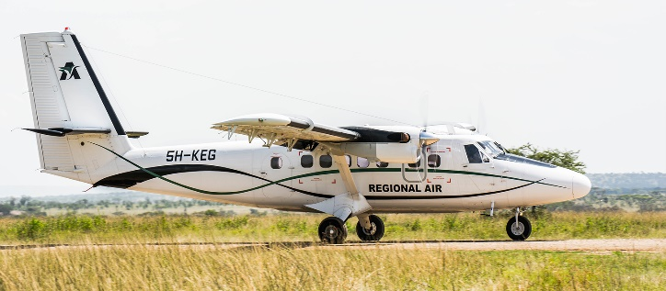

For these smaller, regional flights – they will have a limit of 15kg checked / 5 kg carry on for 20kg total (44 lbs total) and in Kenya on Safarilink/Air Kenya they have 15KG limit including the hand luggage! I will likely do a medium wheeler back and a nice size backpack.
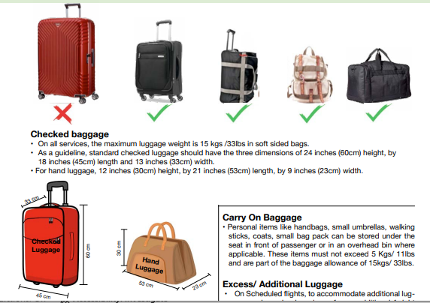

********************

TIPPING
Tipping is an expected, though not compulsory, component of your tour program. The gesture serves as an expression of appreciation for exceptional service, and amounts given are up to your discretion. It is recommended to tip just once at the end of your stay at each safari lodge or camp rather than after each activity. Many camps provide a communal tip box for staff, while others exclude guides from this box (ask at the camp if the guides receive their own tips or if they go in the communal box).
Tanzania & Kenya On Safari:
Guides: $20 per person per full day. Drivers or trackers around $10 per person per day. General staff at safari lodges or camps - $20 p/p p/d that is divided up amongst the staff.
Restaurant/café servers: 10% of the cost of the bill
Kenya – sample:
Tip Per Driver:
- Airport Transfer – US$ 10.00 (for the vehicle)
- Nairobi Excursion – US$ 30.00 (for the vehicle)
- Eg. 2 Nights / 3 Days Safari to Amboseli – approx. $100 for 4 people
Money Exchange
The easiest foreign currency to exchange for locally for any of the local currencies is the $US
ATM’s can be used to get out locally currency - Visa/Plus system cards are the most widely accepted debit cards as well as some machines for Mastercard/Cirrus cards.
Credit cards can be used in major cities and towns and most sit down restaurants but please do not solely rely on them as a method of payment also please note that a credit card fee may sometimes apply.

ELECTRICAL
Kenya & Tanzania’s electrical system uses type G outlets and sockets, 240 volts at 50 Hz. Tanzania also sometimes utilizes a D outlet.
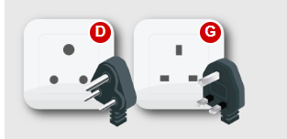

PHONES: - E-SIMS FOR PHONES
This is one company you could use: https://etravelsim.com/ or the one I’ve used before other places that I’ve had luck with is: https://www.airalo.com/africa-esim

Currently, the price with airalo for Africa (includes Kenya, Tanzania, and Rwanda) is:
