Kenya & Tanzania Exploration- Outline / Travel Key App: 28NOAP
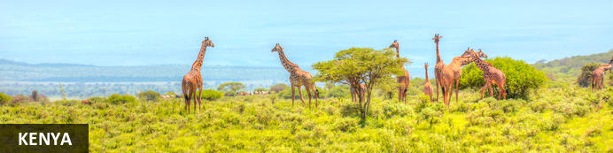
Kenya - Solio Game Reserve - The Rift Valley - Ol Pejeta Conservancy - Arusha National Park - Lake Magadi - Ngorongoro Crater - Ndutu - Ikoma
13 Days / 12 Nights
group trip: 28 January 2026 - 09 February 2026

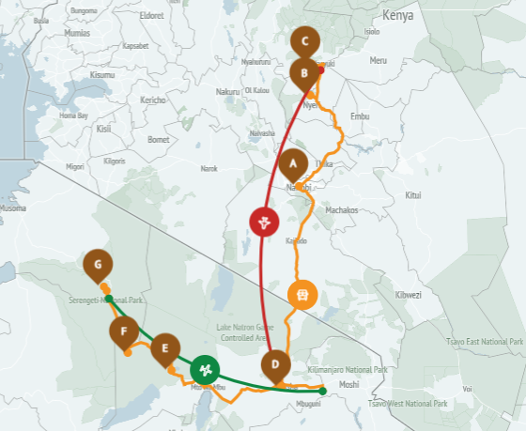
Our journey begins with an introduction to Kenya at the Aberdare Country Club - a heritage property located on Mweiga Hill in the Aberdare Highlands, part of the Great Rift Valley in Kenya. We shall then proceed to Ol Pejeta Sanctuary for an enriching educational experience. Ol Pejeta is a world-renowned role model for conservation in action and home to Jane Goodall’s Chimpanzee Sanctuary. Here we will get an immersive experience where we will enjoy both game driving and some active walking. Kick start the safari with inspiration and promise of the positive impacts that Tourism plays in the preservation of nature!
This will be followed by an incredible wildlife experience in Tanzania's Serengeti National Park, encompassing approximately 14,763 km2 (5,700 sq mi) of land teeming with wildlife. The Serengeti hosts the second largest terrestrial mammal migration in the world.

Accommodation | Destination | Duration
Hermosa Garden Hotel & Spa | Kenya | 1-2 Nights B & B
Aberdare Country Club | Solio Game Reserve | 1 Night FB
Sweetwaters Serena Camp | Ol Pejeta Conservancy | 2 Nights FB+
Kahawa House | Arusha National Park | 2 Nights HB
Ngorongoro Serena Safari Lodge | Lake Magadi | 2 Nights FB+
Ndutu Under Canvas | Ndutu | 1 Nights FB+
Kubu Kubu Tented Lodge | Ikoma | 3 Nights FB+
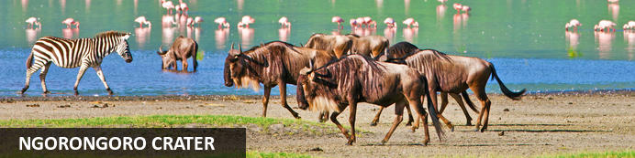
ELECTRICAL
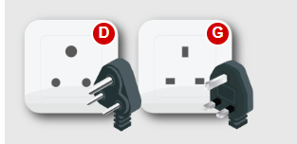
Kenya & Tanzania’s electrical system uses type G outlets and sockets, 240 volts at 50 Hz. Tanzania also sometimes utilizes a D outlet.

PHONES: - E-SIMS FOR PHONES
This is one company you could use: https://etravelsim.com/ or the one I’ve used before other places that I’ve had luck with is: https://www.airalo.com/africa-esim

Currently, the price with airalo for Africa (includes Kenya, Tanzania, and Rwanda) is approx. $40.00 for 30 days / 1 GB.

