

Kenya & Tanzania Exploration – Travel Key App: 28NOAP

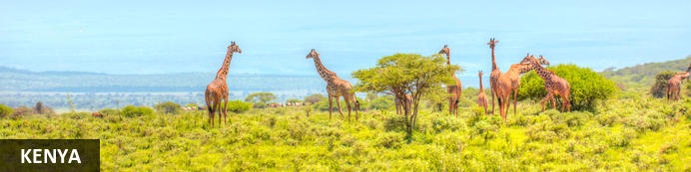
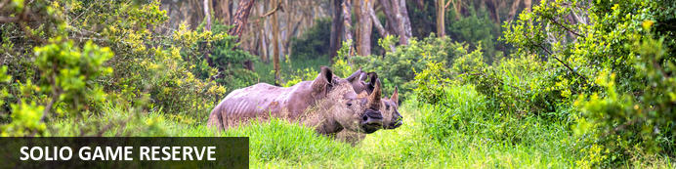

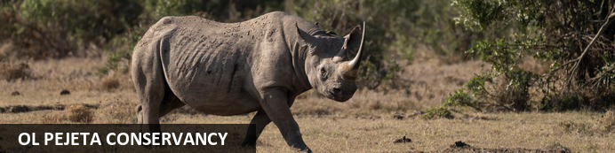
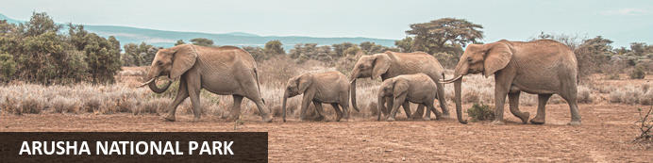

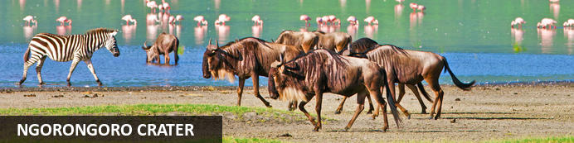
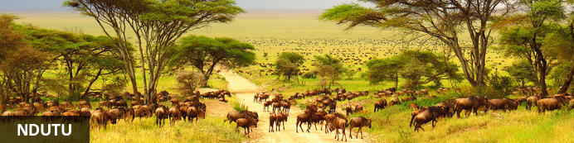
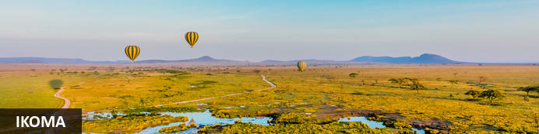

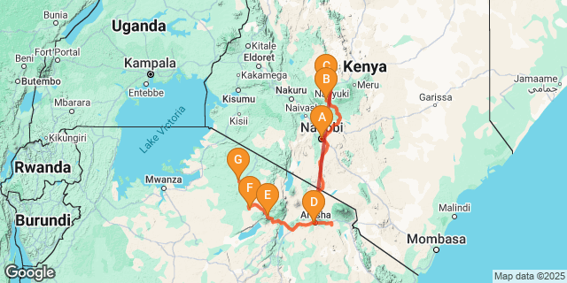
Kathy Oakes

Kenya & Tanzania Experience
Kenya - Solio Game Reserve - The Rift Valley - Ol Pejeta Conservancy - Arusha National Park - Lake Magadi - Ngorongoro Crater - Ndutu - Ikoma
13 Days / 12 Nights
group trip: 28 January 2026 - 09 February 2026

Introduction
Join Kathy Oakes and a small group for an incredible Premium wildlife and cultural journey through Kenya and Tanzania. This itinerary is designed for late January into February, focusing on the Southern and Central Serengeti during the wildebeest migration and calving season.
Our journey begins with an introduction to Kenya at the Aberdare Country Club - a heritage property located on Mweiga Hill in the Aberdare Highlands, part of the Great Rift Valley in Kenya. We shall then proceed to Ol Pejeta Sanctuary for an enriching educational experience. Ol Pejeta is a world-renowned role model for conservation in action and home to Jane Goodall’s Chimpanzee Sanctuary. Here we will get an immersive experience where we will enjoy both game driving and some active walking. Kick start the safari with inspiration and promise of the positive impacts that Tourism plays in the preservation of nature!
This will be followed by an incredible wildlife experience in Tanzania's Serengeti National Park, encompassing approximately 14,763 km2 (5,700 sq mi) of land teeming with wildlife. The Serengeti hosts the second largest terrestrial mammal migration in the world.
This itinerary offers a perfect blend of cultural immersion, leisure time, and thrilling wildlife expeditions. Embark on this unforgettable adventure to witness the beauty of the African wilderness in style, complete with excellent, authentic accommodations, delicious cuisine, and expert guidance.

Accommodation | Destination | Duration
Hermosa Garden Hotel & Spa | Kenya | 1 Night B & B
Aberdare Country Club | Solio Game Reserve | 1 Night FB
Sweetwaters Serena Camp | Ol Pejeta Conservancy | 2 Nights FB+
Kahawa House | Arusha National Park | 2 Nights HB
Ngorongoro Serena Safari Lodge | Lake Magadi | 2 Nights FB+
Ndutu Under Canvas | Ndutu | 1 Nights FB+
Kubu Kubu Tented Lodge | Ikoma | 3 Nights FB+

Price
$9900 USD Per Person
*based on double occupancy / payable by chq, money wire, or e-transfers. (add $312 to pay by credit card).
*extra night in Nairobi - $180 USD per person Bed & Breakfast
contact: kathy@personaltravel.ca 403 714 2126
Extend your travels with extra days for hiking in Kilimanjaro National Park or a Zanzibar beach extension at the end.
Add on package for Gorilla Trekking in Rwanda is also available.

Included
- 12 nights 4+ star accommodation and luxury tented camps
- Breakfasts & All meals while on safari (travel day on Day 5 & Arusha Day 6 - lunch will be on our own)
- local drinks in Tanzania while on safari in Lake Masek and Kubu Kubu (beer, wine, soft drinks)
- 4x4 safari vehicles with guides & driver
- All Park fees to national parks and game drives within the parks
- Flight from Nairobi to Arusha
- Flight from Seronera (Serengeti) to Arusha

Excluded
- International Airfare, Insurance, Tipping, meals or drinks not listed, Items of a personal nature
__

Day 1: Hermosa Garden Hotel & Spa, Nairobi (Wed, 28 January)

Kenya
Resting in the magnificent Great Rift Valley and presided over by the majestic Mount Kilimanjaro, Kenya is characterised by hauntingly beautiful natural landscapes of forested hills, patchwork farms, wooded savanna and vast forests brimming with an extraordinary abundance of wildlife. The nation’s diverse range of traditional African cultures is influenced by over 70 unique ethnic groups from the Maasai, Samburu, Kikuyu, and Turkana tribes to the Arabs and Indians that settled on the coast. Add to this: an exquisite tropical coastline fringed with breathtaking golden sand beaches; gorgeous coral gardens providing excellent snorkeling and diving opportunities; and a slew of lively beach resorts, and it is easy to see why so many visitors flock here from around the world to experience a truly unique African adventure in one of the world’s most pristine safari destinations.

Day Itinerary
Overnight is at the lovely boutique hotel - Hermosa Garden Hotel & Spa.
Half the group will come in the night prior to give today us a "day of R & R" and we will be picked up on the 27th for a private transfer. The other half of the group will come back from the Mara to meet us at the hotel today.
Pre-departure orientation in the Garden Gazebo – approximately 4pm / Welcome event at the Roof Top Terrace (Bamboo Restaurant)– 5pm / can stay up there for dinner if desired!
Hermosa Garden Hotel & SPA is a luxury boutique 30-suite hotel located in the green suburb of Karen, Southwest of Nairobi. We are an oasis of serenity with an exquisite green garden which beholds mesmerizing nature consisting of birds and trees that define history and nature conserved at its best.
Hermosa is a Spanish word meaning beautiful. The hotel opened in December 2020 and is known for offering exceptional services and unforgettable experiences to its guests.
Other facilities in the Hotel include two restaurants, a pool bar, a well-equipped gymnasium, a spa, & a pool
OPTIONS FOR THE DAY:
Besides just the possibility of relaxing by the pool, going to the gym, or having a spa treatment at the hotel - we could go to nearby Nairobi National Park (not included). It is a nice spot for a hike, wildlife excursion, or just a picnic in the Park! We could also then go to Sheldrick's Elephant Orphanage (*must be booked 3 months in advance - end of Oct). The SWT Nursery, located in Nairobi National Park, is where an orphan's journey begins — a journey that will culminate, many years down the line, in their reintegration back into the wild. The public visit takes place every day, except 25th December, from 11am to 12 noon. During this time, we are delighted to welcome those with a confirmed booking to join us for an unforgettable hour with the Nursery herd. Funds from your visit help support the rescue and rehabilitation of the orphaned elephants in our care.
*pricing TBA - Nairobi National Park, Elephant Orphanage Fee, and transportation.

Expert Tips
https://www.hermosanairobi.com/
https://www.kws.go.ke/nairobi-national-park https://www.sheldrickwildlifetrust.org/visiting
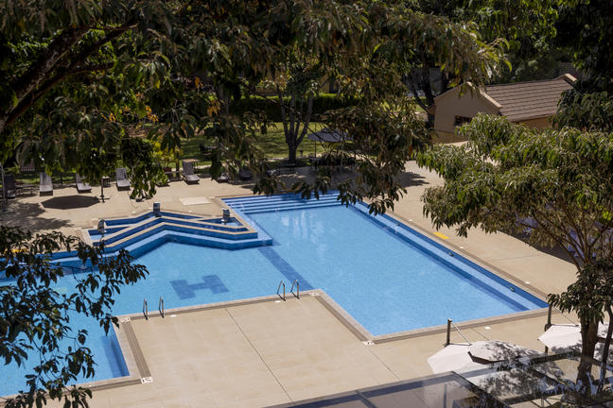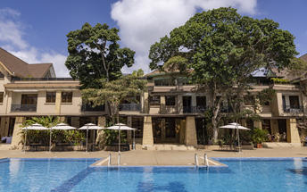

Day 2: Aberdare Country Club, Solio Game Reserve (Thu, 29 January)

Solio Game Reserve
One of Africa’s finest wildlife reserves, Solio Game Reserve, also called Solio Ranch, is a privately-owned wildlife conservancy. It rests in the southern fringes of Laikipia, near the foothills of the Aberdare range. Best known as Kenya's oldest rhino sanctuary, it is renowned for its major role in the breeding and protection of black rhinos in Kenya. This family-run, private 71-square-kilometre sanctuary is also home to an array of other African wildlife including white rhinos, gazelles, oryxes, giraffes, lions, hartebeests, hyenas and buffaloes. Visitors can soak up the incredible landscapes scattered with wild marsh and yellow-fever acacia meeting wide-open skies, stay overnight in the inviting Solio Lodge and spot wildlife on a dawn game drive.

Day Itinerary
After a leisurely breakfast - we will head north to Mount Kenya and the Aberdares.
Today we will have a 4 Hours’ drive on good road with a chance to stop by the local farm produce markets to see the vibrancy of the local economy of the Central Highlands also known as Kenya’s breadbasket. On this scenic drive through the farmlands, you will see small to large plantations of various Tropical Fruits, Cereals, Garden Vegetables & pop-up fresh produce roadside markets. We will be able to stop at a Craft Store for a chance to see the work of the local artisans.
This afternoon we will get to Aberdare National Park, north of Nairobi and east of the Rift Valley. This area provides a diverse eclectic collection of African ecosystems. The forests and moorlands have great hiking trails with the valleys traversed by streams and rivers -backdropped with the Aberdare Mountain Range.
We will arrive for lunch at the Aberdares Country Club then check into the our rooms. The Aberdare Country Club is nestled on a slope of Mweiga Hill in the Aberdare Highlands, part of the Great Rift Valley. This captivating site was the homestead of an English couple that decided to settle in Kenya. Almost a half century later, their home, "The Steep", was renamed the Aberdare Country Club and opened for guests. Considered a heritage property in Kenya, The Aberdare Country Club has retained the charm of a private home with the simple comforts of a country inn.
Lunch & Dinner included at the Lodge / overnight at the Aberdares Country Club

Expert Tips
https://national-parks.org/kenya/aberdare /// https://aberdarecountryclub.com/
Horse riding, golf, tennis, nature walks, animal sanctuary, spa with gym, sauna, steam & massage, WIFI in all areas and rooms, biking and golf carts to rooms.

The Rift Valley
The Rift Valley is a colossal geological feature stretching for 6000 kilometres, running from the Middle East all the way down Africa, through Kenya to northern Botswana. This extraordinary natural attraction can be visited via a short drive north from Nairobi. The ground drops away and opens up to a massive valley, home to lakes, savannah, and impressive volcanic formations. This spectacularly scenic landscape is scattered with abundant plains game, a string of reserves, and traditional Maasai villages. Some highlights include the dramatic cliffs of Hell's Gate, Mount Longonot, Lake Elmenteita, and the beautiful Lake Nakuru National Park.

Overnight: Aberdare Country Club
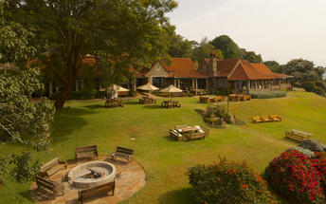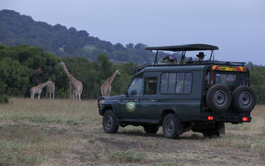

Day 3: Sweetwaters Serena Camp, Ol Pejeta Conservancy (Fri, 30 January)

Ol Pejeta Conservancy
Resting at the foothills of Mount Kenya and the Aberdare Mountain Range, in central Kenya's Laikipia County, the Ol Pejeta Conservancy is the largest black rhino sanctuary in East Africa. It is also home to some of the last remaining northern white rhino in the world. Originally a working cattle ranch in colonial Kenya and now a pioneering wildlife conservancy, Ol Pejeta works to protect wildlife and provide a sanctuary for rescued chimpanzees. The Conservancy is a popular safari destination and is home to the renowned ‘Big Five’ as well as a wide selection of other African animals including zebra, giraffe, hippo, cheetah, jackal, serval, hyena, vervet monkey, and many more. Visitors can look forward to an assortment of outdoor activities such as horse rides, game walks, and nocturnal game drives.

Day Itinerary
After breakfast, we will proceed to Nanyuki ( 1 Hour drive) for a visit to the Spinners Web women’s self-help project before proceeding to Ol Pejeta Conservancy.
Introductory Game Drive with a stop at the Equator Crossing inside the conservancy for an epic Photo session before arriving for Lunch at the Camp. Experience an afternoon Game Drive to visit the Chimps and the Rhino Sanctuary.
Return to the Lodge for Dinner and then if you are up for it - take part in a Night Game Drive in specialized vehicles with the Ol Pejeta Rangers. 23.00 Hrs – return to the Camp for Dinner and overnight.

Expert Tips
https://www.olpejetaconservancy.org/ Rhino sanctuary and Chimpanzee sanctuary:
https://www.olpejetaconservancy.org/wildlife/chimpanzees/sweetwaters-chimpanzee-sanctuary/

Overnight: Sweetwaters Serena Camp View iBrochure
Nestled in the picturesque Ol Pejeta Conservancy, Sweetwaters Serena Camp is an ideal destination for those seeking an unforgettable holiday experience. Surrounded by breathtaking views of Mount Kenya, this sophisticated tented accommodation offers tranquil respite in the wild. Each of the 39 luxury tents features an ensuite bathroom, free Wi-Fi, and a private balcony or veranda overlooking the waterhole. Enjoy delicious meals and scenic views at the light-filled Rhino Restaurant or relax by the pool. With modern facilities and exceptional planning services, this central Kenyan tented camp is an ideal venue for weddings and corporate retreats. Guests can also take advantage of guided game drives to spot the famous "Big Five" or indulge in a massage at the treatment room.
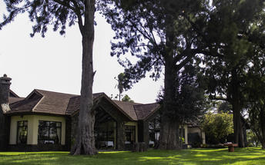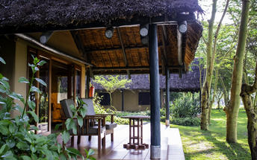

Day 4: Sweetwaters Serena Camp, Ol Pejeta Conservancy (Sat, 31 January)

Day Itinerary
Cultural and Wildlife Experiences.
Activities in Ol Pejeta : Game drive with visit to the endangered enclosure to meet the last 2 Northern White Rhinos and the Anti-poaching Canine Unit. Enjoy a Night Game drive!
Overnight at Serena Sweetwaters Tented Camp - Deluxe tents

Day 5: Kahawa House, Arusha National Park (Sun, 1 February)

Day Itinerary
Possible early morning game drive. Mid-morning departure by scheduled Air service from Nanyuki to Nairobi Wilson and connect to scheduled Air Service to JRO to start your TZ Safari.
Note: Advance Tanzania E-Visa is required and Yellow Fever Vaccination too.

Arusha National Park
Situated in northeastern Tanzania, the Arusha National Park is set against the spectacular backdrop of Mount Kilimanjaro. This 552 square kilometre park is renowned for its other-worldly scenery and excellent choice of trekking possibilities. This beautiful area is divided into three parts: Mt. Meru, a spectacular volcanic cone; the Ngurdoto Crater, with its lost-world feel; and the multi-hued Momela Lakes. The park features a wide range of habitats that provide a home to an array of wildlife and plant species. Commonly spotted animals include Cape buffalo, giraffe, zebra, warthog, monkey, flamingo, lion and elephant.

Overnight: Kahawa House View iBrochure
A lovely lodge situated in a suburban area in northern Tanzania, Kahawa House is located in Arusha, 6km southwest of the centre of town. The accommodation provides convenient access to Arusha Domestic Airport and is an ideal rest stop for visitors to Arusha National Park. Facilities include a swimming pool as well as a deck where guests can enjoy lunch and dinner.
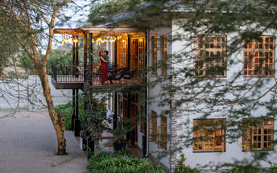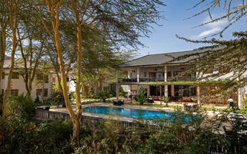

Day 6: Kahawa House, Arusha National Park (Mon, 2 February)

Day Itinerary
Enjoy your time at the beautiful Kahawa House or visit our school project or other projects in the area or visit a coffee plantation or Tanzanite factory. There is laundry service here if anyone needs to "freshen up" from Kenya!
Overnight Kahawa House

Expert Tips
https://twctanzania.com/arusha/kahawa-house/

Day 7: Ngorongoro Serena Safari Lodge, Lake Magadi (Tue, 3 February)

Lake Magadi
Not to be confused with the Kenyan lake of the same name set only a hundred kilomtres away, the Tanzanian Lake Magadi is an exquisite soda lake in the Ngororongo crater, named the Swahili word for salt. This is a wonderful destination for nature photographers, a scene that changes exquisitely through the seasons, moving through lush greens into striking oranges and bright pinks. Along with the changes come captivating, changing groups of animals including rhino, eland and lion, as well as golden jackals who come to hunt the flamingos.

Day Itinerary
Today we drive through Lake Manyara National Park and head to Ngorongoro Serena Safari Lodge. If time permits, enroute we can visit Nashipay Maasai School, an organization supporting appropriate education, nature conservation that respects community rights and sustainable livelihoods for the Maasai in the area. The most unique approach about Nashipay Maasai School is the western and Maasai integrated curriculum.
https://nashipay.org/

After this stop, we will continue to Tanzania’s prehistoric Ngorongoro Crater Formed over two million years ago, this ancient volcanic caldera spans about 100 square miles and boasts one of the most diverse ecosystems on the planet. A UNESCO World Heritage Site known as the Eighth Wonder of the World, Located in Northern Tanzania, the Ngorongoro Crater is best known for its natural beauty and abundance of diverse wildlife; which makes it one of Africa’s most popular safari destinations. Surrounded by Tanzania’s highlands, this UNESCO-listed crater is said to be the world’s largest intact volcanic caldera. Visitors can look forward to spotting the world-renowned Big Five and a host of other wildlife species including large herds of zebra and wildebeest. It is famed as one of Tanzania’s best tourist attractions offering visitors an array of wonderful activities including excellent bird watching, trekking, wildlife viewing, mountain biking and visiting a local Maasai village. Don’t miss the opportunity to jump on an excursion to the magnificent Olduvai Gorge.

Overnight: Ngorongoro Serena Safari Lodge View iBrochure
Nestled high on the jagged rim of the Ngorongoro Crater and shrouded in mist, the Ngorongoro Serena Safari Lodge is a stunning example of ecological and architectural harmony. The boulder-built buildings of the Lodge are camouflaged by indigenous creepers and linked by timber walkways that skirt ancient trees. Inside, guests are greeted by the hushed ambiance of a game-viewing hide and the ochre, rust, and charcoal imagery of a prehistoric cavern, decorated with Maasai iron spears, bright-beaded robes, and intricately-carved artifacts. The rooms, strung around the crater rim, are adorned with brass lamps, wildwood mirrors, and Maasai carvings, each featuring its own rock-enclosed balcony and uninterrupted views of the Crater below. After a day of adventure, guests can follow a gentle nature trail, take a guided walk to the Crater's rim, or simply relax with a herbal massage as the sun sets behind the mountains. Explore the Cradle of Mankind at Ngorongoro Serena Safari Lodge and experience one of the most unique travel experiences in the world.
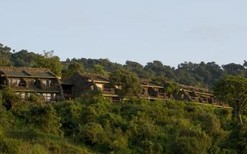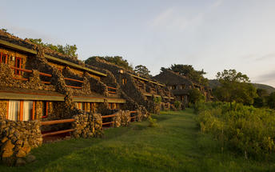

Day 8: Ngorongoro Serena Safari Lodge, Lake Magadi (Wed, 4 February)

Day Itinerary
Today we will get an early start to Ngorongoro Crater for a day on safari. We will enjoy a picnic lunch down in the crater at a special spot.
The Ngorongoro Crater is also home to a significant population of Maasai people, who coexist harmoniously with the area's wildlife. Their presence adds a rich cultural dimension to the natural beauty of the region. As a UNESCO World Heritage Site, the Ngorongoro Crater offers visitors a unique opportunity to witness the intricate balance of nature and human history in one of the most stunning settings in the world.
Overnight Ngorongoro Serena Safari Lodge

Day 9: Ndutu Under Canvas, Ndutu (Thu, 5 February)

Set in the Arusha Region, Ndutu is situated in the northern part of the Ngorongoro Conservation Area within the magnificent Serengeti. The surrounding landscapes are covered in sweeping grasslands which provide the perfect habitat for the migratory route for hundreds of thousands of wildebeest, antelope and zebra. Visitors can look forward to exploring the forest around Lake Ndutu, spotting an array of wildlife, and visiting the fascinating archaeological site at the Olduvai Gorge. Don’t miss the opportunity to jump on a game drive to view the spectacular herds of the annual Great Migration, enjoy a scenic hot air balloon ride over the plains and take a guided tour with the local Maasai and learn about culture and traditions. Other commonly spotted species include: leopard, lion, cheetah, caracal, serval, African wildcat, and a variety of prolific birdlife.

Day Itinerary
After breakfast, head out to Ndutu area - located in the southern Serengeti and within the Ngorongoro Conservation Area, is a hidden gem in Tanzania's vast wilderness. Known for its seasonal lakes and lush acacia woodlands, Ndutu is a haven for wildlife, particularly during the calving season of the Great Migration. This region becomes a vibrant nursery for thousands of wildebeest and zebras, attracting predators and offering unparalleled opportunities for witnessing the raw beauty of nature in action.
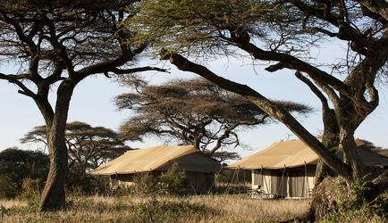
Ndutu’s open plains provide a unique safari experience, where you can get remarkably close to the wildlife in a serene and less crowded environment.
We will stay in Ndutu Under Canvas, a seasonal, mobile tented camp that is set up specifically to follow the wildebeest migration. Unlike permanent lodges, this camp exists only when the migration is present, allowing guests to stay right where the action is—close to the herds, calving grounds, and predators that follow them.
While Ndutu Under Canvas is more authentic and nature-focused rather than traditional luxury, it offers:
• An immersive “in-the-wild” safari experience
• Excellent proximity to wildlife, often right around camp
• A true sense of being part of the migration rather than observing it from a distance
• A quiet, exclusive atmosphere that many guests find more memorable than permanent lodges
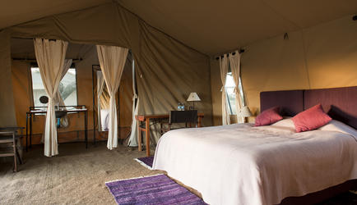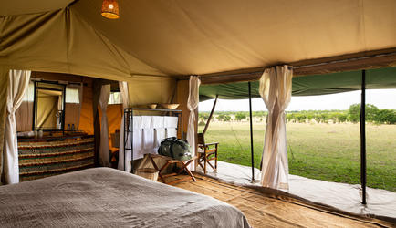

Day 10: Kubu Kubu (Fri, 6 February)

Ikoma is situated in Tanzania, east of the Serengeti National Park, at the base of the majestic Mt. Meru, Ikoma is surrounded by stunning natural beauty. Lake Manyara and the Ngorongoro Crater are both within easy driving distance, making Ikoma the perfect base for exploring the region. In addition to its natural wonders, Ikoma is also home to a number of great activities, including hiking, biking and bird watching. With so much to see and do, it's no wonder Ikoma is one of Tanzania's most popular tourist destinations. Other Highlights in the surrounding area include Lake Ndutu, and the Olduvai Gorge. Ikoma is also home to a number of Masai villages, where visitors can learn about the traditional culture and way of life. With its unique location and range of activities on offer, Ikoma is an ideal destination for those looking to explore the natural beauty and culture of Tanzania.

Day Itinerary
After breakfast we will transfer to the Seronera area of the Serengeti.
Kubu Kubu is the latest addition to the portfolio of properties of Tanganyika Wilderness Camps. This camp is strategically located to ensure that all areas of the Serengeti are within reach of our guests, including legendary locations like the famous Maasai kopjes, Seronera and the Grumeti River.
It has been designed with a modern African decorative style that creates a fresh and bright atmosphere, but very cozy and with the right amount of luxury.

Overnight: Kubu Kubu Tented Lodge View iBrochure
With a modern African appearance, creating a fresh, sleek, yet comfortable ambiance. Situated in the stunning central part of the Serengeti, the camp will be strategically positioned in one of the main migration areas so that guests can enjoy this awesome natural wonder from the comfort of their tents.
There will be 25 spacious en-suite tents which will offer absolute comfort, exclusivity and a genuine African bush experience. In the central restaurant guests will be able to enjoy exceptional food and wines, and the cozy lounge area has been creatively designed to give an atmosphere of intimacy and exclusivity. There will also be a swimming pool in which to relax after a long game drive. Internet access will be available in the camp with Wifi in the central area. Accommodation will be on a full board basis.
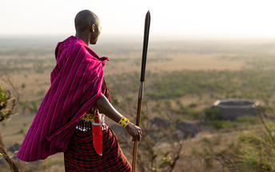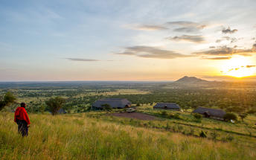

Day 11: Kubu Kubu Tented Lodge, Ikoma (Sat, 7 February)

Day Itinerary
Enjoy your safari day in the Seronera area, located in the heart of the Serengeti National Park and one of Tanzania’s most renowned wildlife regions. Known for its year-round game viewing, Seronera is a vibrant hub where the park's rich biodiversity converges. The area’s network of rivers and lush vegetation attracts a wide array of animals, including large populations of lions, leopards, elephants, and giraffes, making it a prime destination for safari enthusiasts.
The Seronera area in Tanzania, located in the heart of the Serengeti National Park, is renowned for its rich wildlife and is particularly famous for its big cats, such as lions, leopards, and cheetahs. Here are some highlights about the Seronera area for cat enthusiasts:
- Lion Spotting: Seronera is known for its large pride of lions. They are often seen lounging in the grass or under acacia trees, making for excellent photography opportunities.
- Leopard Sightings: Leopards can often be spotted resting in the branches of trees or stealthily moving through the bush, making this area a prime location for leopard sightings.
- Cheetah Sightings: The open plains around Seronera provide a perfect habitat for cheetahs, and visitors often witness their incredible speed while hunting.
- Diverse Ecosystem: The area supports a variety of prey species, including wildebeest, zebras, and gazelles, which attract the big cats and create dynamic predator-prey interactions
Overnight Kubu Kubu

Day 12: Kubu Kubu Tented Lodge, Ikoma (Sun, 8 February)
One more full day of safari in central Serengeti

Day 13: End of Itinerary (Mon, 9 February)

Day Itinerary
After breakfast we will take a local flight from the Seronera Airstrip back to Arusha. Timing should work that you can catch your flight home from Kilimanjaro this evening or go onwards to Zanzibar for a beach vacation, Rwanda for gorilla trekking, or hiking in Tanzania.

