Packing FOR SAFARI’S

WHAT BAGS TO USE:

Checked Bag: a duffle-style/soft bag is great for the smaller flights within Africa. Otherwise, a medium size bag with wheels can be accommodated.

Carry-on: A daypack (small backpack) is perfect. It can hold all the items you need on an aircraft (medications, camera, binoculars etc.), and it will conveniently store those items you may need through the day on touring days.

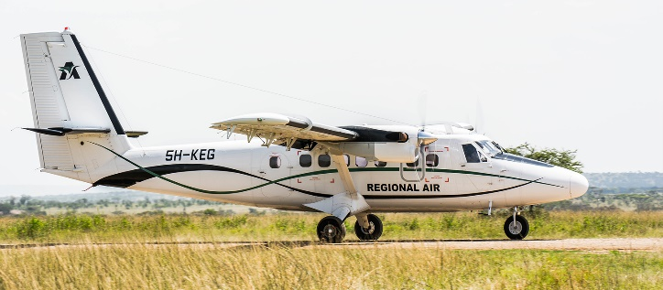

For these smaller, regional flights – they may have a limit of 15kg or 33lbs total with the carry-on being 11lbs of that. I will likely do a medium wheeler back and a nice size backpack.
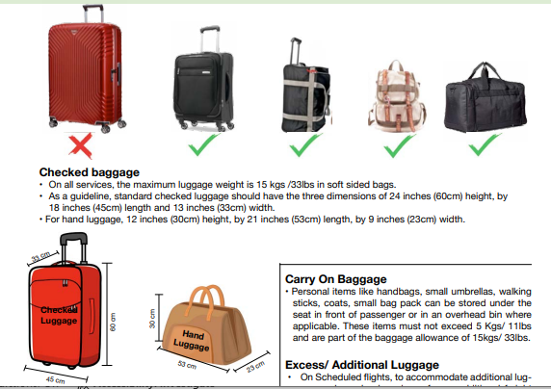

GENERAL SUGGESTIONS

On safari, typically all you will need to bring is casual clothing and most of the safari camps offer laundry services. You will have the opportunity to do small amounts of laundry a couple of times if necessary.

Also, most lodges/camps/hotels provide basic toiletries like shampoo conditioner and soap.

CLOTHING COLORS:

Neutral colours (grey, khaki or beige) are great for travelling; they easily mix and match, and they don’t tend to show the dust of travel. If a walking safari is part of your trip, neutral colours that blend into the surroundings may be helpful to have.

We generally suggest that you avoid white or cream coloured clothing, it’s simply not practical and considered a warning colour to some animals if you’re on a walking excursion or open sided vehicle. Certain shades of blue may attract insects like the tstetse fly. It is also best to avoid brightly coloured clothing like bright yellow, bright pink etc, the colours will likely attract insects if they are drawn to brightly coloured flowers. Typically these rules are for when you are on the actual safari drive or walk, around camp, you can wear whatever you want.

In most countries, where the military plays a strong role, camouflage or military fatigue look-alikes may be illegal so no camouflage please.

Clothing – keep it simple!

- A sweater or hoodie: It can be quite chilly in the highlands or in the desert in the mornings (wool or fleece; the latter usually weighs less).
- Rain gear: a lightweight goretex type jacket/shell with a hood is ideal. Add rain pants if you’re hiking.
- A collapsible umbrella is handy for both sun & rain.
- 2-3 pairs loose slacks/pants
- 2-3 pairs of shorts the longer the better especially for women as there are more conservative parts of the world.
Note: travel pants with the zip-off legs are a good way to save space. They can convert to shorts; some to capris. They carry you through the cool hours of the morning or evening through to the hotter midday hours.
- 3 + t-shirts and/or 3+ short sleeved shirts
- 2 shirts with long, baggy sleeves for protection from mosquitoes and other insects and/or the sun. They are also great for early mornings and for evening warmth
- pairs of underwear (5-6+) / socks (4+)
- Swimsuit
- 1 wide brimmed hat or ball cap
- Bandana (may help with dust or with heat)
- Sarong: handy for sun protection or evening dinners at camp

PERSONAL ITEMS:

- Insect repellent (the higher the DEET % the better) / possible “afterbite” stick if desired
- Sunscreen, Lip balm
- Sunglasses
- Laundry soap
- Facecloth
- Towelettes/wet naps
- Ziploc bag with some toilet paper for unexpected bush stops / hand sanitizer
- Toothbrush, toothpaste, floss, deodorant, moisturizer, shaving gear, Qtips, brush/comb
- Ear plugs / eye mask if desired
- Wide angle binoculars (if possible, can sometimes borrow from camps as well)
- Camera equipment, including battery chargers, cables, SD cards etc.
Note: label batteries and chargers, often camps have main charging station and there can be several “Nikon’s”
- Plug adapters and voltage converters as necessary
- Extension cord for laptops, chargers etc
- Small sewing kit

FIRST AID KIT - When you are considering taking any kind of medication you should consult with your doctor / take small sample sizes of the below:

- Band-aids, polysporin etc
- Antihistamines for allergies/hives
- Prescription medications
- Cold + cough medication
- Constipation/laxative- Diarrhea treatment: TALK TO YOUR DOCTOR about a prescription for CIPRO 500 mg
- Anti-nauseant such as Gravol or the Transderm V patch
- Pain reliever

PHONES: - E-SIMS FOR PHONES
This is one company you could use: https://etravelsim.com/
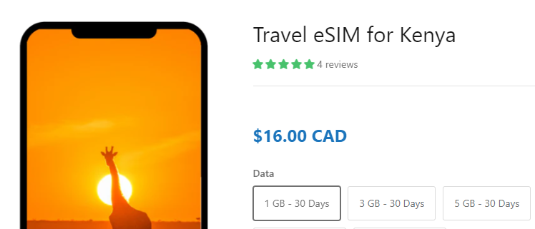
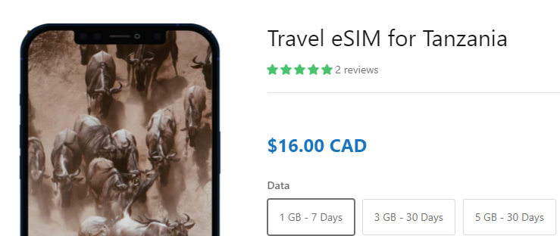

*or there is one for “Africa” for $43.00 if you are also going to Rwanda.

