

Classic Pure South Tanzania Safari
Dar es Salaam - Nyerere National Park - Ruaha National Park
8 Days / 7 Nights

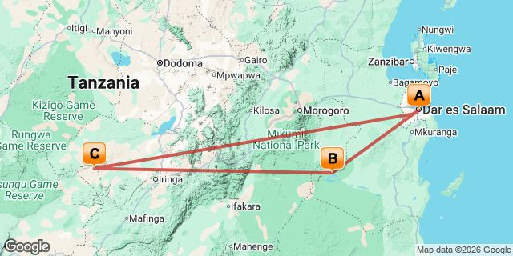

Introduction

Start | Accommodation | Destination | Basis | Duration
Day 1 | Johari Rotana | Dar es Salaam | B&B | 1 Night
Day 2 | Roho Ya Selous | Nyerere National Park | FI | 3 Nights
Day 5 | Jabali Ridge | Ruaha National Park | FI | 3 Nights

Key
B&B: Bed and Breakfast
FB: Full Board - Dinner, Bed, Breakfast and Lunch
FI: Fully Inclusive - Bed, All Meals, Fees and Activities

Price
Prices are per person, based on two adults travelling together, and exclude international flights to/from East Africa but include all other arrangements outlined in the itinerary.
Jabali Ridge Camp, Ruaha National Park, Tanzania and Roho ya Selous Camp, Nyerere National Park, Tanzania closed from 15 March - 31 May 2025

Included
Per person COST pricing based on two people sharing — January to December 2025 All include Asilia conservation charge, Emergency Support Cover, and all relevant park fees, conservancy fees, camping/concession fees, VAT, TDL etc. for the itinerary as outlined.

Day 1
Johari Rotana, Dar es Salaam

Day Itinerary
Day 01: Arrival in Dar es Salaam - Prepare for Your Sensational Southern Circuit Tanzania Safari
Upon your arrival at Dar es Salaam Airport, you will be greeted by one of our drivers, who will transfer you to your hotel. The hotel’s rooms are spacious and comfortable, providing all the amenities you would expect from an international hotel, making it an ideal place to rest after your flights before your safari begins tomorrow.
Overnight at Johari Rotana Hotel
Bed and Breakfast
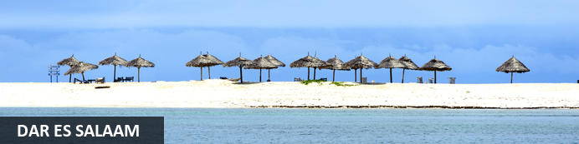
Dar es Salaam is Tanzania’s former capital, her largest city and main port. The distinctly African, colourful markets are well worth a visit and both German and British influences can still be seen in the architecture around the city. Conveniently positioned amidst some of the most important sea routes in the world, the city is the transport and economic hub of the country as well as a centre for arts and culture. It serves as an excellent jumping-off point to explore the surrounding area including Pemba, Mbudya, Unguja islands, a variety of national parks and countless pristine beaches. Visitors can look forward to a number of other activities including: learning about Tanzanian culture at the National Museum and House of Culture, visiting the eclectic Oyster Bay, and taking a stroll through the city's lush Botanical Gardens.

Overnight: Johari Rotana
Johari Rotana is conveniently located in the CBD of Dar es Salaam, close to the Zanzibar ferry, beaches, and major area attractions. The hotel offers luxurious rooms and suites, as well as apartments equipped with in-room safes, tea/coffee-making facilities, minibars, ironing facilities, hairdryers, and TVs. Accommodation with kitchenettes is available. Facilities and services include daily housekeeping, a cigar lounge, restaurants, a gymnasium, a swimming pool, a sauna, massage rooms, a ballroom, meeting rooms, laundry facilities, parking, and Wi-Fi.
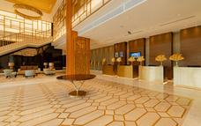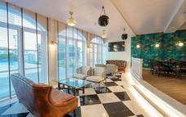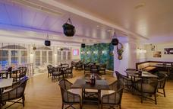

Basis
Bed and Breakfast

Day 2-5
Roho Ya Selous, Nyerere National Park

Day Itinerary
Day 2 – 4: Water and Walking Adventures Await You!
Transfer to Dar es Salaam International Airport
Flight to Nyerere National Park
Today, you will head to the international airport for a light aircraft flight to Nyerere National Park. This is one of Africa’s most exceptional game reserves, and you’re in for a treat! Your destination is Roho ya Selous, located in the heart of Nyerere’s core game viewing area.
Once you settle into your comfortable canvas tent, you can enjoy a delicious lunch with breathtaking views of Lake Nzerakera. After that, you’ll have time to relax before afternoon tea and an exhilarating game drive. The national park is home to a wide variety and high density of wildlife, including abundant giraffe and hippo, herds of elephant and if you’re lucky, wild dog.
Your 3 Night stay here, promises endless safari opportunities. Your safari experience is entirely flexible, with various activities to choose from each morning and afternoon. You can embark on a walking safari to explore the Miombo woodland environment with your guide. The boating safaris are equally fantastic and offer an excellent opportunity to witness wildlife come to the water’s edge to drink, as well as get up close to bird colonies, hippo, and crocodile. If you’re a fishing enthusiast, you can also enjoy catch-and-release fishing.
Overnight at Roho ya Selous
Full Board
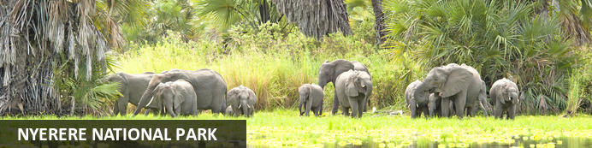
Formerly the northern part of Selous Game Reserve, Nyerere National Park is Tanzania's largest National Park. Stretching over an impressive 30,893 square kilometres, the park is home to some of the world’s largest concentrations of wildlife, and the incredible diversity and sheer volume of animals draw visitors from around the globe. Travellers can look forward to spotting a wide collection of common and rare species including the famous Big Five, some rare species of antelopes like Roan Antelope, and large concentrations of elephant and hippos. Don’t miss the opportunity to take a boating safari on the exquisite Rufiji River, spot the endangered African wild dog, and enjoy a guided walking safari with a highly knowledgeable guide.

Optional
Game drives
Walking safaris
Boating safaris
Catch and release fishing

Game drives
From verdant swamps and palm-fringed rivers to miombo woodland and open plains, the landscapes of Nyerere National Park (formerly known as the Selous) are beautiful for game drives. Rise with the birds and enjoy an early-morning exploration, or head out in the afternoon and see what you can find before returning for dinner. All our game viewing vehicles at Roho ya Selous are opensided for an uninterrupted view of the flora and fauna, and come complete with a shade roof, charging points and cooler boxes to keep sundowner drinks deliciously cool.
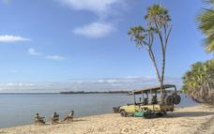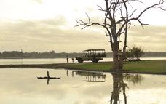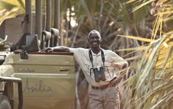

Walking safaris
Lace up your walking boots and discover the bush on foot with one of our expert guides. The perfect complement to game drives and boat trips, a walking safari will awaken all your senses and allow you to feel, smell and hear the bush, not just see it. Game drives Walking safaris Please note walking safaris are only available to individuals aged 16 and over.
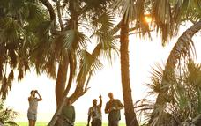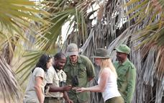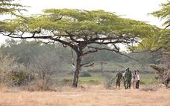

Boating safaris
No safari in Nyerere is complete without a trip on the water. Enjoy morning or evening boating safaris from Roho ya Selous, and cruise alongside pods of hippo in the shallows and spot crocodile sunning themselves on the sandbanks. Don’t forget your binoculars either — boating safaris offer wonderful birdwatching opportunities as you drift up close to nesting colonies.
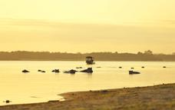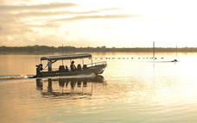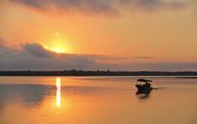

Catch and release fishing
Spend a relaxing afternoon on the boat and try your hand at a spot of catch-and-release fishing. The waters in Nyerere National Park teem with many species of fish, including a variety of catfish and the sought-after tiger fish. At Roho ya Selous, we have all the equipment you need. All that’s left to do is cast your line, sit back and see what happens.
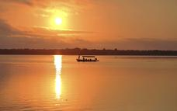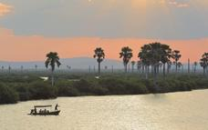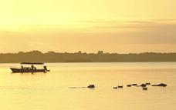

Overnight: Roho Ya Selous
Roho ya Selous sits in the very heart of Nyerere National Park (formerly The Selous), a stone’s throw from a palm-fringed tributary of Tanzania's Rufiji River.
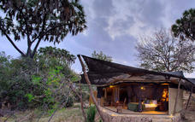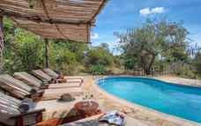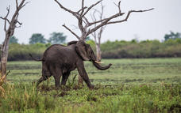

Basis
Fully Inclusive - Bed, All Meals, Fees and Activities
All Drinks (excl Premium Brands) Included

Day 5-8
Jabali Ridge, Ruaha National Park

Day Itinerary
Day 5 – 7: Explore Ruaha’s Diverse Wildlife Wonders
Flight to Ruaha National Park
Your adventure continues after breakfast as you board a light aircraft for a flight to Ruaha National Park. As you arrive, your guide will game drive you to Jabali Ridge, located on a rocky kopje overlooking a beautiful valley of baobab trees. Your day will then be yours to spend at leisure, with the option to embark on an afternoon game drive or unwind and soak up the breathtaking surroundings from the pool.
At Jabali Ridge, you’ll have the option to tailor your days to your preferences. Start your mornings with a walking safari, allowing you to explore the wilderness on equal footing with the wildlife. Alternatively, opt for a morning or full-day game drive with a picnic lunch or a relaxed lunch in camp followed by an afternoon game drive. If you need rejuvenation, spend your day lounging by the pool or indulging in the spa.
As night falls, you can look forward to your favourite drinks and a delicious dinner or combine your afternoon with a nocturnal game drive to discover the park’s rare and secretive night creatures. At Jabali Ridge, the options are endless, and our team will do everything possible to ensure that your stay is nothing short of extraordinary.
Overnight at Jabali Ridge
Full Board

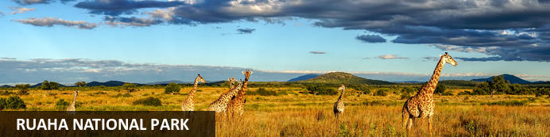
Following its 2008 merger with Usangu Game Reserve and other notable wetlands, Ruaha is counted among Tanzania's biggest national parks, spanning more than 20,000km². It is also a sizeable elephant haven and home to buffalo, huge populations of lion, leopard, and a profusion of bird species, including kingfishers, plovers, egrets, hornbills and sunbirds. Crocodiles and hippos thrive in the Great Ruaha River, which flows along the sanctuary’s eastern border and in the dry season between July and November, animals flock to the last remaining water sources, presenting an exceptional wildlife spectacle. There are a number of accommodation options available but some close for the wet season in March and April.

Optional
Game Drives
Walking Safaris
Night Game Drives
Photographic Vehicle

Game Drives
Guided game drives are offered twice a day from Jabali Ridge. Our six-seater game-viewing vehicles are open-sided with a canvas roof; canvas sides can be rolled down in case of rain (rain ponchos are provided). All vehicles have power points where you can recharge your device, and are fitted with fridges to keep your drinks deliciously frosty. A private game-viewing vehicle can be booked by prior arrangement. In the morning, maximise your game-viewing time by taking a delicious breakfast picnic with you to enjoy under the shade of a baobab tree. In the evening, sip a cold gin & tonic in the heart of the bush as the sun sinks below the horizon.
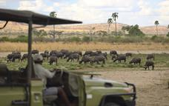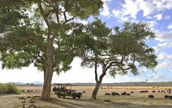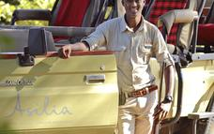

Walking Safaris
A walking safari is one the most intimate ways to experience the bush and can be enjoyed from Jabali Ridge in the company of an experienced armed guide and local tracker. Eye-to-eye with the wildlife, your senses are heightened and the sights, sounds, and smells of the bush come alive.
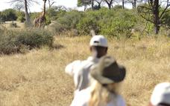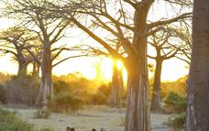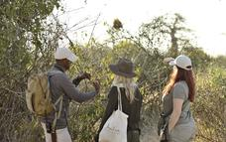

Night Game Drives
When the sun descends, the elusive night animals come out to play. Explore the secrets of these shy creatures on a night game drive from Jabali Ridge.
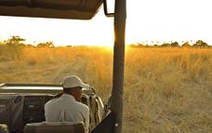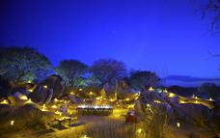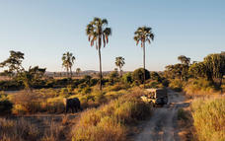

Photographic Vehicle
Calling all passionate photographers! Join us for a photographic safari experience in our specialised photography vehicles. The vehicles have drop-down sides for photographers to capture low, eye-level photographs. Beanbags, foam camera rests, power points, fridges and 360º swivel seats promise to make your wildlife photography experience a dream! (at an additional cost).

Overnight: Jabali Ridge
Set high on a rocky kopje overlooking a landscape dotted with bulbous baobabs, Jabali Ridge is a sophisticated base from which to explore Ruaha National Park. The remarkable beauty of Ruaha is not only in the landscape and its diversity of flora and fauna, or the impressive big game but in the feeling of having the wilderness all to yourself. With only a handful of visitors at any one time in an area the size of New Jersey, this is an exceptional safari experience. There are just eight suites hidden amongst the rocky boulders that cocoon the property, designed to blend in with the environment while offering the highest class accommodation in the park. There is a spectacular four-way infinity pool which overlooks the baobab valley, a spa offering pampering treatments, a gin bar to tempt you with pre- and post- dinner refreshment, and plenty of space to unwind when you aren't on safari. Our team of expert safari guides will lead you on game drives and walking safaris to explore this spectacular wilderness area.
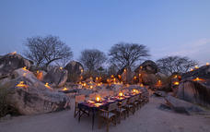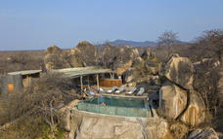

Basis
Fully Inclusive - Bed, All Meals, Fees and Activities
All Drinks (excl Premium Brands) Included

Day 8
End of Itinerary

Day Itinerary
Day 8: Say Bye to the Baobabs and Beyond
Flight to Dar es Salaam International Airport
After breakfast, with your bags packed, say goodbye as you depart on your light aircraft flight to Dar es Salaam International Airport. Bid farewell to the magnificent landscapes and wildlife of Ruaha National Park as you soar above the giant baobab trees dotting the plains and enjoy the delicious, packed lunch from Jabali Ridge.
.
END OF TOUR

Basis
Full Board - Dinner, Bed, Breakfast and Lunch

