

Classic Northern Tanzania Expedition
Arusha - Tarangire National Park - Lake Manyara National Park - Ngorongoro Crater - Central Serengeti
9 Days / 8 Nights

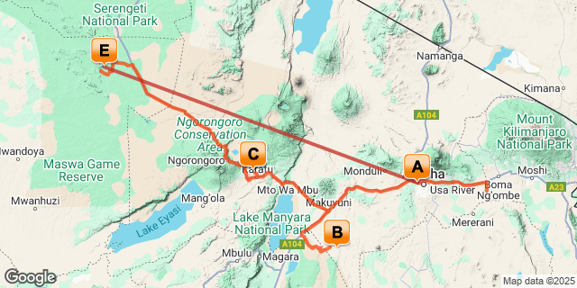

Introduction

Start | Accommodation | Destination | Basis | Duration
Day 1 | Elewana Arusha Coffee Lodge | Arusha | B&B | 1 Night
Day 2 | Elewana Tarangire Treetops | Tarangire National Park | FB | 2 Nights
Day 4 | Elewana The Manor at Ngorongoro | Lake Manyara National Park | FB | 1 Night
Day 5 | Elewana The Manor at Ngorongoro | Ngorongoro Crater | FB | 1 Night
Day 6 | Elewana Serengeti Pioneer Camp | Central Serengeti | FB | 3 Nights

Key
B&B: Bed and Breakfast
FB: Full Board - Dinner, Bed, Breakfast and Lunch

Included
- Accommodation as stipulated in the itinerary.
- Transportation in a chauffeur driven 4x4.
- Services of a professional English speaking driver-guide
- All game viewing drives.
- Flying Doctor’s fee.
- All park entrance fees as indicated in the itinerary.
- One way flight Serengeti – Arusha on a light Aircraft, 15 Kg baggage allowance.
- All Government taxes and levies.
- Complimentary 500 ml mineral water per person per game drive in the safari vehicle.
- All meet and greet services.
- All arrival and departure transfers.
- 24 hours stand-by contact number.
- Meals as indicated in the itinerary.
- Two-way long range high frequency radio communication in each vehicle.
- On safari accessories in each vehicle: - First-aid kit, wildlife books, a pair of binoculars, cool box and fire extinguisher.

Excluded
- All items of personal nature e.g. telephone call bills, fax/email bills etc.
- Tipping / Gratuities
- Extra Meals Not Included above
- International flight and departure taxes.
- Laundry services.
- Visa Fees
- Travel Insurance
- Any other item(s) not included in our itinerary.

Day 1
Elewana Arusha Coffee Lodge, Arusha

Day Itinerary
Jambo! Upon arrival at Kilimanjaro International Airport, you will be met by Classic Safaris Representative who will greet you and assist with the transfer to Arusha Coffee Lodge for Overnight stay.
Overnight Stay: Arusha Coffee lodge
Meal Plan: Bed & Breakfast
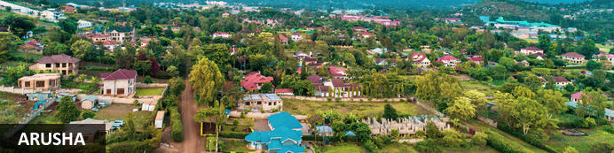
Resting at the foot of Mount Meru, the sprawling city of Arusha is known as the safari capital of northern Tanzania. It serves as an excellent base from which to explore the remarkably scenic surrounding area which includes majestic Mount Kilimanjaro, as well as the Manyara, Tarangire and Ngorongoro National Parks. Arusha is a good spot to take a day or two off from the safari circuit as it features a temperate climate and lush surrounds. Visitors can look forward to exploring the wildlife-abundant Serengeti National Park; the magnificent Arusha National Park; and taking on the challenge of climbing Mount Meru, Africa’s fifth highest mountain.

Overnight: Elewana Arusha Coffee Lodge
Located in the middle of a verdant coffee plantation, Elewana Arusha Coffee Lodge is a sanctuary of aromatic tranquility and a welcome retreat after a long international flight, or the dust and excitement of a thrilling bush safari.
Take residence in one of 30 luxury wooden chalets - 12 Plantation Suites and 18 Plantation Rooms - nestled amongst the surrounding gardens and sea of coffee trees.
Turning off the road, a tree-lined drive guides you to the warm and inviting main area with its quiet understated aura of luxury. Vibrant gardens, a spa, and a swimming pool await, and a restaurant, Bacchus, and café bistro, 3° South, boast menus to satisfy the most discerning of palates, successfully fusing international culinary prowess with locally-sourced ingredients.
Visitors are also welcome to enjoy convenient gift shopping at the Traders Walk Boutiques, located on site. Browse through a collection of five boutiques offering arts and crafts, jewellery, clothing, gourmet coffee and cakes and traditional Swahili food.
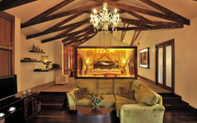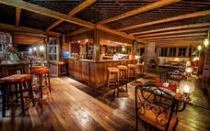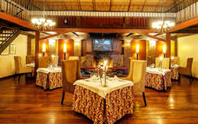

Basis
Bed and Breakfast

Included
Bed and breakfast rates include accommodation and " a la carte" breakfast in the respective rooms.
Check-in time is 2:00 pm and Check-out time is 10:00 am

Day 2
Elewana Tarangire Treetops, Tarangire National Park

Day Itinerary
After breakfast, check out and drive to Tarangire. Arrive in time for lunch at the lodge. Afternoon game drive. Tarangire is noted as a safari destination for its large concentration of wildlife population. Animals like elephants, eland, giraffe, lions, buffalo, cheetah, leopards and zebra are easily spotted
Dinner and Overnight stay at Tarangire Treetops Lodge
Meal Plan: Full Board
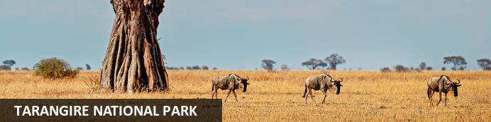
Tarangire National Park, situated within Tanzania’s spectacular Manyara Region, is an awe-inspiring national park comprising of granite ridges, river valleys, mixed vegetative landscapes, and free-roaming wildlife. During the annual dry season, the Tarangire River is a magnet for thirsty wildlife. Large herds of elephants and migratory wildebeest, zebra, buffalo, impala, gazelle, hartebeest and eland gather and not surprisingly the predators follow. With lion being among the most commonly spotted animal, it is a rare day that a visitor does not spot this majestic animal prowling or grazing. Tarangire is also the one place in Tanzania where dry-country antelope such as oryx and gerenuk are seen regularly. This expansive area is also known for its spectacular baobab trees, its breathtaking views of the Masaai Steppe and the wondrous mountains to the south.

Overnight: Elewana Tarangire Treetops
On the path of an annual elephant migration, Elewana Tarangire Treetops sits alone in a 312km2 community wildlife area bordering Tarangire National Park, amid a landscape of rolling and baobab-studded hills. Our elevated "treehouse" suites are perched high up with views over the adjacent baobab and marula trees, giving Elewana Tarangire Treetops an adventurous and exotic feel.
Twenty suites, each 65 sq metres with a private balcony, are lavishly furnished. Natural materials are blended with contemporary Africana décor, to provide guests with a unique and most memorable safari experience.
Encasing an impressive baobab tree, the spacious and tranquil dining room, reception and lounge overlook the swimming pool and a waterhole that sees a steady flow of wild animal visitors.
With the natural beauty of the hills and dry river beds begging to be explored, guests can enjoy guided walking safaris, day or night time game drives and the enchantment of bush dining.
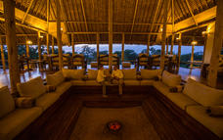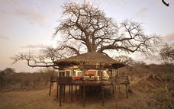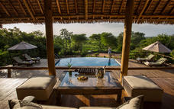

Basis
Full Board - Dinner, Bed, Breakfast and Lunch

Included
Full board rates include accommodation, all meals (breakfast, lunch and dinner), soft drinks, beer, house wines and selected spirits, teas, coffees and refreshments (on the property), and laundry services.
The rates exclude champagne, private cellar wines and premium spirits/beers

Day 3
Elewana Tarangire Treetops, Tarangire National Park

Day Itinerary
Early morning and afternoon gam drives. All meals and overnight stay at the camp.
Overnight stay at Tarangire Treetops Lodge
Meal Plan: Full Board

Basis
Full Board - Dinner, Bed, Breakfast and Lunch

Day 4
Elewana The Manor at Ngorongoro, Lake Manyara National Park

Day Itinerary
Breakfast at the lodge, check out and drive to lake Manyara Serena for lunch. After lunch, an afternoon game drive. Animals found here includes elephant, buffalo, hippo, lion, leopard, occasional cheetah and giraffe. Lions here have opted to rest up during the heat of midday in trees, giving Manyara lions somehow different behavior.
Dinner and overnight stay at The Manor at Ngorongoro
Meal Plan: Full Board
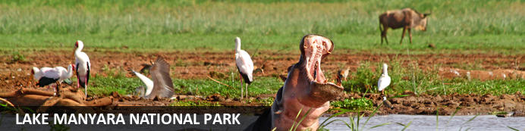
Situated in Tanzania’s central-northern region with the Lake Manyara to its east and the Manyara Escarpment to its west, the Lake Manyara National Park offers breathtaking views and a large variety of habitats supporting an array of wildlife. This small park is home to surprising biodiversity and features a magnificent landscape of acacia woodlands, forests, baobab strewn cliffs, algae-streaked hot springs, swamps and the lake itself. The park supports over 400 species of bird and the largest concentration of baboons anywhere in the world. Other species to spot include giraffes, zebras, wildebeest, impala, waterbuck, warthog, the Cape clawless otter, and the Egyptian mongoose. Don’t miss the opportunity to see thousands of flamingos on the lake, the renowned tree-climbing lions, and large families of elephants strolling through the forest.

Overnight: Elewana The Manor at Ngorongoro
Poised adjacent to the famous Ngorongoro Conservation Area, Elewana The Manor at Ngorongoro is a grand mansion that exudes old-world charm in north-west Tanzania. The manor is comprised of 18 cottage suites, each with its own private entrance and adjoining private sun terrace. In-room amenities include an en-suite bathroom with a rain shower, Wi-Fi and tea and coffee making facilities. Guests can enjoy an array of activities such as lunch on the Ngorongoro Crater Floor, a game drive in the Ngorongoro Crater and Lake Manyara National Park, and horse riding around the 1500-acre coffee estate.
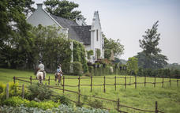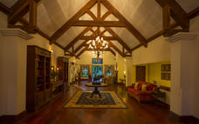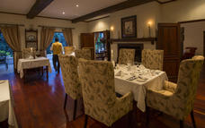

Basis
Full Board - Dinner, Bed, Breakfast and Lunch

Included
Full board rates include accommodation, all meals (breakfast, lunch and dinner), soft drinks, beer, house wines and selected spirits, teas, coffees and refreshments (on the property), and laundry services.
The rates exclude champagne, private cellar wines and premium spirits/beers

Day 5
Elewana The Manor at Ngorongoro, Ngorongoro Crater

Day Itinerary
Descend into the 8th Wonder of the World, a unique biosphere that has remained virtually unchanged since the dawn of time. Enclosed within its towering walss are grasslands, forests, saltpans, a fresh water lake and a glorious variety of birdlife. Here too are all the members of the 'Big Five' (Lion, Rhino, elephant, Leopard and Buffalo) as well as a large cast of plains game and one of Africa's densest populations of predators. Enjoy a picnic lunch on the crater floor before climbing back up to the lodge in time for relaxation before dinner.
Dinner and overnight stay at The Manor at Ngorongoro
Meal Plan: Full Board
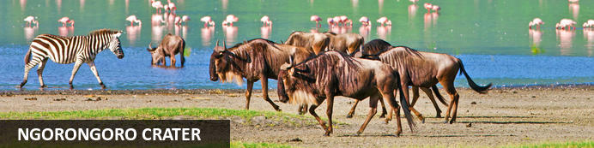
Located in Northern Tanzania, the Ngorongoro Crater is best known for its natural beauty and abundance of diverse wildlife; which makes it one of Africa’s most popular safari destinations. Surrounded by Tanzania’s highlands, this UNESCO-listed crater is said to be the world’s largest intact volcanic caldera. Visitors can look forward to spotting the world-renowned Big Five and a host of other wildlife species including large herds of zebra and wildebeest. It is famed as one of Tanzania’s best tourist attractions offering visitors an array of wonderful activities including excellent bird watching, trekking, wildlife viewing, mountain biking and visiting a local Maasai village. Don’t miss the opportunity to jump on an excursion to the magnificent Olduvai Gorge.

Overnight: Elewana The Manor at Ngorongoro
Poised adjacent to the famous Ngorongoro Conservation Area, Elewana The Manor at Ngorongoro is a grand mansion that exudes old-world charm in north-west Tanzania. The manor is comprised of 18 cottage suites, each with its own private entrance and adjoining private sun terrace. In-room amenities include an en-suite bathroom with a rain shower, Wi-Fi and tea and coffee making facilities. Guests can enjoy an array of activities such as lunch on the Ngorongoro Crater Floor, a game drive in the Ngorongoro Crater and Lake Manyara National Park, and horse riding around the 1500-acre coffee estate.

Basis
Full Board - Dinner, Bed, Breakfast and Lunch

Day 6-9
Elewana Serengeti Pioneer Camp, Central Serengeti

Day Itinerary
Drive to Serengeti National Park. You will have 3 days of game drives in this Park. Serengeti National Park is a World Heritage Site teeming with wildlife: over 2 million ungulates, 4000 lions, 1000 leopard, 550 cheetahs and some 500 bird species inhabit an area close to 15,000 square kilometers in size. Join us on a safari and explore the endless Serengeti plains dotted with trees and kopjes from which majestic lions control their kingdom; gaze upon the Great Migration in awe or find an elusive leopard in a riverine forest. Or perhaps see everything from a bird’s-eye view and soar over the plains at sunrise during a hot air balloon safari.
All meals and Overnight Stay at Serengeti Pioneer Camp
Meal Plan: Full Board.
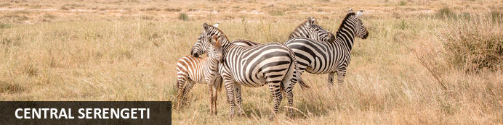
Situated in the heart of Tanzania, the Central Serengeti encompasses the world-famous Seronera Valley which is known for its prime wildlife-viewing opportunities. This picture-perfect landscape is characterised by endless stretches of savannah-covered open plains interspersed by rocky outcrops of granite and scattered with acacia woodlands and covered in a network of rivers and streams. The Central Serengeti forms part of the great wildebeest and zebra migration and provides an ideal habitat for a variety of wildlife such as giraffe, impala, waterbuck, hippo, elephant, buffalo, lion, leopard, hyena, jackal, serval and much more. Popular activities include: game viewing, cultural tours, horse riding safaris, and hot air ballooning over the spectacularly scenic terrain.

Optional
Game Driving
Bush Meals
Lake Magadi
Moru Kopjes

Game Driving
Elewana Serengeti Pioneer Camp's prime location allows guests to be in the midst of the drama of the annual Great Migration calving season, which occurs January - March. An evolutionary phenomenon, in the short span of just a few weeks some 400'000 calves are born while the herds reside in the Southern Serengeti region. The event attracts numerous predators, and visitors to the area have the opportunities to witness one of the grandest shows in nature.
When the herds of wildebeest and zebra have left on their journey back north, what remains in the area is an abundance of wildlife and excellent game viewing year-round. The Serengeti is famed for its Big 5, and guests to Serengeti Pioneer Camp will be treated to some of the best game viewing opportunities in East Africa.
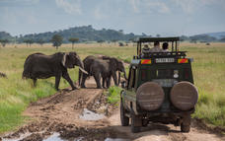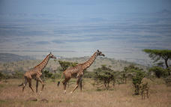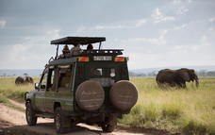

Bush Meals
Take a breakfast or lunch hamper on a game drive and enjoy a delicious gourmet meal while taking in the views over the Serengeti.

Lake Magadi
Lake Magadi is a large soda lake, and seasonally home to thousands of pink flamingo, a sight to behold. Year round the lake is home to numerous bird species to be enjoyed, and is an easy drive from camp.
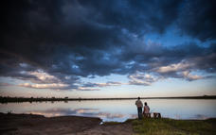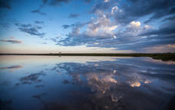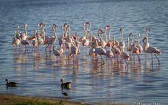

Moru Kopjes
A rocky outcrop with great historical significance to the Maasai people, Moru Kopjes features ancient maasai paintings on many of its boulders. Another fascination of the kopje, are the gong rocks, a geological phenomenon of rocks that produce musical sounds when hit, which were used as a communication tool by the Maasai people.

Overnight: Elewana Serengeti Pioneer Camp
Located in the Southern Serengeti (within the Moru Kopjes area), Elewana Serengeti Pioneer Camp is ideally situated to offer superlative access to the annual migration and the ‘Big 5’ with sweeping views overlooking Moru Kopjes, Lake Magadi and the endless plains.
Elewana Serengeti Pioneer Camp has its own individual style and feel, paying homage to the mobile camps of the 1930’s, a time when an African safari was truly a journey into the unknown, Elewana Serengeti Pioneer Camp’s ‘zero footprint’ and close proximity to nature combines to make an unmistakably distinctive and truly individual offering.
Comprising of twelve tented accommodations, all of which have ensuite facilities including a flushing toilet, vanity basin, and showers, the tent interiors are designed to evoke the very best of an era long-gone but certainly not forgotten.
A dining tent hosts the Camp’s guests for both breakfast and dinner, whilst luncheons are taken either in the camp or in the bush during what will no doubt be yet another enthralling day in the Serengeti.
It captures the original essence of the mobile African safari, engendering nostalgic wonderment whilst unlocking the adventurous spirit within all of us. The drama and beauty of the Serengeti National Park is indeed awe-inspiring.
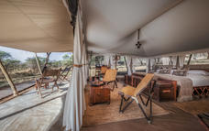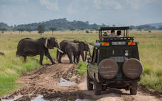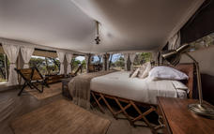

Basis
Full Board - Dinner, Bed, Breakfast and Lunch

Included
Full board rates include accommodation, all meals (breakfast, lunch and dinner), soft drinks, beer, house wines and selected spirits, teas, coffees and refreshments (on the property), and laundry services.
The rates exclude champagne, private cellar wines and premium spirits/beers

Day 9
End of Itinerary

Day Itinerary
Bid farewell to the Serengeti as you are transferred to the airstrip for your morning flight to Arusha. You will be met and transferred to Arusha Coffee Lodge where a day room has been resreved for you until 1800hrs. Later you will be escorted to the airport for your departure flight back home.

Basis
Full Board - Dinner, Bed, Breakfast and Lunch

