

Classic Sky Safari 10 Days in Kenya
Nairobi City - Amboseli National Park - Loisaba Conservancy - Masai Mara
10 Days / 9 Nights

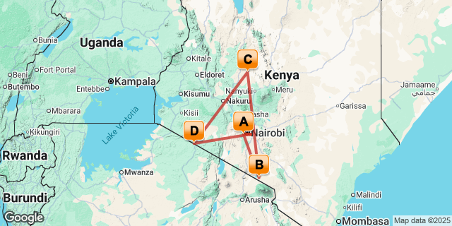
Introduction

Start | Accommodation | Destination | Basis | Duration
Day 1 | Hemingways Nairobi | Nairobi City | B&B | 1 Night
Day 2 | Elewana Tortilis Camp Amboseli | Amboseli National Park | FB | 2 Nights
Day 4 | Elewana Loisaba Tented Camp | Loisaba Conservancy | FB | 3 Nights
Day 7 | Elewana Sand River Masai Mara | Masai Mara | FB | 3 Nights

Key
B&B: Bed and Breakfast
FB: Full Board - Dinner, Bed, Breakfast and Lunch

Included
The SkySafari Itineraries Include:
- All domestic flights in Sky Safari’s executive aircraft
- All statutory departure taxes for the flights mentioned above
- Overnight stay at Hemingways Hotel or similar standard property on half board with drinks* included on the first day of the SkySafari Kenya itinerary.
- Full board accommodation, drinks* and laundry services as per itinerary.
- Shared daytime game drives in specially adapted 4x4 game drive vehicles
- Services of an English-speaking driver-guide at each camp / lodge
- Safari activities as per itinerary
- All road transfers, including to / from international airports and local airstrips
- Temporary Medical Emergency Evacuation insurance (conditions apply)
- Last day lunch and day room at Hemingways Hotel or similar standard property in Kenya, subject to availability and outbound flight departure timings
- VIP airport assist at Jomo Kenyatta International Airport and Kilimanjaro International Airport on arrival (subject to change)
* Drinks include: mineral water, soft drinks, juices, tea/coffee, beer, house wines, selected spirits
Special Offer: Single room supplement will not be charged for the first single room per booking

Excluded
- Visa Fees
- Travel Insurance
- Tipping
- Premium drinks
- International flight and departure taxes.
- Laundry services.
- All items of personal nature e.g. telephone call bills, fax/email bills etc.
- Any other item(s) not included in our itinerary.

Day 1: Hemingways Nairobi, Nairobi City

Day Itinerary
- Land in Nairobi, where we’ll fast-track you through Jomo Kenyatta International Airport and deliver you quickly to Hemmingways Hotel or similar standard property depending on the availability
- Dinner at Hotel
Accommodation - Hemmingways Hotel or similar standard property
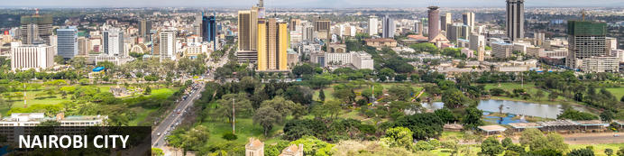
Nairobi is Africa’s 4th largest city and is a vibrant and exciting place and although it has developed a reputation which keeps tourist visits brief there are some fascinating attractions: its café culture, unbridled nightlife, the National Museum, the Karen Blixen Museum and most notably just 20 minutes from the city centre wild lions and buffalo roam in the world’s only urban game reserve.

Overnight: Hemingways Nairobi
Set within the leafy suburb of Karen, Hemingways Nairobi is a serene, plantation-style boutique hotel where space, sophistication, and warm hospitality define the experience.
Forty-five airy suites open onto private balconies overlooking the iconic Ngong Hills, with personalised service, including dedicated butlers ensures every detail is seamlessly taken care of.
Conveniently located within easy reach of both Jomo Kenyatta and Wilson airports, the hotel offers a calm escape from the city, with private transfers available on request. Its tranquil setting also places guests close to many of Nairobi’s most celebrated attractions, including Nairobi National Park, the Giraffe Centre, the David Sheldrick Wildlife Trust, the Karen Blixen Museum, and a rich array of galleries and cultural landmarks.
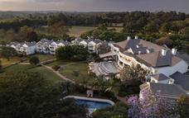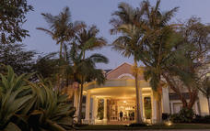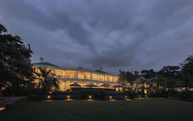

Basis
Bed and Breakfast

Day 2: Elewana Tortilis Camp Amboseli, Amboseli National Park

Day Itinerary
- Breakfast and briefing at hotel by SkySafari representative
- SkySafari private ground transfer to Nairobi – Wilson Airport
- SkySafari flight to Amboseli National Park
- Game drive enroute to Tortilis Camp
- Lunch at camp
- Afternoon game drive
- Dinner at camp
Accommodation – Elewana Tortilis Camp Amboseli
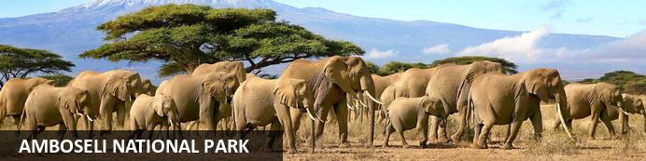
Located in the southern reaches of Kenya, the Amboseli National Park is renowned for its excellent variety of wildlife such as Maasai giraffe, elephant, lion and cheetah and not surprisingly it is one of Kenya's most popular parks. The landscape of Amboseli is dominated by the majestic snowcap of Mount Kilimanjaro, as well as open plains, acacia woodland, swamps and the massif of Ol Doinyo Orok. The birding is excellent, especially closer to the lakes and swamps. The park is famous for being the best place in Africa to get close to large herds of elephants among other wildlife species. Other attractions include opportunities to meet the Maasai people and soak up spectacular views of Mount Kilimanjaro, the highest free-standing mountain in the world.

Overnight: Elewana Tortilis Camp Amboseli
Amboseli is best known for its unrivalled views of Kilimanjaro and the local elephant population. There are over 1000 elephants in the park’s eco-system, featuring some of the largest in Africa. Elewana Tortilis Camp is situated in one of Amboseli's areas of Acacia Tortilis woodland, with the majestic backdrop of Africa's highest mountain, and the World’s highest free-standing mountain, snow-capped Kilimanjaro. Game drives, walks, sundowners and bush meals take place both inside the park and within a private 30,000-acre game concession. The tents are all spacious, with king or twin beds and elegant ensuite bathrooms. There is a main lounge, bar and dining area, all exquisitely built with natural materials and thatched roofs.
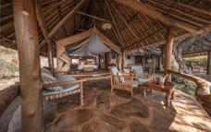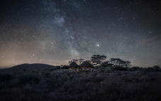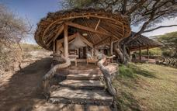

Basis
Full Board - Dinner, Bed, Breakfast and Lunch

Day 3: Elewana Tortilis Camp Amboseli, Amboseli National Park

Day Itinerary
- Early morning game drive
- Bush breakfast
- Lunch at camp
- Guided bush walk
- Scenic sundowners in the bush
- Private dinner at camp
Accommodation – Elewana Tortilis Camp Amboseli

Basis
Full Board - Dinner, Bed, Breakfast and Lunch

Day 4: Elewana Loisaba Tented Camp, Loisaba Conservancy

Day Itinerary
- Breakfast at camp
- Morning game drive enroute to Amboseli airstrip
- SkySafari flight to Loisaba Conservancy
- VIP welcome and briefing about conservancy
- Game drive enroute to Loisaba Tented Camp
- Arrive at camp in time for lunch
- Afternoon game drive or choice of activities*
- Sundowners
- Dinner at camp
Accommodation – Elewana Loisaba Tented Camp
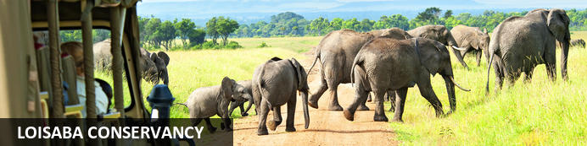
Set in Northern Laikipia in Kenya, East Africa, Loisaba Conservancy stretches over 20 000 hectares of magnificent African landscape. The terrain is traversed by two permanent rivers and abundant springs which make it a perfect habitat to sustain a myriad of wildlife. It is known as a world-class ecotourism destination offering a variety of unique opportunities for visitors looking to immerse themselves in nature. Spot majestic elephants journeying along the elephant migration corridor, stay overnight in a tented camp under the stars, soak up the incredible views and enjoy a thrilling game safari. Other popular activities include camel-trekking, mountain biking, horse-riding, fishing, guided bush walks, and cultural visits to Samburu villages.

Overnight: Elewana Loisaba Tented Camp
Elewana Loisaba Tented Camp is situated on the beautiful Loisaba Conservancy in Laikipia. Perched on the edge of an escarpment, the camp is designed to capitalize on unhindered views across Laikipia's mottled landscape all the way to Mt Kenya. All accommodations and main areas enjoy a breathtaking vantage point over an expansive panorama.
African-themed sophistication and style is the flavour of Elewana Loisaba Tented Camp. Spacious and airy tents are custom-built with large top-to-bottom doors and windows, high ceilings and polished wood floors. The tent suites are adorned in chic Africana furniture with a modern European twist. The bathrooms are luxurious with flush toilets, double-basin vanity and solar-heated hot water cascading from a rainfall shower to deliver a revitalizing cleanse after an action-packed day.
The inviting main areas of Loisaba Tented Camp include a large open dining area, separate open lounge and bar, a large wooden decking area for outside dining, relaxing and enjoying the view, and one of Africa's most picturesque infinity pools.
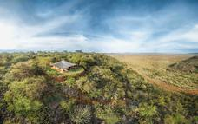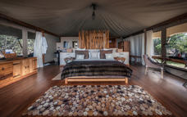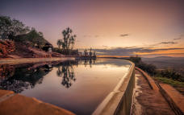

Basis
Full Board - Dinner, Bed, Breakfast and Lunch

Day 5: Elewana Loisaba Tented Camp, Loisaba Conservancy

Day Itinerary
- Morning - game drive / guided bush walk / horse or camel safari
- Breakfast in the bush
- Lunch at camp
- Afternoon game drive or choice of activities*
- Sundowners
- Dinner at camp
Accommodation – Elewana Loisaba Tented Camp

Basis
Full Board - Dinner, Bed, Breakfast and Lunch

Day 6: Elewana Loisaba Tented Camp, Loisaba Conservancy

Day Itinerary
- Breakfast in camp
- Morning - game drive / guided bush walk / horse or camel safari
- Lunch at camp
- Afternoon game drive or choice of activities*
- Sundowners
- Dinner at camp
Accommodation – Elewana Loisaba Star Beds or Elewana Loisaba Tented Camp

Basis
Full Board - Dinner, Bed, Breakfast and Lunch

Day 7: Elewana Sand River Masai Mara, Masai Mara

Day Itinerary
- Breakfast at camp
- Game drive enroute to Loisaba airstrip
- SkySafari flight to the world famous Masai Mara
- Game drive enroute to Sand River Masai Mara Camp
- Lunch at camp
- Afternoon game drive
- Sundowners in the bush
- Dinner at camp
Accommodation – Elewana Sand River Masai Mara
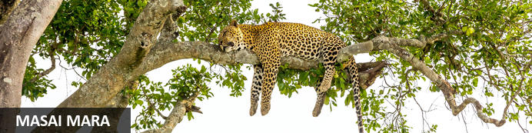
Situated in southwestern Kenya, the Masai Mara encompasses the celebrated national reserve and its surrounding community conservancies, forming part of the Greater Serengeti–Mara ecosystem. Rolling savannahs, dotted with acacia trees and crossed by the Mara River, create a rich and varied landscape. Vast herds of wildebeest, zebra, and antelope graze across the plains, while elephants, giraffes, and buffalo roam freely. The river’s lush banks support hippos and crocodiles and sustain wildlife throughout the dry season. Predators are abundant, with lions, leopards, cheetahs, and hyenas regularly seen in action. Each year, the spectacular Great Migration transforms the region, as millions of wildebeest and zebra traverse the plains. Visitors can soak up the breathtaking scenery, diverse wildlife, and Maasai cultural heritage in one of Africa’s most iconic safari destinations.

Overnight: Elewana Sand River Masai Mara
Situated along the banks of a river from which it has taken its name, Elewana Sand River Masai Mara is located within the Masai Mara National Reserve in Kenya on a secluded and picturesque site. The camp enjoys stunning views over the Sand River and out to the neighbouring grassy hills and plains of Tanzania.
The camp sits on the migration route for the millions of wildebeest, zebra and Thompson's gazelle that move between Serengeti and Maasai Mara every year. Guests enjoy the privilege of exclusive views of the plains and hills dotted with thousands of animals as well as being in the thick of the excitement of frenetic and famed river crossings, all from the comfort of camp.
Comprising of 16 tented accommodations, Elewana Sand River Masai Mara replicates the heyday of exclusive permanent tented camps of the late 1920’s.
Divided into two separate but adjoining campsites of 10 and 6 tents, each area possessing its own designated dining and public areas, Elewana Sand River Masai Mara provides an atmosphere of exclusivity and class.
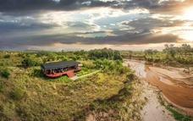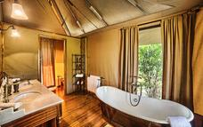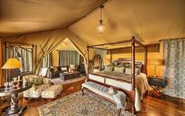

Basis
Full Board - Dinner, Bed, Breakfast and Lunch

Day 8: Elewana Sand River Masai Mara, Masai Mara

Day Itinerary
- Early breakfast at camp
- Full day game drive
- Picnic hamper lunch served in the bush
- Dinner under the stars at camp
Accommodation – Elewana Sand River Masai Mara

Basis
Full Board - Dinner, Bed, Breakfast and Lunch

Day 9: Elewana Sand River Masai Mara, Masai Mara

Day Itinerary
- Early morning game drive
- Bush breakfast
- Lunch at camp
- Afternoon game drive
- Sundowners in the bush
- Farewell dinner under the stars at camp
Accommodation – Elewana Sand River Masai Mara

Basis
Full Board - Dinner, Bed, Breakfast and Lunch

Day 10: End of Itinerary

Day Itinerary
- Breakfast at camp
- Transfer back to Keekorok airstrip
- SkySafari flight to Wilson Airport, Nairobi
- SkySafari private ground transfer to Hotel for lunch
- A day room will be available depending on your outbound flight, subject to availability
- SkySafari private ground transfer to Jomo Kenyatta International Airport for outbound flight

