

Classic Pearl of Africa Safari
Kampala - Murchison Falls National Park - Kibale Forest National Park - Northern Queen Elizabeth National Park - Bwindi Impenetrable Forest National Park - Lake Mburo National Park
10 Days / 9 Nights

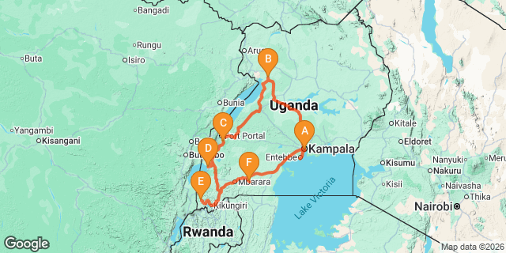
Introduction
Start | Accommodation | Destination | Basis | Duration
Day 1 | Latitude 0 Degrees | Kampala | B&B | 1 Night
Day 2 | Paraa Safari Lodge | Murchison Falls National Park | FB | 2 Nights
Day 4 | Crater Safari Lodge- Kibale | Kibale Forest National Park | FB | 2 Nights
Day 6 | Mweya Safari Lodge | Northern Queen Elizabeth National Park | FB | 1 Night
Day 7 | Gorilla Safari Lodge | Bwindi Impenetrable Forest National Park | FB | 2 Nights
Day 9 | Mihingo Lodge | Lake Mburo National Park | FB | 1 Night

Key
B&B: Bed and Breakfast
FB: Full Board - Dinner, Bed, Breakfast and Lunch

Day 1: Latitude 0 Degrees, Kampala

Day Itinerary

Meet and greet at Entebbe International Airport where your Uganda Adventure Safari starts by our representative who will warmly welcome you and facilitate seamless arrival formalities. Your will then be transferred to your hotel where you will be briefed about your adventure safari.
Depending on the time of arrival you are advised to have money Changed on this day, if time allowing you may go for a city tour. All activities today are at your own cost. You may visit the botanical gardens at a supplement of $25 per person or visit the Uganda Wildlife Educational centre at supplement of $35 per person or go for a cheese and wine sundowner on Lake Victoria at a supplement of $130 per person.

Accommodation: Latitude 0 Degrees
Meal Plan: Bed & Breakfast
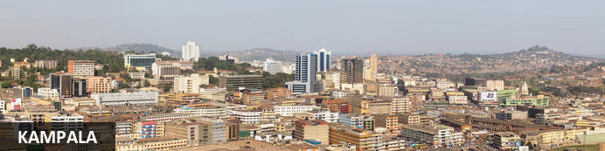
Bordering the magnificent Lake Victoria, Uganda’s capital city - Kampala - sprawls out over a series of undulating hills and despite the development, this ‘Garden City’ is known for its tree-lined avenues. It serves as the commercial hub of the country boasting a blend of African markets, modern skyscrapers, international hotels, bars, and casinos. It provides an excellent base from which to explore the surrounding area. Visitors can look forward to learning about the country’s rich and colourful history at the Uganda Museum; enjoying a number of activities on Lake Victoria, Africa’s largest lake; and visiting the Namugongo Martyrs Shrines, a UNESCO World Heritage Site. Don’t miss the opportunity to visit the nearby Mburo National Park to catch a glimpse of local wildlife including: hippo, zebra, gazelles, crocodiles, warthog, and a variety of magnificent birdlife.

Overnight: Latitude 0 Degrees
Situated in Kampala, Latitude 0 Degrees hotel is nestled among indigenous orchid-filled trees on Makindye Hill, offering stunning views over Lake Victoria and the city. The hotel features stylish, naturally light-filled guestrooms equipped with full-sized baths, walk-in showers, and Smart TVs. Each room includes fresh Ugandan coffee with French presses, complimentary still and sparkling water, and free Wi-Fi. Guests can enjoy an outdoor swimming pool, spa, and fitness area, along with a restaurant serving indoor and outdoor dining options. Relax with a drink at the rooftop bar while taking in the scenery. The property also provides free private parking, a 24-hour front desk, airport transfers, room service, and a business center, ensuring a comfortable stay.
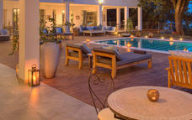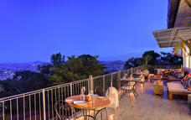

Basis
Bed and Breakfast

Included
- Airport Transfer

Day 2: Paraa Safari Lodge, Murchison Falls National Park

Day Itinerary
After your early morning breakfast drive northwest to Murchison Falls National Park, you may stopover at the Rhino Sanctuary where you will have an opportunity to trek Rhinos.
A local ranger guide will lead you on foot to an up-close encounter with the rhinos and it may take about 1 and half hours. Proceed to Masindi Town for lunch and later continue to Murchison Falls National Park arriving at your lodge late afternoon. Time allowing, you may visit the Top of the Falls on the way to your lodge.

Accommodation: Paraa Safari Lodge
Meal Plan: Full Board

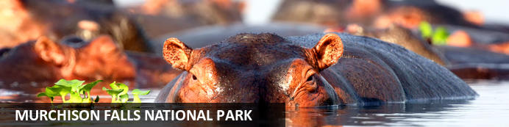
Stretching from the shores of Lake Albert, Murchison Falls National Park is Uganda's largest National Park. The Nile River flows through the middle of the park creating the impressive Murchison Falls which is the park’s major attraction. The landscape features dense rainforest, undulating savannah and a diversity of abundant wildlife. Visitors can enjoy prime game-viewing along the Buligi Circuit. The forests are home to numerous primates, including Chimpanzees, and near the river, buffalo, elephants and Rothschild-Giraffes can be seen. Other commonly spotted wildlife include: lions, antelope, waterbucks, hippos and crocodiles.

Overnight: Paraa Safari Lodge
Nestled in the heart of Murchison Falls National Park in northwest Uganda, Paraa Safari Lodge unveils the wonders of nature, offering breath-taking views of the River Nile on its majestic journey from Lake Victoria.
Accommodation Elegance:
Choose from a range of luxurious options, including cottages, suites, and double, twin, and single rooms, all adorned with fans, balconies, and en-suite bathrooms.
Culinary Delights:
Indulge your taste buds with a delectable array of local and international specialties at our on-site restaurant.
Leisure Oasis:
Dive into leisure at our swimming pool, unwind at the bar, and explore unique treasures at our gift shop.
Paraa Safari Lodge invites you to a haven where nature meets luxury, promising an unforgettable escape in the heart of Uganda's wilderness.
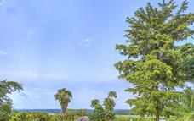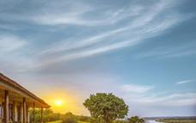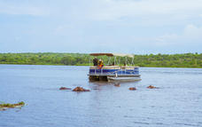

Basis
Full Board - Dinner, Bed, Breakfast and Lunch

Included
- Rhino Tracking
- Park Entrance Fees

Day 3: Paraa Safari Lodge, Murchison Falls National Park

Day Itinerary
Arise very early in the morning for your game drive on the northern bank of the River Nile in your open-roof vehicle which will give you an excellent opportunity to view and photograph the diverse wildlife. Your guide will help you spot elephant, lion, cape buffalo, Roth child’s giraffe, hartebeest, waterbuck, oribi, bushbuck, bohor reed buck, hyena and if you are lucky, the leopard.
After lunch, go for a boat cruise upstream the calm Victoria Nile to the base of the falls stopping just few of meters from the ‘Devil’s Cauldron’, marvel at the schools of hippos, crocodiles and over the 17km stretch you may see elephant, waterbuck and Uganda Kob. This is also the zone of many birds, species like goliath heron, Egyptian goose, pelican bee-eater, kingfisher, hornbill, cormorant and the rare shoebill stork.
After taking shorts of the photogenic Murchison Falls, you may choose to continue to the top of the falls, where you will have the amazing view of the falls! See where the Nile -world's longest river explodes violently through a narrow cleft in the Rift Valley escarpment to plunge into a frothing pool 43m below. Later, return to your lodge and relax in the evening.

Accommodation: Paraa Safari Lodge
Meal Plan: Full Board
Basis
Full Board - Dinner, Bed, Breakfast and Lunch

Included
- Boat Cruise
- Top of the falls hike
- Park entrance fees
- Game Drive

Day 4: Crater Safari Lodge- Kibale, Kibale Forest National Park

Day Itinerary
After your morning breakfast, begin your journey to Kibale Forest National Park.
Drive South of Fort Portal through verdant countryside passing through traditional homesteads, farms and Tea Estates. You will arrive at you lodge in the afternoon. Check in at your lodge for dinner and an overnight stay.
Accommodation: Crater Safari Lodge
Meal Plan: Full Board
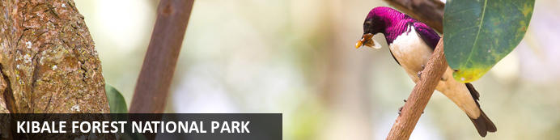
Kibale Forest National Park, situated in Western Uganda, is famous for its high density of primates, breath-taking crater lakes, and thick, beautiful jungle. Thirteen primate species inhabit the beautiful tropical forest, including red-tailed monkey, L’Hoest's monkey, grey-cheeked mangabey, red colobus, and black and white colobus monkeys. Visitors may spot some of the 300 bird species and 250 butterfly species, and buffalo, forest elephants, leopards, bushbucks, and sitatungas also live in the park but are generally shy. The area is decorated by around 50 enthralling crater lakes and numerous pristine hiking trails. Several cultural tours are on offer which delve into the rich traditions of the Batoro people, giving travellers a chance to see Batoro dancing, singing and traditional healing up close.

Overnight: Crater Safari Lodge- Kibale
Crater Safari Lodge has been designed in such a way that it doesn’t intrude on its pristine surrounds. Thatched
chalets with expansive wooden balconies provide the perfect luxurious jungle escape. Hammocks and garden
swings on the grounds of the lodge add an extra element of tranquillity to your remote safari experience.
In total, there are 11 thatched stand-alone wooden cabins and 10 standard pool facing cabanas, each catering for a
different style of guest.
Crater Safari Lodge is the perfect place to base yourself for a true jungle and wilderness experience in Uganda.
The lodge is an award winning eco-lodge, and offers an unsurpassed remote wilderness experience.
standard pool facing cabanas
• Romantic bush dinner options on the shores of the
lake
• Lodge is ideal for both honeymoons and weddings
• From swamp walks, to fishing, canoeing and hiking;
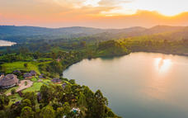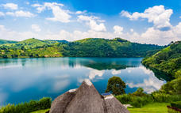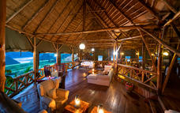

Basis
Full Board - Dinner, Bed, Breakfast and Lunch

Included
-Transfer to Kibale

Day 5: Crater Safari Lodge- Kibale, Kibale Forest National Park

Day Itinerary
After breakfast at your lodge, transfer to the starting point of your Chimpanzee tracking experience in Kibale Forest National Park which is reputed to have the greatest variety and highest concentration of primates in East Africa. The most famous of its 13 species is the Chimpanzee, man’s closest relative. Kibale’s 1450 Chimpanzee represent Uganda’s largest population of this endangered primate. Kibale is also a home to the rare I’Hoest’s monkey. Other primates include the black and white Colobus, Blue monkey, Grey cheeked mangabey, Red tailed monkey, Olive baboon to mention but a few. So you will enjoy a guided nature walk in the tropical rainforest in search of the wild chimpanzees, red-tailed monkeys, black and white colobus monkeys and many others. Although chimp sightings are not guaranteed, visitors stand a good chance of hearing and seeing our distant cousins as they gloom and bond with one another.

After lunch, head to Bigodi. Bigodi was established by a local development organization to protect the 4sq-km Magombe Swamp that's home to around 200 species of birds (highlights include papyrus gonolek, white-winged warbler and great blue turaco). The highlight of this tour is catching a glimpse of the great blue turaco. The swamp is also good for spotting butterflies and primates, with 8 different species here, including grey-cheeked mangabey. The 2-3 hour guided walk is led by experienced local guides who interact with the guests and make the trip both enjoyable and exciting.
Accommodation: Crater Safari Lodge
Meal Plan: Full Board

Basis
Full Board - Dinner, Bed, Breakfast and Lunch

Included
-1 Chimp Permit per person
-Bigodi swamp walk

Day 6
Mweya Safari Lodge, Northern Queen Elizabeth National Park

Day Itinerary
After an early breakfast at your lodge before you proceed to Queen Elizabeth National Park. The drive takes you through the Switzerland of Africa area known as the Kigezi Highlands with its terraced hillside. Your expert driver guide will take you through the game park where you might spot some animals. Of course you won’t miss seeing the beautiful scenery of the crater lakes.
Upon arriving at your lodge, you will enjoy a hot lunch and later in the afternoon take a unique 2hour boat cruise on the Kazinga Channel into Lake Edward. This trip passes through possibly the highest concentration of hippos and this launch/cruise offers an excellent platform for photography, bird watching and game viewing. The prolific bird life is colourful and stupendous, with well over 550 resident species.

Accommodation: Mweya Safari Lodge
Meal Plan: Full Board
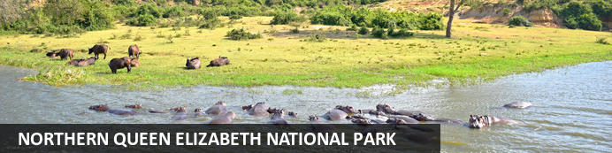
One of the most popular parks in Uganda, the Queen Elizabeth National Park lies in the western region of the country. In the northern part of the park, visitors can look forward to boating along the Kasinga Channel, which is home to the largest population of hippos in the world and an abundance of Nile crocodiles. Along the banks, an incredible number of birds and wild animals flock to the river’s edge. At Kyambura Gorge, fondly known as ‘Valley of the Apes’, chimpanzees are at home in a world of lush tropical rainforest spread with canopies, and three salty crater lakes are decorated with swathes of pink flamingos. On the western shore of Lake George, the vast Kasenyi Plains are inhabited by lions and several interesting bird species.

Overnight: Mweya Safari Lodge
Mweya Safari Lodge is ideally located on a peninsula within the heart of the Queen Elizabeth National Park, surrounded by the Rwenzori Mountains in Kenya. Accommodation options include rooms, cottages and safari tents on raised platforms with private bathrooms, furnished patios, coffee stations, and fans. Facilities and services include a restaurant, a bar, a swimming pool, a fitness centre, and a spa.
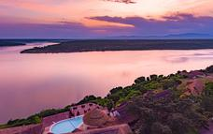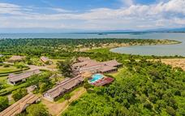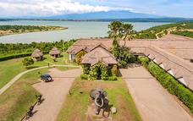

Basis
Full Board - Dinner, Bed, Breakfast and Lunch

Included
- Boat Cruise on Kazinga channel
- Game Drive
- Park Entrance fees

Day 7: Gorilla Safari Lodge, Bwindi Impenetrable Forest National Park

Day Itinerary
After your breakfast, drive to Bwindi Impenetrable Forest
The drive takes you through the Switzerland of Africa area known as the Kigezi Highlands with its terraced hillside and winding roads to Bwindi Impenetrable National Park, arriving in the evening. Check into the lodge for dinner and your overnight stay.
Accommodation: Gorilla Safari Lodge
Meal Plan: Full Board
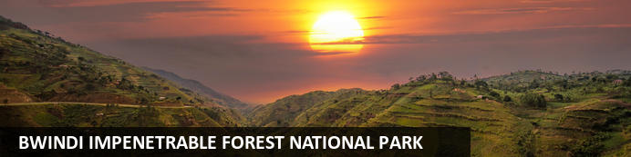
Located in south-western Uganda, the Bwindi Impenetrable National Park is said to be Africa’s oldest rainforest. It is world-renowned for its excellent gorilla-sighting opportunities - the forest is home to half of the remaining mountain gorillas on earth. This gorilla experience takes place among a rugged landscape of dense jungle, cascading waterfalls, sparkling mountain streams, deep valleys, and steep ridges. The untouched forest has been declared a UNESCO World Heritage Site for its breath-taking natural beauty and unique ecological significance. Aside from the amazing gorilla interactions, there are other drawcards such as a network of forest walks, over 340 species of bird to spot, and a variety of brightly-coloured butterflies to identify.

Overnight: Gorilla Safari Lodge
Gorilla Safari Lodge is an up market facility tucked away at the boundary line of Bwindi Impenetrable Forest - home of the endangered mountain gorilla. It is the ideal base from which to trek the Nshongi group of Gorillas, the biggest group ever habituated. The lodge offers accommodation in Twenty, en suite spacious luxurious units with individual verandas allowing excellent views towards the pristine tropical rain forest. All bathrooms have hot and cold running water and flush toilets. The camp is composed of a main lodge which includes a restaurant, bar, lounge and campfire overlooking the tropical Rain Forest.
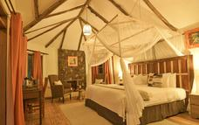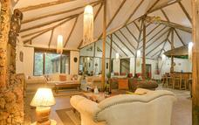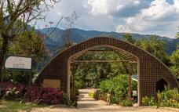

Basis
Full Board - Dinner, Bed, Breakfast and Lunch

Included
Transfer

Day 8: Gorilla Safari Lodge, Bwindi Impenetrable Forest National Park

Day Itinerary
After an early breakfast depart to the starting point for briefing about your gorilla trekking adventure after which you will be led by experienced gorilla trackers on the slopes of the volcanoes. You will start from the site where the gorillas were encountered the day before and from here the gorilla tracking begins. Although the hike can be physically demanding, the anticipation of the exciting experience ahead is amazing, and the beauty of the gorilla forest and its inhabitants are fascinating. One of Africa’s major highlights is when you encounter these gentle apes. It is a humbling experience to stand just meters from man’s distant cousins as they eat rest, play and bond with their young ones.
Follow the mountain gorillas as they range freely in the impenetrable forest, and discover their gorgeous natural habitual and the many species they share it with. You are allowed an hour with the gorillas before finally sloping down back to your lodge. If your trek was relatively short, you may have a guided nature walk around the lodge and the surrounding communities in the evening at a supplement of $35 per person. Return to the lodge where you will enjoy dinner with your fellow travellers before getting a good night’s rest for tomorrow's safari adventure.

You may opt for Gorilla Habituation on supplement of $700 per person – here you will be sure of meeting and spending enough time with the Gorillas.

Don’t forget to carry your rain gear, packed lunch, plenty of water, gloves, hat, and water proof bag for protection of your camera in case of rain
Accommodation: Gorilla Safari Lodge
Meal Plan: Full Board

Basis
Full Board - Dinner, Bed, Breakfast and Lunch

Included
Gorilla Trekking -1 Permit

Day 9: Mihingo Lodge, Lake Mburo National Park

Day Itinerary
After breakfast, at 08.00 hours you will travel to L. Mburo National Park, the smallest National Park of Uganda. Though being small, it has a lot offer!! Cantered on a series of swamp-fringed lakes its birdlife is very rich. The green acacia woodland harbours wildlife like Zebra, warthog, Eland, Impala, not to mention the lake itself, which is home to schools of hippos and crocodiles!
You will arrive at the lodge in time for lunch. Later in the afternoon at 16:00 enjoy the boat ride on Lake Mburo and get quite close to the croc and hippos. As you return to your Lodge, you may have an evening game drive as you return to your lodge.

Accommodation: Mihingo Lodge
Meal Plan: Full Board
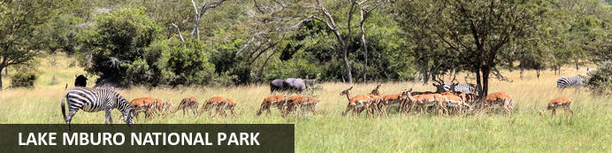
Situated in southwestern Uganda, Lake Mburo National Park is a compact and easily accessible gem, renowned for its striking biodiversity. Nearly seventy mammal species and more than 300 bird species thrive in its mix of forests, swamps and rolling grasslands. The landscape blends open savanna with rocky ridges, forested gorges and pockets of dense woodland, creating a rich habitat for wildlife. Crocodiles, hippos and abundant water birds gather around the park’s five lakes, with Lake Mburo the largest. Visitors frequently spot impala, oribi, eland, zebra, buffalo, Defassa waterbuck, reedbuck, hyena and occasionally leopard. It’s a rewarding destination for travellers seeking varied scenery and accessible wildlife viewing.

Overnight: Mihingo Lodge
Mihingo Lodge is a peaceful and exclusive retreat adjacent to Lake Mburo National Park and features twelve comfortable rooms which are built on wooden platforms. Each luxury tented room is nestled on a private piece of the lodge's property, enabling guests to enjoy the tranquil environment in complete seclusion. Placed in varied settings, some rooms are situated in a forest, some with a lake view, and some on rocky outcrops. The lodge offers a variety of amenities that include a cosy main dining area as well as an infinity swimming pool. Aside from lounging by the pool, enjoying the sounds of nature, or watching nearby wildlife, guests can also avail themselves of the numerous activities offered by Lake Mburo National Park and Mihingo Lodge that include boat trips on Lake Mburo, savannah walks, walking with giraffe, game drives in Lake Mburo National Park, and horseback safaris.
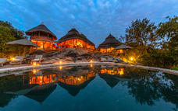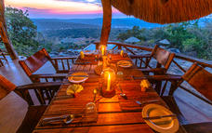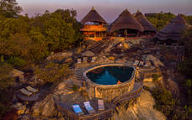

Basis
Full Board - Dinner, Bed, Breakfast and Lunch

Included
- Park entrance fees
- Boat Cruise
- Game Drive
- Transfer

Day 10: End of Itinerary

Day Itinerary
After breakfast have a safari walk under the escort of an armed ranger. The Kopjes are particularly interesting with the camouflage kilspringers and topis. Due to cattle herding in the area it is amusing to see zebra grazing alongside the long horned Ankole cattle peaceably. It is exciting to approach wildlife at such close range.

Alternatively, you may choose to go for mountain bike safari (on payment of a supplement of $45 per person for 2 hours) or horseback riding safari in the park (on payment of $115 person for 1 hour).
Later Leisurely drive back to Kampala with a stopover at the Equator where you will have an opportunity to stand in 2 hemispheres at the same time. Take some photos, then another stops over at the Mpigi Royal Drum Makers Time Allowing where you will be able to watch the ceremonial drums being crafted using methods passed down through the generations arriving in the afternoon and transferring to Entebbe Airport to catch your flight to your next destination. (flight should be in the late evening)

Included
•All ground transportation in A 4x4 i vehicle with all fuel
•Full time driver/ English speaking guide with all his associated expenses
•Accommodation based on per person sharing
•Meals are on Full Board apart from in Cities or Towns.
•Boat cruises
•Game drives
•1 Chimpanzee permit per person
•Rhino Tracking
•Bigodi Swamp Walk
•Top of the Falls Hike
•Drinking water in the vehicle
•1 Gorilla permit per person

Excluded
•International Air tickets
•Visas
•Personal insurance
•Personal expenses such as drinks, tips, telephone calls, etc
•Any other items which are not included in the above itinerary
•All optional activities

