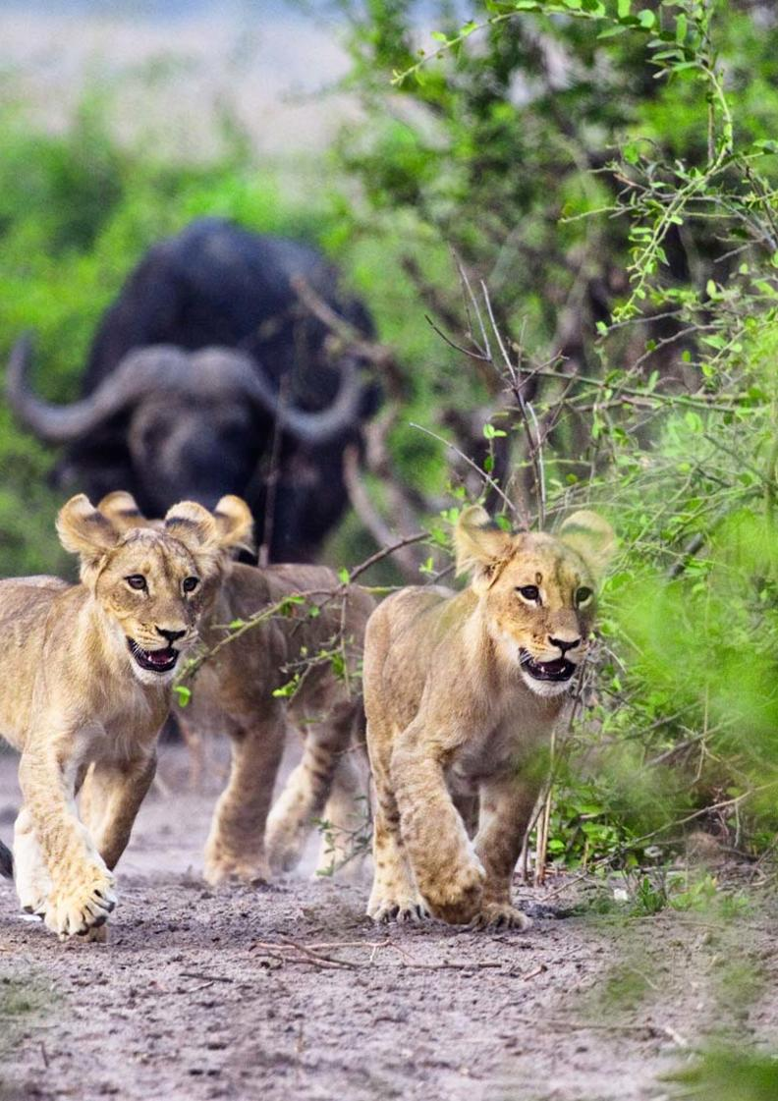


7-Day Three Rivers Safari - Luxury - RACK

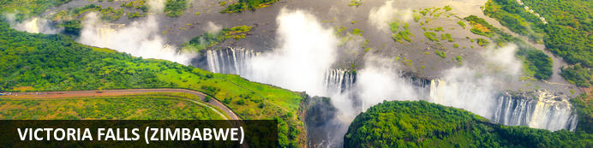
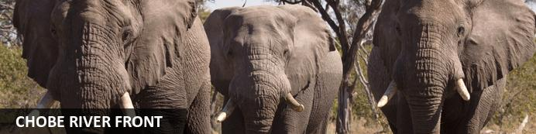
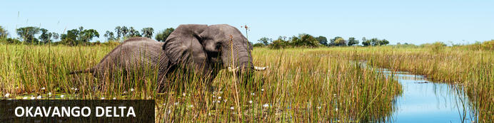

7-Day Three Rivers Safari - Luxury - RACK
Victoria Falls (Zimbabwe) - Chobe River Front - Okavango Delta
7 Days / 6 Nights
Reference: 2024
Date of Issue: 22 January 2024

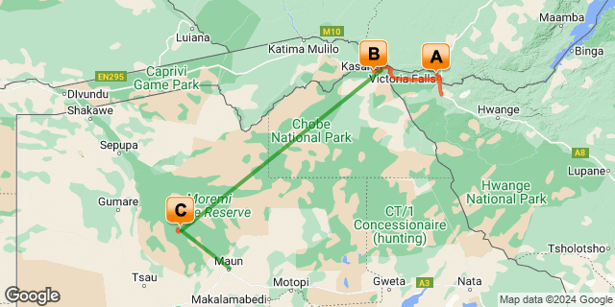

Click here to view your Digital Itinerary

Introduction
The seven-day Three Rivers Safari is an excellent way to visit Zimbabwe for Victoria Falls and cross the border into Botswana for the Chobe National Park before flying into the Okavango Delta. This tour starts in Victoria Falls and ends in Maun.
A chance to view one of the Seven Wonders of the World – Victoria Falls. Then make your way by road transfer into Botswana for a game viewing spectacle in Chobe National Park, where you are likely to see some of the largest concentrations of elephants from up close. Head back to Kasane and take an internal flight into the Okavango Delta. This is true African wilderness.
The Zambezi River, the Chobe River and the Okavango Delta. Cover all the highlights in just one week.

Accommodation | Destination | Basis | Duration
Old Drift Lodge | Victoria Falls (Zimbabwe) | FI | 2 Nights
Chobe Game Lodge | Chobe River Front | FI | 2 Nights
Kanana | Okavango Delta | FI | 2 Nights

Key
B&B: Bed and Breakfast
FI: Fully Inclusive - Bed, All Meals, Fees and Activities

Price
1st December 2023 – 20th December 2023
2 or more guests - USD 4390 per person sharing
Single supplement - None
21st December 2023 – 31st December 2023
2 or more guests - USD 4740 per person sharing
Single supplement - USD 720
11th January 2024 – 29th February 2024
2 or more guests - USD 4720 per person sharing
Single supplement - USD 455
1st - 31st March 2024
2 or more guests - USD 5455 per person sharing
Single supplement - USD 715
1st April - 31st May 2024
2 or more guests - USD 6360 per person sharing
Single supplement - USD 1545
1st - 30th June 2024
2 or more guests - USD 7815 per person sharing
Single supplement - USD 2585
1st July 2024 – 31st October 2024
2 or more guests - USD 7885 per person sharing
Single supplement - USD 2625
1st - 30th November 2024
2 or more guests - USD 5975 per person sharing
Single supplement - USD 715
1st December 2024 – 20th December 2024
2 or more guests - USD 5455 per person sharing
Single supplement - USD 715

** Rates are subject to change
Includes airport and inter-camp road and air transfers starting VFA, ending MUB on a seat basis

Included
- Accommodation as indicated – can change depending on availability and request at time of booking
- Meals as indicated
- Activities as indicated
- Shared road transfers as mentioned
- Seat on internal flights as indicated
- Tour file with detailed itinerary, map with route descriptions, vouchers etc.
- 24 hour personal and friendly support
- Fast and efficient response to service providers

Excluded
- Items of a personal nature
- Optional extra activities
- International flights
- Holiday or personal insurance
- Staff gratuities
- Park entry fees (for optional extra activities in Victoria Falls)
- Visas and visa applications

Day 1-3: Old Drift Lodge, Victoria Falls (Zimbabwe)

Victoria Falls (Zimbabwe)
A gazillion tonnes of water thundering over a sheer cliff drowns all other sounds. The swirling mist hides all sign of human activity. Beyond your rain forest sanctuary people are hurling themselves off bridges, across gorges, into walls of raging water and out of aircraft.
Victoria Falls is a paradox of tranquil beauty and exciting adventure.
Mosi-oa-Tunya, 'The Smoke that Thunders' is undoubtedly Zimbabwe's finest and most well-known attraction. It is or rather was (if you're keeping up with the latest list) one of the Seven World Wonders. We still believe it deserves the title. It truly is spectacular and not considered to be one of the world's largest waterfalls without good reason. It's not the widest or the highest, yet it is considered to the largest based on its combined width, at 1,708 metres wide and height, at 108 metres. Impressively it takes the title for the largest sheet of falling water.

Day Itinerary
- Airport transfer from Victoria Falls Airport on arrival to your lodge in town
- Airport Transfer Time: 40 minutes from Victoria Falls Airport
- 1 full day is set aside to enjoy any of the many activities on offer
Included Activities: morning and afternoon game drives and river safaris, bush walks, guided Tour of the Falls (excluding entry fee)

Overnight: Old Drift Lodge View iBrochure
On the banks of the Zambezi River, Old Drift Lodge is an upmarket and luxury safari lodge with spacious elegant tented suites spaced out beneath the bush. Frequented by elephants and other wildlife, here you’re immersed in nature and you’re only 7km from the majestic Victoria Falls.
Old Drift is easily one of the most luxurious options for accommodation on the Zimbabwean side of the falls and since you aren’t in town itself, you will feel as though you are on safari from the moment you arrive. You get here by boat transfer by the way. Great news: at Old Drift you are the closest lodge with the Zambezi National Park to Victoria Falls. You’re just a short way away and your activities are included in your stay.
You have the chance to see elephants, buffalo, sable, eland, giraffe, zebra, waterbuck and impala. Either around your tent, along the river or at the waterhole. It’s serene, beautiful and quiet.
Your tented suite is stylish and modern including all the necessities and the added extras which takes this safari lodge up a notch from the guesthouse or hotel you could have opted for in town. As if the wildlife wasn’t enough of a drawing card? You have an indoor and outdoor shower, an open-air bath with a view and your very own private plunge pool.
With only 10 double suites and 4 family suites it is a small safari lodge and the ideal getaway just down the drag from the bustling town of Victoria Falls. Listen to the river as you soak in your bath on the deck. Enjoy the tranquility and calmness. Revel in the night skies from your star bed. This is the pinnacle of relaxation.
The large wooden deck at the main lodge area is terrific for sundowners, further relaxation and stories around the campfire after a dining experience you won’t forget. Expect fine dining of traditional African flavours. Here the food reflects and celebrates a sense of place, and well, there really is no place like Old Drift.
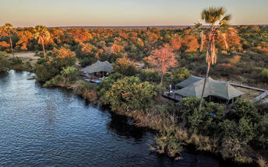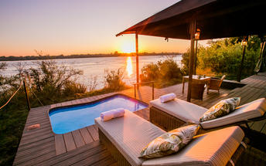

Basis
Fully Inclusive - Bed, All Meals, Fees and Activities
All Drinks (excl Premium Brands) Included

Included
- Meals, selected activities, local drinks, return Victoria Falls/Livingstone airport transfers, conservation levy park fees, town shuttle & laundry

Excluded
- Premium drinks, additional activities & rain forest entry fee

Day 3-5: Chobe Game Lodge, Chobe River Front

Chobe River Front
The Chobe River forms the northern boundary of the Chobe National Park which is renowned for its diverse and abundant game viewing opportunities. This section of the park is best known for its dense concentration of wildlife, including elephant and hippo populations, but the waters attract all manner of game including large herds of buffalo and the lions that prey on them - a visit to the Chobe River Front guarantees close encounters with an array of African wildlife. Visitors can look forward to a range of exciting activities such as 4WD along the banks; motorboat cruises; and rare birdlife spotting. For a unique, luxury safari experience, hire a houseboat.

Day Itinerary
- After breakfast, and a last morning activity (if time allows), you will be collected from the lodge and transferred across the border into Botswana. Your driver will assist with the border crossing which is an experience in itself
- Check in at the lodge and enjoy your activities as included
- A chance to see large herds of elephants from up close and plenty other wildlife from an open safari vehicle and the river
- This property is located within the Chobe National Park, providing the prime bush location for exploring the Chobe Riverfront. The location inside the park gives guests the advantage of a head start on vehicle traffic entering the Riverfront from Kasane for activities, and therefore a more exclusive Chobe safari
Activities: game drives and boating

Overnight: Chobe Game Lodge View iBrochure
Chobe Game Lodge is a rough-clad vaulted maze of courtyards, passages and verandahs that face the Chobe River and its great flood plain.
The 44 rooms have barrel-vaulted ceilings and high archways that frame a delightful view of the river. All rooms have air conditioning, ceiling fans, complimentary mini bars and private terraces with river views.
Dining is either a high table bonanza on the river-facing terrace or a sumptuous buffet on the lawn beneath an ancient mahogany tree. The food is a Westerner's introduction to local ingredients and the wine list features some of South Africa's regular offerings.
One of the only lodges inside the Chobe National Park, you are on your game drive or boat cruise long before anyone else. In fact, by the time anyone else has ventured where you've already been, you are back at the lodge relaxing and enjoying a spa treatment.
As if you need any further selling on this superb safari lodge, most of the game drive vehicles and all of the boats are electric, which, apart from the obvious environmental benefit, means minimal noise so your sightings are a true bush experience. Something else for the win, the staff and all guides are female, which makes for a different experience compared to most safari lodges.
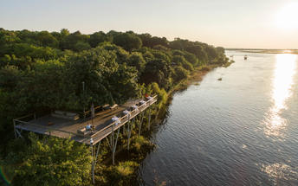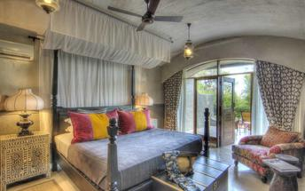

Basis
Fully Inclusive - Bed, All Meals, Fees and Activities
All Drinks (excl Premium Brands) Included

Included
- Meals, local drinks, activities, park fees, laundry & intermittent WIFI

Excluded
- Premium drinks

Day 5-7: Kanana, Okavango Delta

Okavango Delta
Crammed with every conceivable species of bird and beast, the delta is an Eden of excess. Amazing game viewing and birding in a scenic and tranquil African wilderness. If you’re looking for a true African safari. Look no further.
The quintessential delta experience: game drives in open safari vehicles and gliding in silence through the waterways on an African-style gondola carved from a single tree.
Access into the Okavango Delta is difficult, getting around is difficult, carting supplies in and waste out is difficult. These are all good things for this vast wildlife wilderness is utterly picturesque and devoid of human influence.
If constant close-ups of elephant, buffalo, lion, giraffe, hyena, jackal and plenty of large and small antelope start to grow old, there's always the chance encounter with cheetah, leopard, wild dog, and red lechwe to spice things up.

Day Itinerary
- After a morning activity (depending on your transfer and onward flight time) you will be transferred to Kasane Airport where you then meet with your pilot for your light aircraft transfer to the Okavango Delta
- Airport Transfer Time: 30 minutes to Kasane Airport
- Airstrip Transfer Time: 30 minutes from Kanana Airstrip to the lodge
- Enjoy the scheduled activities with your lodge guide as included
- The Kanana area encompasses a necklace of islands on the Xudum River, northeast of Pom Pom lagoon and is incredibly picturesque with winding waterways meandering through open lagoons
Activities: game drives (maximum 4 guests per vehicle), mokoro, boat cruises (water level dependent) and walking

Overnight: Kanana View iBrochure
Kanana Camp is a water and land-based safari lodge in the Okavango Delta. A private concession on the Xudum River, where game viewing delivers year round and guarantees a true Delta experience.
On the edge of a lagoon fed by the constant channels of the Okavango Delta, Kanana Camp has a sensational position with permanent water and island floodplains all around.
A classic, explorer safari style throughout with rustic hints, all tied together with utmost elegance and pure luxury. The rooms are tented chalets on decks with gauze front and sides through which you can see the delta from your cozy bed. A small shaded balcony with modern Morris chairs gives you a chance to relax and watch the delta paradise do its thing. The en suite bathroom has hot running water and flushing toilets; rooms have standard fans, mini safes and a welcome basket on arrival.
The living area, also raised on stilts, surrounds a massive fig tree filled with birds. Wooden decks clad in comfortable chairs enjoy the generous shade of the riparian forest and command timeless views across the delta and the elephant- and hippo-friendly lagoon just below you.
Game viewing activities are on water with excellent poler/guides taking you in motorboat or mekoro along the channels to bird-infested groves, islands and papyrus lined lagoons. And on land exploring the concession by game drives. The birdlife, wilderness and unhurried semi-aquatic wildlife are an altogether different tableau to the big game safaris in nearby Chobe and Namibia's Etosha National Park.
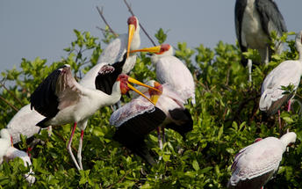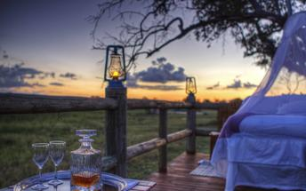

Basis
Fully Inclusive - Bed, All Meals, Fees and Activities
All Drinks (excl Premium Brands) Included

Included
- Meals, local drinks, activities, park fees and laundry

Excluded
- Premium drinks

Day 7: End of Itinerary

Day Itinerary
- After a morning activity (if time allows) you will be transferred back to the airstrip and then board for your light aircraft transfer to Maun Airport where your tour ends
- Airstrip Transfer Time: 30 minutes from the lodge to Kanana Airstrip
- End of services

Basis
Bed and Breakfast

Transport

Flight Information
Date | Flight | Airline | Departure Airport | Time | Arrival Airport | Time | Class | Ref
 | Charter Flight |  | Kasane Airport [BBK] |  | Kanana Airstrip
 | Charter Flight |  | Kanana Airstrip |  | Maun International Airport [MUB]

Transfers
Date | Company | Pick Up | Drop Off | Time | Vehicle
 |  | Victoria Falls International Airport [VFA] | Old Drift Lodge |  | Transfer
 |  | Old Drift Lodge | Chobe Game Lodge |  | Transfer
 |  | Chobe Game Lodge | Kasane Airport [BBK] |  | Transfer
 |  | Kanana Airstrip | Kanana |  | Transfer
 |  | Kanana | Kanana Airstrip |  | Transfer

Terms and Conditions

Namibia Tours & Safaris Terms and Conditions
Contract
1.1 The contract will become effective as from the date the invoice is completed and the deposit, referred to in Clause 2.1, is received by Africa Tours & Safaris CC (hereinafter known as the Company).
1.2 The contract is subject to the Namibian Law.
1.3 Any person making a reservation as per Clause 8.4 accepts the terms and conditions of this agreement set out hereunder.
How to Book
2.1 A 20% deposit of the full amount due is required to confirm any reservation and is to be done by the agent or client (see Clause 8.1) in writing or by e-mail.
2.2 The Company must receive the balance of the contract price no later than 42 days (6 weeks) prior to departure.
2.3 If the Company does not receive the full contract price 42 days (6 weeks) before the departure date, the Company may cancel the reservation and retain whatever deposit or other funds it has already received from the client or his agent.
How to Pay
3 The payment options will be provided upon confirmation of a booking.
Our Cancellation Policy
4.1 Any cancellation of a confirmed booking must be done in writing (email) to the Company whereupon cancellation charges as per Clause 4.2 will apply.
4.2 The following cancellation fees (as a percentage of the fully quoted price) are applicable to any cancelled travel:
Notice from date of travel: Cancellation fee:
42 days or more 20% (deposit forfeited)
29 – 41 days 50%
15 – 28 days 75%
0 – 14 days 100%
Please note: the notice period is calculated from the date of cancellation to the start date of the tour/safari booking.
4.3 No refund will be made by the Company if, for any reason, inclusions or parts of the tour cannot be carried out / or utilised. These would include all facets such as meals, game drives, accommodation etc. This would also apply to any client who has booked a tour but fails to undertake the tour for any reason.
Our Changes Policy
5 If a booking is changed to an earlier date than originally reserved, the Company will endeavour to change it. If the booking is for a later date, charges as per Clause 4.2 could apply.
As things go, we've all had to adapt to changes during the Coronavirus pandemic and so too have we therefore amended our terms and conditions for travel during such times. Check out the Updated COVID Terms and Conditions here.
Price Changes
6.1 The Company reserves the right to increase the price of any tour prior to departure due to factors beyond the control of the Company, such as, without being limited to, and increase in fuel prices, new Government legislation, accommodation price increases, fluctuations in exchange rates, etc.
6.2 If the Company announces an in increase in the tour price in terms of this Clause, such addition amount must be paid to the Company before the departure of such tour or else the Company shall have the right to cancel the tour and the charges in Clause 4.2 will apply.
Changes to Itineraries
7 The Company shall at any time have the right, in its entire discretion, to alter the terms of the booking in relation to the route, timetable, itinerary and accommodation. The Company shall, however, make every effort to offer the client an alternative tour of a comparable standard.
Should the alternative be of a lesser standard, the client will be refunded the difference, but should there be an increase, the client shall have the right to either reject the alternative and obtain a refund of the relevant portion of the original contract sum, or to accept the alternative and pay the increased cost. In the event of the client rejecting the alternative tour and claiming a refund, such rejection will be treated as a cancellation and the refund will be calculated according to Clause 4.2 hereof. The client shall have no claim against the Company for any damages arising out of the alternative booking.
Responsibility and Liability
8.1 Neither the Company nor any person acting for through and on behalf of the Company shall be liable for any loss or damage whatsoever arising from any cause whatsoever and without restricting the generality of the aforegoing shall particularly not be responsible for the loss or damage arising from any errors or omissions contained in its brochure or other literature, late or non-confirmation or acceptance or bookings, loss or damage caused by delays, sickness, injury or death, whether occasioned by negligence or not.
8.2 The Company shall have the right at any time at is sole discretion, to cancel or the remainder thereof or to make an alteration in the route, accommodation price or other details. This would include any event of any tour being rendered impossible, illegal or inadvisable by weather, avalanches, strike, war, government or other interference or due to any other cause whatsoever. The extra expenses incurred as a result thereof shall be the responsibility of the client.
8.3 The Company may at its discretion and without liability or cost to itself at any time cancel, or terminate, a client's booking and in particular, without limiting the generality of the aforegoing, it shall be entitled to do so in the event of illness or the illegal or incompatible behaviour of any client undertaking the tour, who shall in such circumstances not be entitled to any refund.
8.4 Any person making a reservation with the Company (refer to Clause 1.1) warrants that her or she has the necessary authority to enter into this contract on behalf of the person or persons included in such a booking. The person making the reservation shall be liable for the total amount due to the Company.

Client's Obligations
9.1 It is the onus and responsibility of the client to obtain the necessary comprehensive insurance before departure for any possible cancellations, medical expenses, protection or personal property and money.
9.2 The onus is upon the client to ensure that passports and visas are valid for the duration of the safari. The Company cannot be held liable for any necessary visas or other travel documents not held by clients. In the event of a client not having the necessary documentation to enter any area or country the Company shall reserve the right to leave the client a the point of entry of such area or country. In such an event, the Company will not be held responsible to the client for further travel arrangements.
9.3 The onus is upon the client to ensure that the SARS-CoV-2 PCR tests are done prior to commencement of the safari and valid on arrival in accordance to the requirements of the country of intended travel and for the airline with which the client will travel. The same applies for any necessary testing for departure. The costs of any such COVID testing will be for the clients own account. While The Company can assist with arrangements for testing in-country, The Company will not be held responsible to the client for such arrangements and with regards to return time of test results.
9.4 Should the client need to undergo mandatory quarantine once in-country with regards to the SARS-CoV-2 virus, either on arrival as called for by the authorities or due to testing positive once in-country, this will be at the clients own expense.
Health and Personal Safety
10.1 The client shall be reasonably fit to undertake the tour.
10.2 Anti-malaria precautions should be commenced prior to tour departure. A medical doctor should be consulted for advice.
10.3 Tours offered by the Company cover a wide spectrum of the African wilds and neither the Company, its employees or agents can be held responsible for any injury or other related incidents whilst on the tour / safari.
10.4 The Company cannot be held responsible for any client who falls ill or contracts the SARS-CoV-2 virus while in-country. The client accepts that travel is at own risk.
Baggage
11.1 Clients are limited to one soft sports type bag per person with a maximum weight of 20 kilograms. This includes photographic equipment and hand luggage.
11.2 Due to the rugged terrain, the Company cannot be held responsible for damage or loss of any personal items including bags, contents of bags or photographic and related equipment. Due to extremely dusty conditions, please ensure all bags are dust proof.
Airline and Car Hire Clause
12.1 The Company will act as the agent of the client when booking the client with a car hire company, an airline or air charter service. The client therefore contracts with the car hire company, airline or charter service and not with the Company.
12.2 Charter flights are normally operated by smaller type aircraft such as Cessna 210. Luggage is strictly limited to 10-15 kgs (depending on terms of particular airline used) per person in soft hold all type bags. Due to the desert heat, it is not safe to overload aircraft thus this limit needs to be strictly controlled.
Travelling or thinking of travelling during the COVID-19 pandemic? Take a look at our COVID Terms and Conditions for more information on how this will work and differ from our standard terms and conditions as listed above.

