

Classic Truly Tanzania Adventure Safari
Arusha - Lake Manyara National Park - Serengeti National Park - Ngorongoro Crater - Tarangire National Park
9 Days / 8 Nights

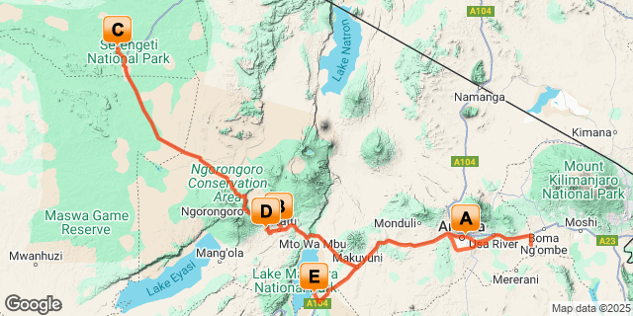

Introduction

Start | Accommodation | Destination | Basis | Duration
Day 1 | The African Tulip | Arusha | B&B | 1 Night
Day 2 | Tloma Lodge | Lake Manyara National Park | FB | 1 Night
Day 3 | Kubu Kubu Tented Lodge | Serengeti National Park | FB | 3 Nights
Day 6 | Ngorongoro Farm House | Ngorongoro Crater | FB | 1 Night
Day 7 | Maramboi Tented Lodge | Tarangire National Park | FB | 2 Nights

Key
B&B: Bed and Breakfast
FB: Full Board - Dinner, Bed, Breakfast and Lunch

Included
● Accommodation as stipulated in the itinerary.
● Transportation in a chauffeur driven 4x4.
● Services of a professional English speaking driver-guide
● All game viewing drives.
● Lunch at Arusha Coffee lodge on day 09.
● Visit to Olduvai Gorge.
● All parks entrance fees as indicated in the itinerary.
● All Government taxes and levies.
● Complimentary 500 ml mineral water per person per game drive in a safari vehicle.
● All meet and greet services.
● All arrival and departure transfers.
● 24 hours stand-by contact number.
● Meals as indicated in the itinerary.
● Two-way long range high frequency radio communication in each vehicle.
● On safari accessories in each vehicle: - First-aid kit, wildlife books, a pair of binoculars, cool box and fire extinguisher

Excluded
- All items of personal nature e.g. telephone call bills, fax/email bills etc.
- Tipping
- Alcoholic and non-alcoholic drinks,
- International flight and departure taxes.
- Laundry services.
- Any other item(s) not included in our itinerary.
- Visa fees

Day 1
The African Tulip, Arusha

Day Itinerary
Jambo! Upon arrival at the Kilimanjaro International Airport, you will be met and transferred to the hotel for overnight stay
African Tulip Hotel
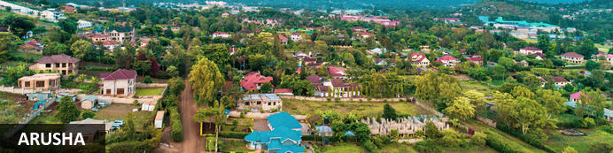
Resting at the foot of Mount Meru, the sprawling city of Arusha is known as the safari capital of northern Tanzania. It serves as an excellent base from which to explore the remarkably scenic surrounding area which includes majestic Mount Kilimanjaro, as well as the Manyara, Tarangire and Ngorongoro National Parks. Arusha is a good spot to take a day or two off from the safari circuit as it features a temperate climate and lush surrounds. Visitors can look forward to exploring the wildlife-abundant Serengeti National Park; the magnificent Arusha National Park; and taking on the challenge of climbing Mount Meru, Africa’s fifth highest mountain.

Overnight: The African Tulip
The African Tulip is an elegant and charming Luxury Boutique Hotel in the heart of Arusha. A warm and friendly welcome awaits guests who want to experience the best of Tanzanian hospitality. The hotel has been designed with safari travellers, business persons, families, honeymooners, elite and leisure travellers in mind. It has amenities of convenience whilst offering a high standard of luxury.
The hotel has 29 guest rooms, 7 of which are suites. The rooms are individually and stylishly decorated using warm African tones. A lot of African material and local art has been used reflecting the common thread that runs throughout the hotel which is one of consistence and quality.
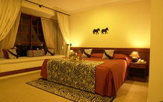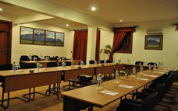

Basis
Bed and Breakfast

Day 2
Tloma Lodge, Lake Manyara National Park

Day Itinerary
After breakfast, depart to the beautiful Lake Manyara, a shallow alkaline lake that shimmers in a cleft in the Great Rift Valley. You will arrive for lunch at your lodge followed by afternoon game drive.
Tucked below the majesty of the Rift Valley wall, Lake Manyara National Park consists of a thin green band of forest, flanked by the sheer 600 m high red and brown cliffs of the escarpment on one side and by the white-hot shores of an ancient soda lake on the other. Acacia woodland shelters the park’s famous tree climbing lions, lying languidly among the branches in the heat of the day. Lake Manyarasafaris offers many unique views including elephant, giraffe, buffalo and wildebeest can be found grazing in unexpected clearings or heading towards the water to drink or wash, and the rivers and riverbeds
provide scenic vistas for possible animal spotting.
Dinner and Overnight stay at the lodge.
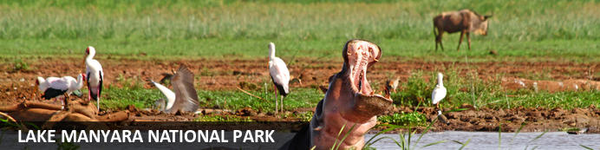
Situated in Tanzania’s central-northern region with the Lake Manyara to its east and the Manyara Escarpment to its west, the Lake Manyara National Park offers breathtaking views and a large variety of habitats supporting an array of wildlife. This small park is home to surprising biodiversity and features a magnificent landscape of acacia woodlands, forests, baobab strewn cliffs, algae-streaked hot springs, swamps and the lake itself. The park supports over 400 species of bird and the largest concentration of baboons anywhere in the world. Other species to spot include giraffes, zebras, wildebeest, impala, waterbuck, warthog, the Cape clawless otter, and the Egyptian mongoose. Don’t miss the opportunity to see thousands of flamingos on the lake, the renowned tree-climbing lions, and large families of elephants strolling through the forest.

Overnight: Tloma Lodge
Tloma Lodge is a small, exclusive lodge situated on top of a valley overlooking a coffee plantation, the Eastern wall of the Ngorongoro crater and a beautiful waterfall. It consists of 36 spacious suites in cottages built in the style of an old colonial farm offering guests a relaxing, quiet atmosphere surrounded by beautiful gardens.
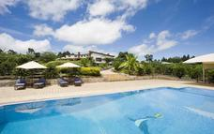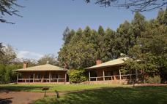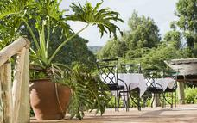

Basis
Full Board - Dinner, Bed, Breakfast and Lunch

Day 3-6
Kubu Kubu Tented Lodge, Serengeti National Park

Day Itinerary
Drive to Serengeti National Park. You will have 3 days of game drives in this Park. Serengeti National Park is a World Heritage Site teeming with wildlife: over 2 million ungulates, 4000 lions, 1000 leopard, 550 cheetahs and some 500 bird species inhabit an area close to 15,000 square kilometres in size. Join us on a safari and explore the endless Serengeti plains dotted with trees and kopjes from which majestic lions control their kingdom; gaze upon the Great Migration in awe or find an elusive leopard in a riverine forest. Or perhaps see everything from a bird’s-eye view and soar over the plains at sunrise during a hot air balloon safari at an extra expense
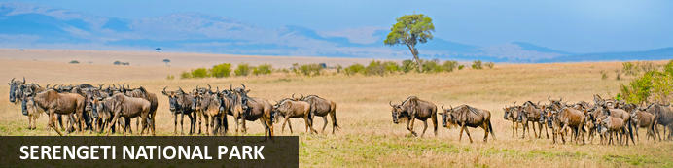
The Serengeti, together with Kenya’s Masai Mara Game Park, constitute Africa's most famous wildlife park, spread over the enthralling landscapes of northern Tanzania. This is a precious ecosystem, supporting the annual wildebeest migration through the Serengeti and the Masai Mara. The largest mass movement of land mammals on the planet involves more than a million animals following the rains, including more than 1.5 million white-bearded wildebeest and 250 000 zebras. Prides of lions, as well as groups of elephants, giraffes, gazelles, and eland, roam among the photogenic vast grass plains between weird-and-wonderful-looking acacia trees. Aside from traditional vehicle safaris, hot-air ballooning over the Serengeti plains and horse riding safaris are on offer.

Optional
Sundowner
Massages Cabin
Gym

Sundowner
In a nearby hill to the camp. Wak up for 5 minutes escorted by a Masai Warrior and enjoy a beautiful sundowner.
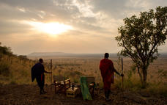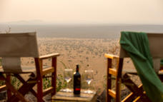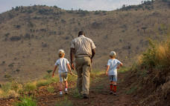

Massages Cabin
Selection of Massages and treatments are available.
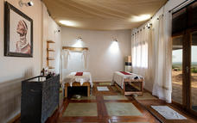

Gym
The gym is available at Kubu Kubu

Overnight: Kubu Kubu Tented Lodge
Kubu Kubu Tented Camp, is an exciting new addition to Tanganyika Wilderness Camps’ collection of luxury safari accommodation. With a modern African appearance, creating a fresh, sleek, yet comfortable ambiance. Situated in the stunning central part of the Serengeti, the camp will be strategically positioned in one of the main migration areas so that guests can enjoy this awesome natural wonder from the comfort of their tents.

There will be 25 spacious en-suite tents which will offer absolute comfort, exclusivity and a genuine African bush experience. In the central restaurant guests will be able to enjoy exceptional food and wines, and the cozy lounge area has been creatively designed to give an atmosphere of intimacy and exclusivity. There will also be a swimming pool in which to relax after a long game drive. Internet access will be available in the camp with Wifi in the central area. Accommodation will be on a full board basis.
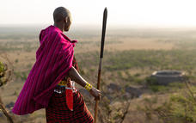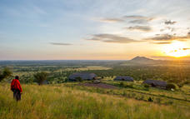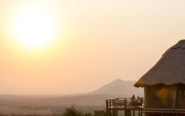

Basis
Full Board - Dinner, Bed, Breakfast and Lunch

Day 6
Ngorongoro Farm House, Ngorongoro Crater

Day Itinerary
After breakfast, depart to the famous Ngorongoro Crater Conservation Area. Descend into the ‘8th Wonder of the World’, a unique biosphere that has remained virtually unchanged since the dawn of time. Enclosed within its towering walls are grasslands, swamps, forests, saltpans, a fresh water lake and a glorious variety of birdlife. Here too are all the members of the ‘Big Five’ (lion, elephant, rhino, leopard and buffalo) as well as a large cast of plains game and one of Africa’s densest populations of predators.
Enjoy a picnic lunch on the crater floor before continuing with your expedition inside this land that time forgot. Climb up and drive back to your lodge for dinner and overnight.
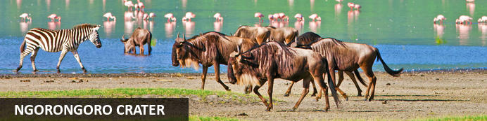
Located in Northern Tanzania, the Ngorongoro Crater is best known for its natural beauty and abundance of diverse wildlife; which makes it one of Africa’s most popular safari destinations. Surrounded by Tanzania’s highlands, this UNESCO-listed crater is said to be the world’s largest intact volcanic caldera. Visitors can look forward to spotting the world-renowned Big Five and a host of other wildlife species including large herds of zebra and wildebeest. It is famed as one of Tanzania’s best tourist attractions offering visitors an array of wonderful activities including excellent bird watching, trekking, wildlife viewing, mountain biking and visiting a local Maasai village. Don’t miss the opportunity to jump on an excursion to the magnificent Olduvai Gorge.

Overnight: Ngorongoro Farm House
Ngorongoro Farmhouse Lodge is situated beneath the majestic Oldeani Volcano, and boasts easy access to both the untamed wilderness of Ngorongoro Conservation Area, as well as the simple pleasure of a ramble through 500 acres of farmland.
Ngorongoro Farm House was inaugurated on February 20th 2003, and is offering 52 room cottages, 49 standard rooms and 3 suite rooms, all with ample space inside, built on the style of an old colonial farm and rustically decorated with local materials and full of details of good taste, with the purpose of offering our clients an imaginary journey to the life of the days gone.
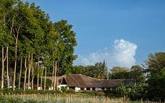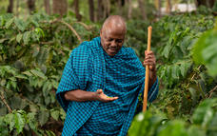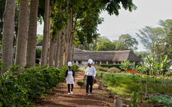

Basis
Full Board - Dinner, Bed, Breakfast and Lunch

Day 7
Maramboi Tented Lodge, Tarangire National Park

Day Itinerary
After breakfast this morning, meet your naturalist guide and depart for Tarangire National Park. Arrive for lunch at your camp followed by afternoon game viewing drive. The Tarangire River runs through the center of the park and provides a year-round supply of water to the animals. Bird watching is exceptional in the park's diverse habitats, from palm groves to acacia woodlands, and you may spot a bateleur or martial eagle during your stay.
Dinner and Overnight stay at the Camp
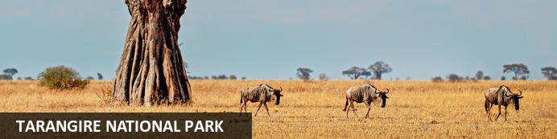
Tarangire National Park, situated within Tanzania’s spectacular Manyara Region, is an awe-inspiring national park comprising of granite ridges, river valleys, mixed vegetative landscapes, and free-roaming wildlife. During the annual dry season, the Tarangire River is a magnet for thirsty wildlife. Large herds of elephants and migratory wildebeest, zebra, buffalo, impala, gazelle, hartebeest and eland gather and not surprisingly the predators follow. With lion being among the most commonly spotted animal, it is a rare day that a visitor does not spot this majestic animal prowling or grazing. Tarangire is also the one place in Tanzania where dry-country antelope such as oryx and gerenuk are seen regularly. This expansive area is also known for its spectacular baobab trees, its breathtaking views of the Masaai Steppe and the wondrous mountains to the south.

Overnight: Maramboi Tented Lodge
This is a unique opportunity to experience and explore the Tarangire and Manyara ecosystem.
Maramboi Tented Camp offers permanent camp facilities and endless vistas of rolling golden grasslands and palm lined desert between Tarangire and Manyara Lake. A visit to the area is essential for anyone interested in evolution and the origins of Mankind and an explanation of the Rift Valley and Africa’s big picture. It is a complete semi desert experience focusing on safari walks and game drives.
Maramboi boots 30 spacious superior suites and, among them there are 5 family units consisting in 2 rooms interconnected, ideal for families with children.
They all have en suite facilities and private veranda with 24 hours 220V electric lighting and WIFI.
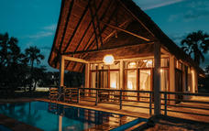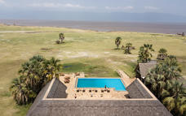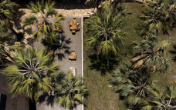

Basis
Full Board - Dinner, Bed, Breakfast and Lunch

Day 8
Maramboi Tented Lodge, Tarangire National Park

Day Itinerary
Full day game drive with packed lunch.
Dinner and Overnight stay at the Camp

Basis
Full Board - Dinner, Bed, Breakfast and Lunch

Day 9
End of Itinerary

Day Itinerary
After breakfast drive towards Arusha for lunch, after lunch you are transferred to the Kilimanjaro airport for your departure flight back home.

