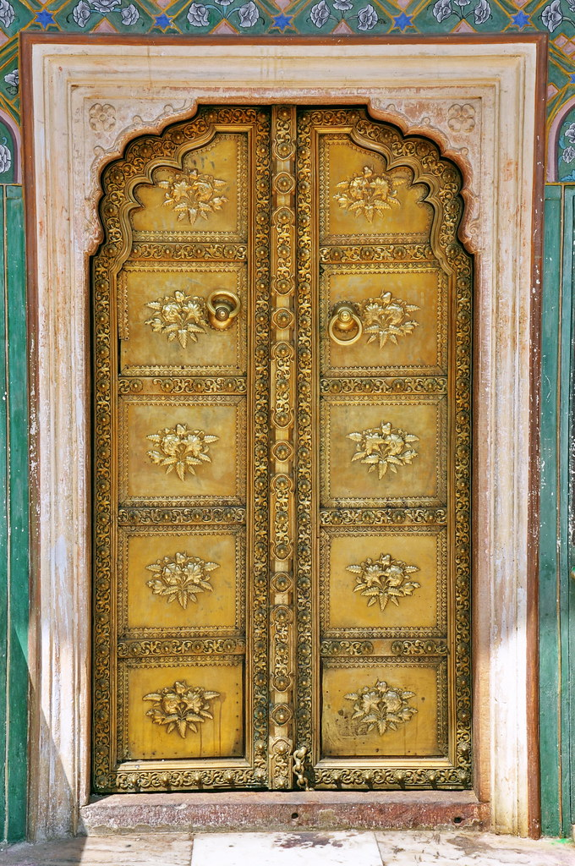

Cost Proposal
For
04 Nights / 05 Days

COST PROPOSAL
Accommodation Details on Bed & Breakfast Basis
Dates | Nights | City | 5 Star Luxury | 5 Star Standard
17 Nov – 20 Nov’24 | 03 | Delhi | The Imperial  (Heritage Room) | The Claridges  (Heritage Balcony Room)
20 Nov – 21 Nov’24 | 01 | Agra | The Oberoi Amarvilas  (Premier with balcony) | ITC Mughal  (Royal Mughal Room)

Particulars | 5 Star Luxury Cost | 5 Star Standard Cost
01 Pax traveling alone | USD 4947 Per Single | USD 3097 Per Single
02 Pax traveling together using a Double/Twin Room | USD 2687 Per Person | USD 1757 Per Person

Price Includes: -
- 04 Nights’ accommodation at the hotels mentioned above or similar
- Daily buffet breakfast at the hotels mentioned above or similar
- VIP assistance on arrival at Delhi airport
- Assistance on arrival and departures at the airport
- Chauffer driven Air-conditioned Innova Crysta as per the itinerary.
- Specially customized Five Senses tour of Delhi with a local expert
- Specially customized New Delhi tour with a local expert with NGO and local market visit
- Wi-fi available in the vehicle throughout the itinerary
- 2 Water bottles per person per day and other amenities available in the vehicle throughout.
- Services of local English-speaking guide during the sightseeing as per the itinerary at Agra
- Single entry to the specified monuments as per the itinerary at Delhi and Agra
- All applicable taxes on hotel & transport
- Govt. service tax

Price Excludes: -
- Expenses of personal nature like tipping, laundry, telephone / telephone calls, alcoholic & non- alcoholic beverages, camera / video camera fee at all monuments, medical expenses, etc.;
- Meals other than those specified above;
- Any Visa;
- Any insurance;
- Any other services not mentioned in the inclusions;

Special Notes: -
- The clients require a visa to visit India.
- In case on any currency fluctuations or amendment in local Government taxes, or any fuel hike, we reserve the right to adjust the tour price accordingly.
- Hotel check-in check-out time is 1400 Hrs. and 1200 Hrs. respectively.
- All the hotels and room categories are yet to be booked. Any change in hotel or room category may attract a supplement or reduction in the tour cost.
- Rate quoted above includes only those items as specified in the above inclusion column.
- Quote is valid only for the above-mentioned period.

Cancellation Clause for the Tour: -
CANCELLATION CLAUSE FOR LAND ARRANGEMENTS & HOTEL BOOKINGS:
90 days prior to the arrival | 25% of the total tour cost
89 days to 60 days prior to the arrival | 45% of the total tour cost
59 days to 45 days prior to the arrival | 65% of the total tour cost
44 – 30 days prior to the arrival | 75% of the total tour cost
29 days or less | 100% of the total tour cost
Airfare once issued | USD 60 Per Person Per Sector

Payment Policy-
- At the time of booking confirmation: 25% of the total tour cost plus the airfare
- 90 days prior to the arrival: Balance 75% of the payment

