Visit our official website: www.spain.info https://www.spain.info/en/brochures/
Madrid - https://www.spain.info/en/destination/madrid/
Capital of food, fashion and nightlife. Anyone in search of culture will find some of the most important museums in the world, such as the Prado, Reina Sofía or Thyssen. But we must not forget smaller options, full of charm, such as the Sorolla Museum or cultural centres like the Matadero or Conde Duque, which are continuously offering innovative exhibitions, concerts, guided tours, etc.Walking around Madrid means coming across iconic spots such as the stunning Royal Palace, the Plaza Mayor with 400 years of history, the buzzing Puerta del Sol, the famous Gran Vía full of shops, or the four tallest towers in Spain. Each neighbourhood offers a different experience: La Latina is ideal for tapas, Las Letras has the perfect combination of literature and fine dining… But Madrid also means relaxing in enormous green spaces such as the Retiro Park (which together with the Paseo del Prado boulevard have been added to UNESCO's World Heritage List), and other lesser-known but equally charming parks like El Capricho.

Why the Royal Collections Gallery is the Trendiest Museum in Spain
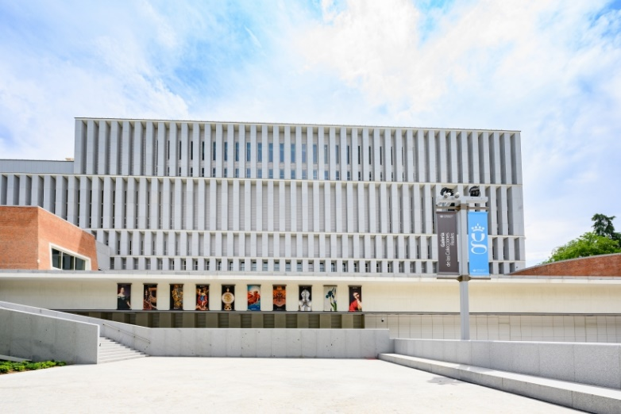
The Royal Collections Gallery is a new museum in Spain belonging to Patrimonio Nacional, a public institution that preserves and cares for the cultural assets and spaces bequeathed to the nation by Spain’s Crown over the course of centuries. The museum opened this summer and its location in the heart of Madrid, near to the Royal Palace, makes it a must-see on your clients’ next trip to Spain.
The museum’s permanent exhibition contains a selection of more than 650 pieces out of the 170,000 that make up the Royal Collections, including paintings, sculptures, tapestries, furniture, books, porcelain and photographs. Artists include such well-known names as Caravaggio, Velázquez, Goya and Mengs. All the other Royal Sites managed by Patrimonio Nacional are represented here, meaning that the museum provides a window onto the heritage preserved by the institution.
How to Visit the Museum
Visitors to the museum follow a chronological order through the galleries. They start with the collections gathered by the Habsburg dynasty. Here is also where they can view the oldest section of the Arab city walls of Madrid. The next floor is dedicated to the collections of the Bourbons. The final floor houses the temporary exhibitions galleries and “The Cube,” an immersive space within to explore the Royal Sites of Patrimonio Nacional through a 360-degree visual experience.
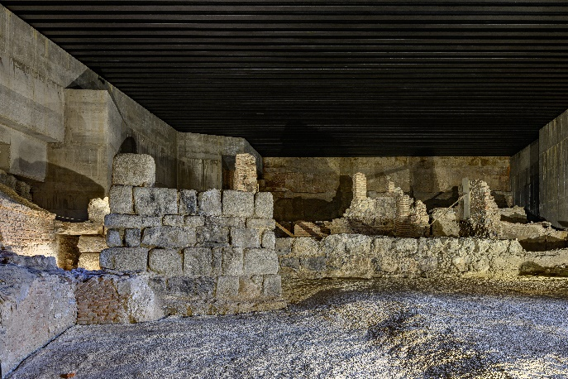
© Madrid, Patrimonio Nacional
Exhibitions include introductory panels, exhibit labels, screens displaying digital images and audiovisual contents. All of these are available in English and there is an audio guide available in 16 different languages. The Royal Collections Gallery has two entrances for visitors—one on the ground floor from the Mirador de la Cornisa of Madrid’s Royal Palace, and the other through Campo del Moro’s gardens.
The museum’s building itself has received more than 10 awards, including the FAD Architecture Award and the American Architecture Prize. Luis Moreno Mansilla and Emilio Tuñón were the architects who designed the building and they addressed the main challenge of the project, which was to finish the most monumental cornice in Madrid.
Discover the Masterpieces of the Museum
When you book your clients on a trip to Madrid, here’s what you can recommend they see at the Royal Collections Gallery.
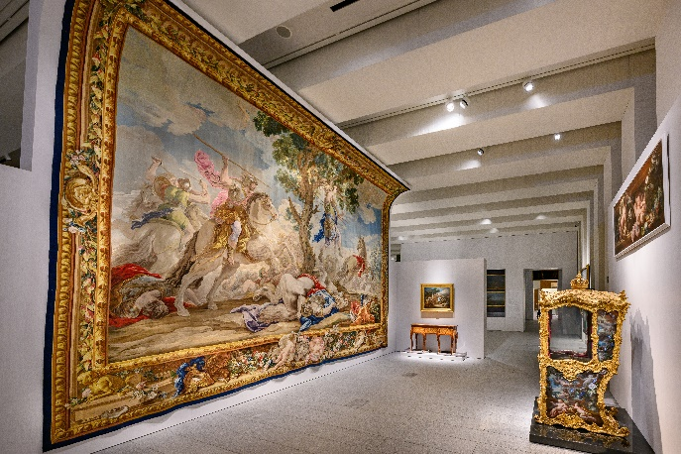
© Madrid, Patrimonio Nacional
Saint Michael Defeating the Devil (Luisa Roldán, 1692): With this work, Luisa Roldán became the first Spanish woman to obtain the title of Court Sculptor from Charles II. This image is the work that best embodies her masterful treatment of anatomy and skill in balancing sculptural bodies.
Salomé With the Head of John the Baptist (Caravaggio, ca. 1607): In this masterpiece the artist successfully generates a scene of extraordinary inventiveness, which juxtaposes beauty and brutality, focusing on the contrast between Salome’s cold indifference and the old lady next to her.
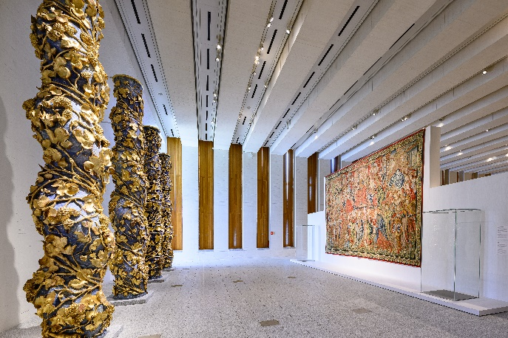
© Madrid, Patrimonio Nacional
Solomonic Columns (Herrera “el Mozo” & Churriguera, 1674-1678): This ensemble belonged to the main altarpiece of the former church of the Hospital Virgen de Montserrat in Madrid. Each of the columns is assembled from eight pine trunks from the forests of Valsaín. The twisted shafts are decorated with vine leaves and bunches of grapes.
The White Horse (Velázquez, 1634-1638): The finish of this work suggests that it was meant to include a rider on the saddle, although it may have been a completed work as it is that would serve as a model for other equestrian portraits. It demonstrates Sevillian artist’s great ability to achieve a natural portrayal with great economy of technical means.
The Triumph of Time (1502-1504): This is an exceptional tapestry from the early 16th century due to the vibrancy of the colors, the number of threads per-square-inch and the quality of the silk, wool and dyes used to create it. It is part of the series “The Triumphs of Petrarch,” which is also on view at the Metropolitan Museum of Art in New York.

© Madrid, Patrimonio Nacional
In Motion: Carriages and Other Vehicles at the Museum
The Royal Collections Gallery has a dedicated space for temporary exhibitions, and currently displays a very unique collection of Patrimonio Nacional—the royal carriages. In Motion (through June 2024) offers visitors a chance to explore the history of the vehicles in Spain from the 16th to the 20th century through some 50 historical pieces, including seven carriages, two sledges, two carriages and a sedan chair.
Space and Content Adapted to People With Disabilities
The Royal Collections Gallery is a building free from architectural barriers. Visitors can experience the three exhibition floors using elevators and ramps with handrails and the visitor service counters are adapted for wheelchair users. There are also wheelchairs and walkers provided, along with folding chairs in the permanent collection areas that allow visitors to take a break during their visit.
Many specific resources have been created to favor cognitive accessibility, such as easy reading guides, videos in
Spanish Sign Language and other resources that help people with different challenges, such as hearing loops that amplify acoustic signals, tactile maps, Braille button panels and sound recording in the lifts. Audiovisual content in the exhibition includes voice-over and subtitles.
Toledo - https://www.spain.info/en/destination/toledo/
Christians, Muslims and Jews. Followers of the three religions lived side by side for centuries and left their mark in Toledo. It is one of Spain’s most interesting and intriguing cities, where you can see a Gothic cathedral, a 10th century mosque and two synagogues in the space of just a few metres.
It was once an Imperial City, and its beauty was depicted in the paintings of El Greco. Visitors to the city should be sure to see its views, visit the Alcázar, walk around its winding streets, or see a sunset from theAlcántara or San Martín bridges. Less than 80 kilometres from Madrid, it’s worth spending more than a day to see the city lit up at night and explore it in more depth.

Granada https://www.spain.info/en/destination/granada/
At the foot of the Sierra Nevada mountains, between the rivers Darro and Genil, lies one of the most interesting cities in eastern Andalusia. This impressive Andalusian legacy comes together with architectural jewels from the Renaissance and the most modern 21st-century facilities.
Granada has an unmistakably Moorish flavour, as it was the last city to be reconquered by the Catholic Monarchs in 1492. Its gastronomy, craftwork and urban landscape are shaped by its glorious historical past.

Malaga - https://www.spain.info/en/destination/malaga/
Beyond its 16 sunny beaches, this Andalusian city on the shores of the Mediterranean has a fascinating cultural side. And the birthplace of Pablo Picasso has reinvented itself in recent year, inaugurating museums for all tastes.
If we take the combination of culture and the sea and add a lively atmosphere, numerous tapas served in bars, cutting-edge neighbourhoods like Soho, areas like the port that have transformed and become more modern and monuments with centuries of history, the result is a city full of passion that anyone would want to explore. Because if everyone says that Malaga is prettier than ever then it must be true.

A journey in time
Malaga is a city full of historic spots, like the Alcazaba, one of the largest Arab fortresses in Andalusia, or Gibralfaro Castle, which offers the best views over the whole city. At the foot of the castle there is a Roman theatre and an old town to stroll around. As you walk through its streets you'll find spots like the Atarazanas Market, where you can try a vermouth, and monuments like the Cathedral, which is known as “The One-Armed” (la manquita) due to its unfinished south tower. You can’t miss visiting its roof; a unique experience. Here in the city of Picasso, you can visit the excellent Picasso Museum in the centre, and the home where he was born.

Ronda https://www.spain.info/en/destination/ronda/
This town in the Málaga region sits on either side of the Tajo del Ronda, a narrow gorge more than 150 metres deep. Its old town has been declared Property of Cultural Interest. Celts, Phoenicians, Romans and Arabs all inhabited these lands, which were reconquered by the Catholic Monarchs.
The historic quarter, reminiscent of the Arab age and with a medieval layout is scattered to the south of the Guadalevín, while more modern Ronda, the part which sprang up after the 16th century, unfolds to the north of the course of this river. Several bridges unite the two halves of one of the most interesting towns on the route of the Whitewashed Villages, in the heart of the the Ronda hills, only a few kilometres from the Costa del Sol.

Seville - https://www.spain.info/en/destination/seville/

A monumental city
You can see it for yourself in the few metres that separate the Giralda tower, the Cathedral and the Real Alcázar of Seville. La Giralda is a city icon and one of its main charms lies in its viewpoint. The views of Seville are fantastic with its courtyards of orange trees, typical in Andalusia, and a close-up of the largest Gothic temple in Europe, the Cathedral. A visit to the Real Alcázar reveals an extraordinary palace full of details. If you visit in the summer, take advantage of the night visits and the festival held in its gardens.

