

Classic Tanzania Showcase Safari
Arusha - Lake Manyara National Park - Central Serengeti - Ngorongoro Conservation Area
7 Days / 6 Nights

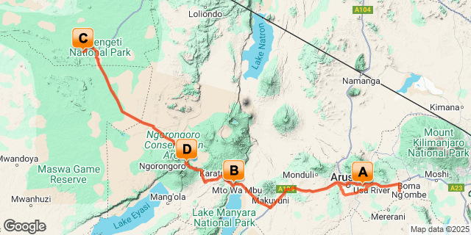

Introduction

Start | Accommodation | Destination | Basis | Duration
Day 1 | Arusha Serena Hotel Resort & Spa | Arusha | B&B | 1 Night
Day 2 | Lake Manyara Serena Safari Lodge | Lake Manyara National Park | FB | 1 Night
Day 3 | Serengeti Serena Safari Lodge | Central Serengeti | FB | 2 Nights
Day 5 | Ngorongoro Serena Safari Lodge | Ngorongoro Conservation Area | FB | 2 Nights

Key
B&B: Bed and Breakfast
FB: Full Board - Dinner, Bed, Breakfast and Lunch

Included
- Accommodation as stipulated in the itinerary.
- Transportation in a chauffeur driven 4x4.
- Services of a professional English speaking driver-guide
- All game viewing drives.
- Flying doctor’s fee.
- Lunch at Arusha Coffee lodge on day 07.
- All parks entrance fees as indicated in the itinerary.
- All Government taxes and levies.
- Complimentary 500 ml mineral water per person per game drive in a safari vehicle.
- All meet and greet services.
- All arrival and departure transfers.
- 24 hours stand-by contact number.
- Meals as indicated in the itinerary.
- Two-way long range high frequency radio communication in each vehicle.
- On safari accessories in each vehicle: - First-aid kit, wildlife books, a pair of binoculars, cool box and fire extinguisher

Excluded
- All items of personal nature e.g. telephone call bills, fax/email bills etc.
- Tipping
- Alcoholic and non-alcoholic drinks,
- International flight and departure taxes.
- Laundry services.
- Any other item(s) not included in our itinerary.
- Visa fees

Day 1
Arusha Serena Hotel Resort & Spa, Arusha

Day Itinerary
Jambo! Upon arrival at the Kilimanjaro International Airport, you will be met and transferred to your hotel for overnight stay.

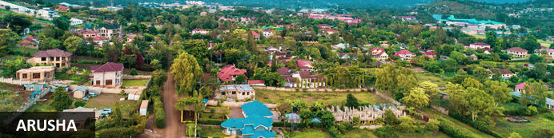
Resting at the foot of Mount Meru, the sprawling city of Arusha is known as the safari capital of northern Tanzania. It serves as an excellent base from which to explore the remarkably scenic surrounding area which includes majestic Mount Kilimanjaro, as well as the Manyara, Tarangire and Ngorongoro National Parks. Arusha is a good spot to take a day or two off from the safari circuit as it features a temperate climate and lush surrounds. Visitors can look forward to exploring the wildlife-abundant Serengeti National Park; the magnificent Arusha National Park; and taking on the challenge of climbing Mount Meru, Africa’s fifth highest mountain.

Overnight: Arusha Serena Hotel Resort & Spa
Nestled at the foot of Mount Meru in Tanzania, Arusha Serena Hotel is a unique destination that blends colonial-era elegance with bespoke experiences that showcase the natural beauty of the Northern Safari Circuit. Originally a coffee farm, the stone-built reception area and cottage-style rooms of the hotel evoke its heritage, with French doors and leaded windows that open to landscaped lawns and colourful bougainvillea banks. In addition to a library, lounge and restaurant with a wood fireplace and garden views, the hotel offers tailor-made experiences such as an English breakfast on the shore of Lake Duluti, hiking to the summit of Mount Meru or exploring the crater lakes of Arusha National Park. For a relaxing evening, guests can sip sundowner cocktails by the lake and watch the sun set over the horizon. The hotel also offers a range of outdoor activities such as walking, mountain biking, canoeing and trips to nearby national parks.
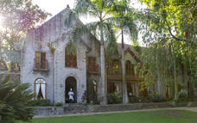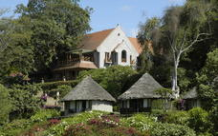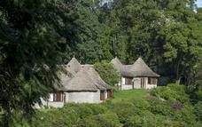

Basis
Bed and Breakfast

Day 2
Lake Manyara Serena Safari Lodge, Lake Manyara National Park

Day Itinerary
After breakfast, depart to beautiful Lake Manyara, a shallow alkaline lake that shimmers in a cleft in the Great Rift Valley. You will arrive for lunch at your lodge followed by afternoon game drive.
Tucked below the majesty of the Rift Valley wall, Lake Manyara National Park consists of a thin green band of forest, flanked by the sheer 600 m high red and brown cliffs of the escarpment on one side and by the white-hot shores of an ancient soda lake on the other. Acacia woodland shelters the park’s famous tree climbing lions, lying languidly among the branches in the heat of the day. Lake Manyara safaris offers many unique views including elephant, giraffe, buffalo and wildebeest can be found grazing in unexpected clearings or heading towards the water to drink or wash, and the rivers and riverbeds provide scenic vistas for possible animal spotting.
Warthog seem to thrive here, growing notably fat and tuskered, and it is a natural playground for baboons and monkeys. Later on in the afternoon, you will be transferred to which stands on the edge of the escarpment, overlooking the lake.

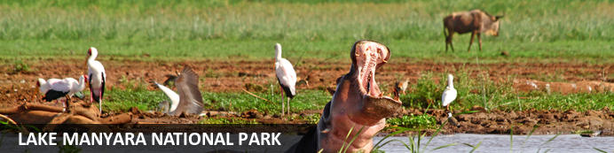
Situated in Tanzania’s central-northern region with the Lake Manyara to its east and the Manyara Escarpment to its west, the Lake Manyara National Park offers breathtaking views and a large variety of habitats supporting an array of wildlife. This small park is home to surprising biodiversity and features a magnificent landscape of acacia woodlands, forests, baobab strewn cliffs, algae-streaked hot springs, swamps and the lake itself. The park supports over 400 species of bird and the largest concentration of baboons anywhere in the world. Other species to spot include giraffes, zebras, wildebeest, impala, waterbuck, warthog, the Cape clawless otter, and the Egyptian mongoose. Don’t miss the opportunity to see thousands of flamingos on the lake, the renowned tree-climbing lions, and large families of elephants strolling through the forest.

Overnight: Lake Manyara Serena Safari Lodge
Lake Manyara Serena Safari Lodge is nestled in a peaceful location within the Lake Manyara National Park, offering a stunning view of Tanzania's Mto wa Mbu escarpment. The lodge is designed to reflect the brilliant birdlife of the region with avian curves and wall frescoes depicting migratory patterns, while the accommodation, housed in circular two-story rondavels, offers traditional charm and modern amenities. The lodge provides opportunities for game drives, outdoor excursions, village tours, lounging by the "vanishing horizon" pool, and dining at the Flamingo Restaurant, with the option of arranging a bush meal. Additionally, Lake Manyara is a popular destination for birdwatching, as it is home to over 300 migratory birds, including flamingos, eagles, and kingfishers. The park is also abundant in wildlife, with sightings of monkeys, hyenas, giraffes, elephants, and many more.
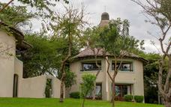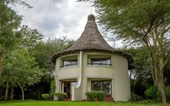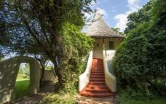

Basis
Full Board - Dinner, Bed, Breakfast and Lunch

Day 3
Serengeti Serena Safari Lodge, Central Serengeti

Day Itinerary
After breakfast, depart to the famous Serengeti national park arriving for lunch at your lodge. Embark on an afternoon game viewing drive in the park. Return later as the sun sets for dinner and overnight.
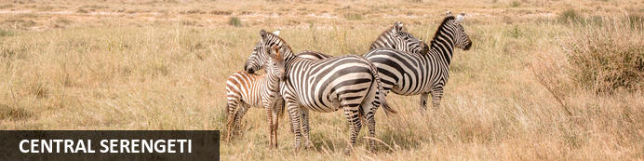
Situated in the heart of Tanzania, the Central Serengeti encompasses the world-famous Seronera Valley which is known for its prime wildlife-viewing opportunities. This picture-perfect landscape is characterised by endless stretches of savannah-covered open plains interspersed by rocky outcrops of granite and scattered with acacia woodlands and covered in a network of rivers and streams. The Central Serengeti forms part of the great wildebeest and zebra migration and provides an ideal habitat for a variety of wildlife such as giraffe, impala, waterbuck, hippo, elephant, buffalo, lion, leopard, hyena, jackal, serval and much more. Popular activities include: game viewing, cultural tours, horse riding safaris, and hot air ballooning over the spectacularly scenic terrain.

Overnight: Serengeti Serena Safari Lodge
Perched high on an acacia-lined ridge overlooking the vast, grassy plains of the Serengeti, Serengeti Serena Safari Lodge seamlessly blends traditional African architecture with modern style to offer an award-winning hotel experience. Stay in stone-built, thatched-roof "rondavel" lodges, dine under a blanket of stars, and enjoy unforgettable adventures such as private safaris, guided nature walks, and massage treatments. The lodge is centrally located near the Western Corridor and Grumeti River and boasts a pool that looks out over the endless plains. Cultural entertainment is on offer, with traditional Makonde carvings adorning the rooms and the stunning domed dining room showcasing performances, heritage, and art.
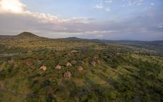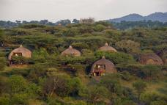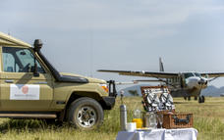

Basis
Full Board - Dinner, Bed, Breakfast and Lunch

Day 4
Serengeti Serena Safari Lodge, Central Serengeti

Day Itinerary
On the second day, you will have a full day of game viewing drives in the park with packed lunch
Dinner and overnight at the park.
The spectacle of predator versus prey dominates greatest park during a Serengeti safari. Golden-maned lion prides feast on the abundance of plain grazers. Solitary leopards haunt the acacia trees lining the Seronera River, while a high density of cheetahs prowls the southeastern plains.
Almost uniquely, all three African jackal species occur here, alongside the spotted hyena and a host of more elusive small predators, ranging from the insectivorous aardwolf to the beautiful serval cat. But there is more to a safari in the Serengeti Plain than large mammals. Gaudy agama lizards and rock hyraxes scuffle around the surfaces of the park's isolated granite koppies. A full 100 varieties of dung beetle have been recorded, as have 500-plus bird species, ranging from the outsized ostrich and bizarre secretary bird of the open grassland, to the black eagles that soar effortlessly above the Lobo Hills.

Basis
Full Board - Dinner, Bed, Breakfast and Lunch

Day 5
Ngorongoro Serena Safari Lodge, Ngorongoro Conservation Area

Day Itinerary
Breakfast at the lodge before having a mid morning game viewing as you depart to the famous Ngorongoro Crater Conservation Area (NCCA), which features rolling plains, lakes, craters, mountains and dormant volcanoes. Journey up the side of the vast Ngorongoro Crater, a World Heritage Site, which is one of the largest volcanic craters in the world (almost 20 kilometers wide, 610-760 metres deep and covering a total area of 264 sq km) and arrive at your lodge in time for dinner and overnight.
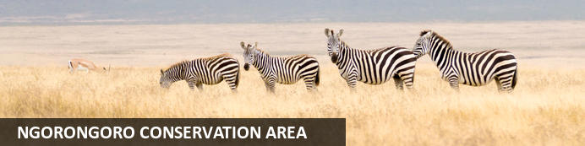
Situated in the Crater Highlands in Northern Tanzania, the Ngorongoro Conservation Area is best known for its archaeological and geological significance, rich wildlife, and beautiful scenery. The conservation area encompasses the famous Crater, the renowned Olduvai Gorge and vast plains of grasslands, forests and mountains extending to the Serengeti. This 8000-square-kilometre protected area is recognised for its natural beauty and has been placed on the UNESCO World Heritage List. Visitors flock here to soak up the spectacular views of the Ngorongoro Crater, voted as one of the Seven Natural Wonders of Africa, it is famed for its natural beauty and abundant wildlife. Popular activities include: mountain biking, hiking, game drives, bush walks, and visiting a local Maasai village.

Overnight: Ngorongoro Serena Safari Lodge
Nestled high on the jagged rim of the Ngorongoro Crater and shrouded in mist, the Ngorongoro Serena Safari Lodge is a stunning example of ecological and architectural harmony. The boulder-built buildings of the Lodge are camouflaged by indigenous creepers and linked by timber walkways that skirt ancient trees. Inside, guests are greeted by the hushed ambiance of a game-viewing hide and the ochre, rust, and charcoal imagery of a prehistoric cavern, decorated with Maasai iron spears, bright-beaded robes, and intricately-carved artifacts. The rooms, strung around the crater rim, are adorned with brass lamps, wildwood mirrors, and Maasai carvings, each featuring its own rock-enclosed balcony and uninterrupted views of the Crater below. After a day of adventure, guests can follow a gentle nature trail, take a guided walk to the Crater's rim, or simply relax with a herbal massage as the sun sets behind the mountains. Explore the Cradle of Mankind at Ngorongoro Serena Safari Lodge and experience one of the most unique travel experiences in the world.
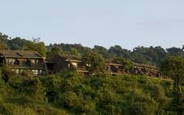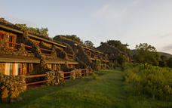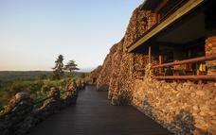

Basis
Full Board - Dinner, Bed, Breakfast and Lunch

Day 6
Ngorongoro Serena Safari Lodge, Ngorongoro Conservation Area

Day Itinerary
After breakfast, descend into the ‘8th Wonder of the World’, a unique biosphere that has remained virtually unchanged since the dawn of time. Enclosed within its towering walls are grasslands, swamps, forests, saltpans, a fresh water lake and a glorious variety of birdlife. Here too are all the members of the ‘Big Five’ (lion, elephant, rhino, leopard and buffalo) as well as a large cast of plains game and one of Africa’s densest populations of predators.
Enjoy a picnic lunch on the crater floor before continuing with your expedition inside this land that time forgot. Climb up and drive back to your lodge for dinner and overnight.

Basis
Full Board - Dinner, Bed, Breakfast and Lunch

Day 7
End of Itinerary

Day Itinerary
After breakfast this morning, meet your naturalist guide and depart for Arusha for lunch. Transfer to JRO for your return flight back home (Dayrooms available at an extra cost)

