Directions from Mlilwane Game Sanctuary to Mkhaya Game Reserve

Distance + 75km – about 1 hour 10 min

- From the Main Gate continue ± 3km STRAIGHT to tar road (MR103)
- Turn right onto the old Manzini / Mbabane road.
- After about 13km you will come to the Matsapha traffic circle under the Mbabane/Manzini highway
- Take the 3rd exit left and onto the highway towards Manzini (± 4km)

There are 2 options around or through Manzini:

Option 1
- At the 2nd set of traffic lights, after coming from the highway and before you get to Manzini, turn LEFT onto By-pass Road, sign posted “Mavuso Trade Centre”. Beware the road is off-camber – please negotiate corners carefully.
- Cross straight over traffic lights.
- Turn left at T-junction.

Option 2
- Drive straight through Manzini – the one-way road is very busy, be careful of the mini buses. Try to keep to the right hand lane as most of the taxi’s and buses use the left hand lane. This road will take you straight out of Manzini.
- Travel ± 8km from Manzini.
- Turn right towards Big Bend, just after Kai Kai Resort at the Hhelehhele junction. There is a filling station on your right.
- After ± 40km you will reach Siphofaneni. Travel a further 6km.
- Cross over a small bridge over the railway, which runs UNDER the road.
- Immediately (10m) after the bridge, turn left at the Mkhaya Game Reserve sign and park your vehicle behind the small shop. This is the Mkhaya meeting point, where you will be met by an Mkhaya guide/ranger, who will then accompany you into the park.
- Please do not drive further without a guide as the gates are kept locked.
- Meeting Times are strictly 10:00 or 16:00 – please refer to your reservation for your correct pick up time.

SUMMARY OF DIRECTIONS (OPTION 2)
D55, Eswatini – MLILWANE GAME SANCTUARY (S26° 28’ 47.4” E31° 11’ 46.6”)

- Head northeast on D55 3.2 km
- Turn right onto MR103 6.3 km
- Slight left 6.6 km
- At the roundabout, take the 2nd exit onto the MR3 ramp 500 m
- Merge onto MR3 7.5 km
- Continue onto Ngwane St 1.1 km
- Continue onto MR3 7.0 km
- Turn right onto MR8 43.1 km
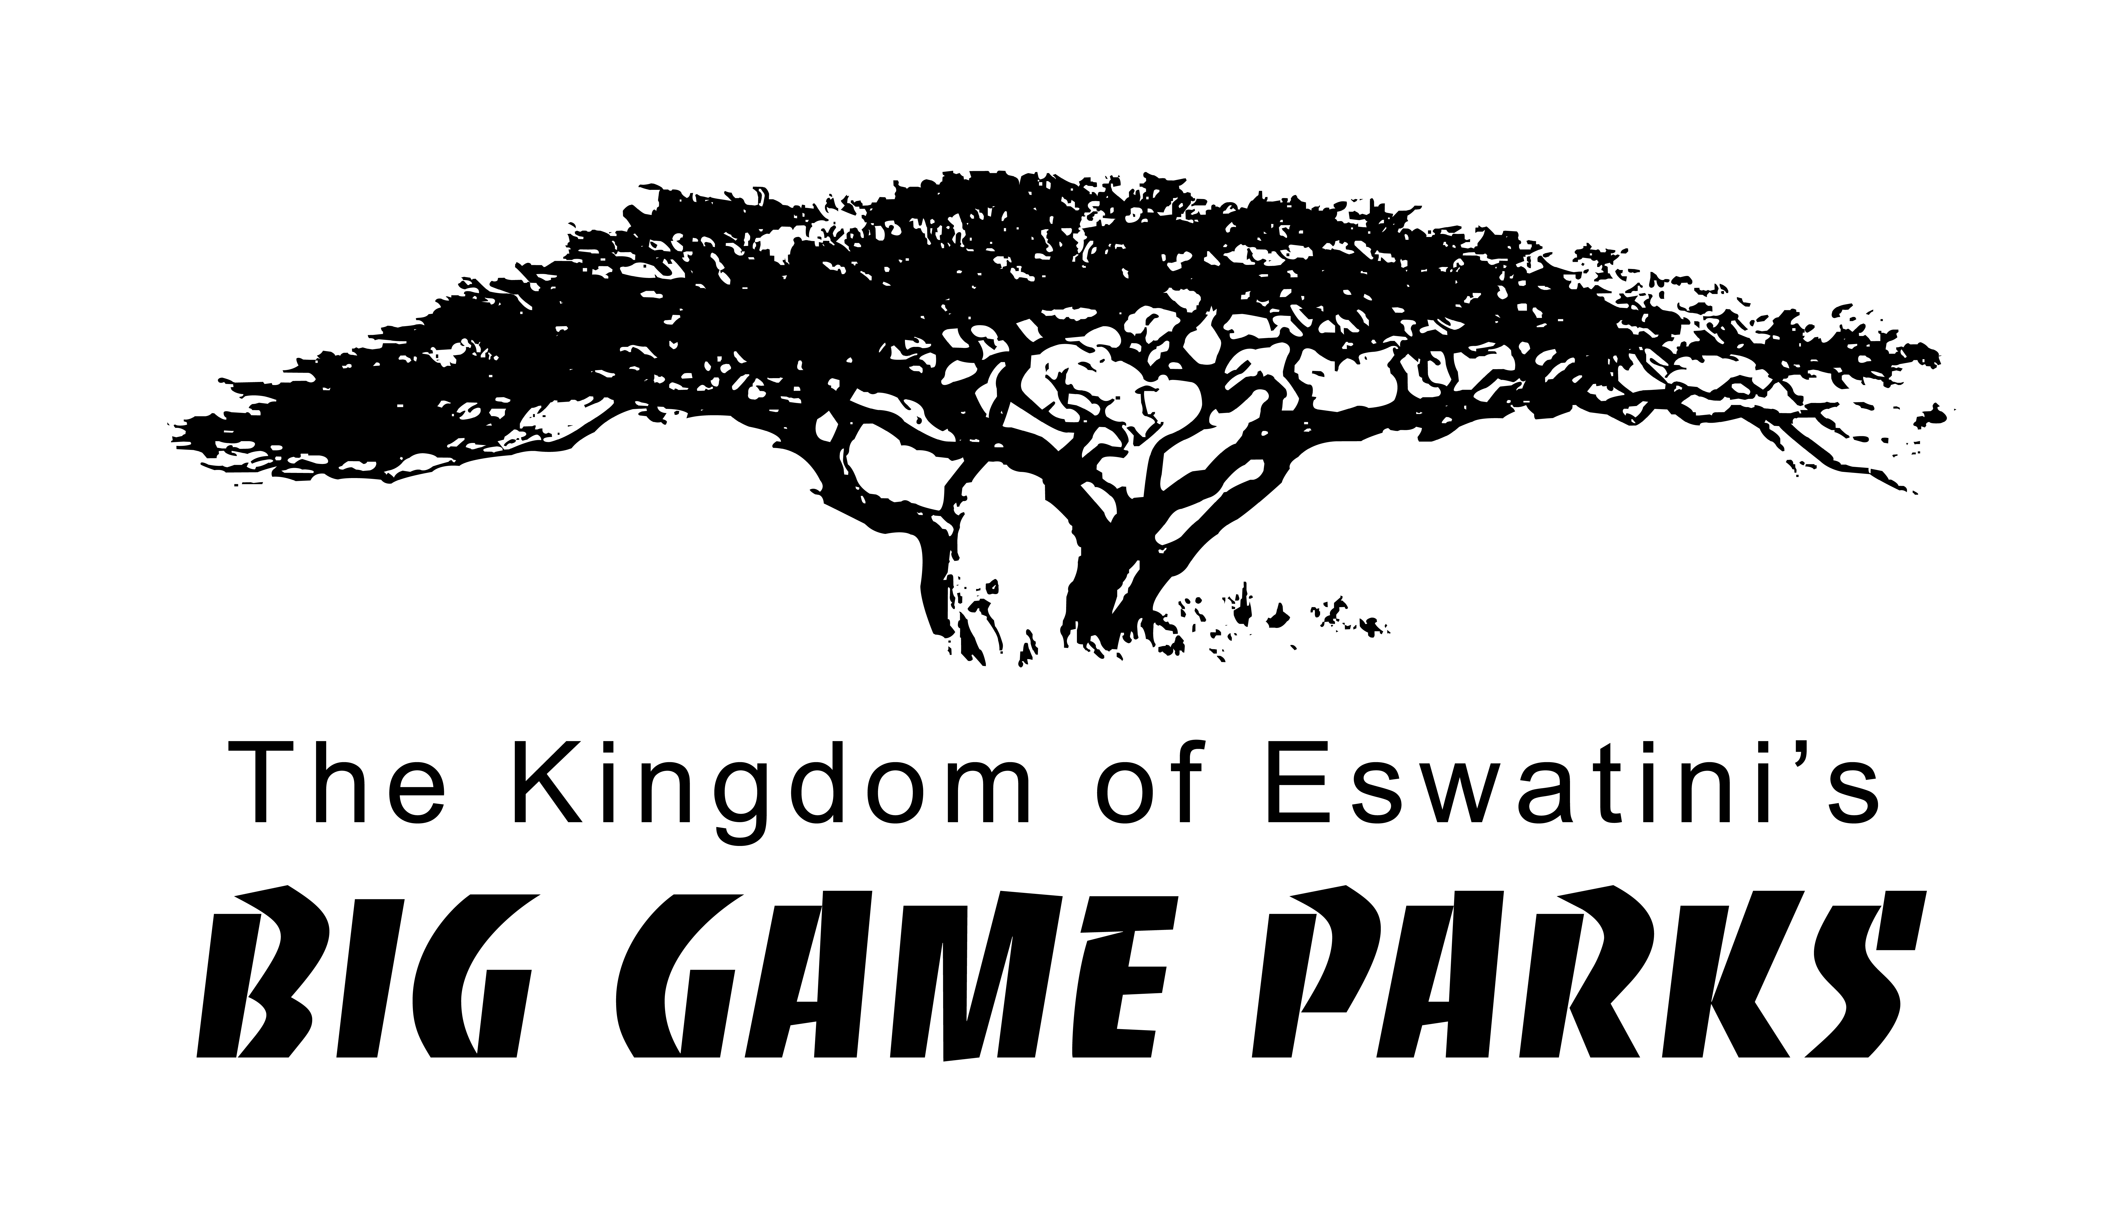
Destination will be on the left
MR8, Eswatini – MKHAYA GAME RESERVE (S26° 41' 2.49" E31° 44' 47.73")

