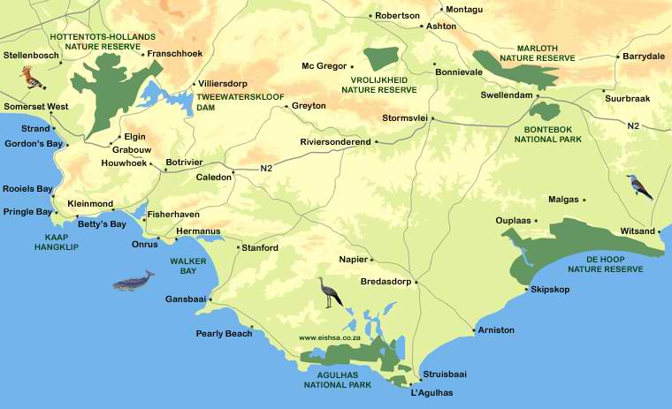

DIRECTIONS FROM CAPE TOWN / AIRPORT
Follow the N2 towards Somerset West, over Sir Lowry's Pass and Houwhoek Pass. Exit the N2 to the left towards Hermanus onto the R43. Drive through Hermanus to Stanford and turn right onto Queen Victoria Street. Drive 0.9 km; turn left onto Moore Street. Drive 0.4 km to the stop sign. Continue straight on the gravel Wortelgat Road for 7 km to the MOSAIC entrance sign. •
CHECK-IN FOR LAGOON LODGE GUESTS: Drive 400 m and turn right onto the dirt road at the sign to the Lagoon Lodge. Drive 1 km to the Lodge. Check-in at the Reception. GPS Coordinates: -34.420664, 19.380717
FROM THE GARDEN ROUTE: Follow the N2, 10 km past Riviersonderend; take the R326 to Stanford. At the stop sign at Stanford, continue straight through the intersection onto Queen Victoria Street. Follow the same directions from Queen Victoria Street above.

